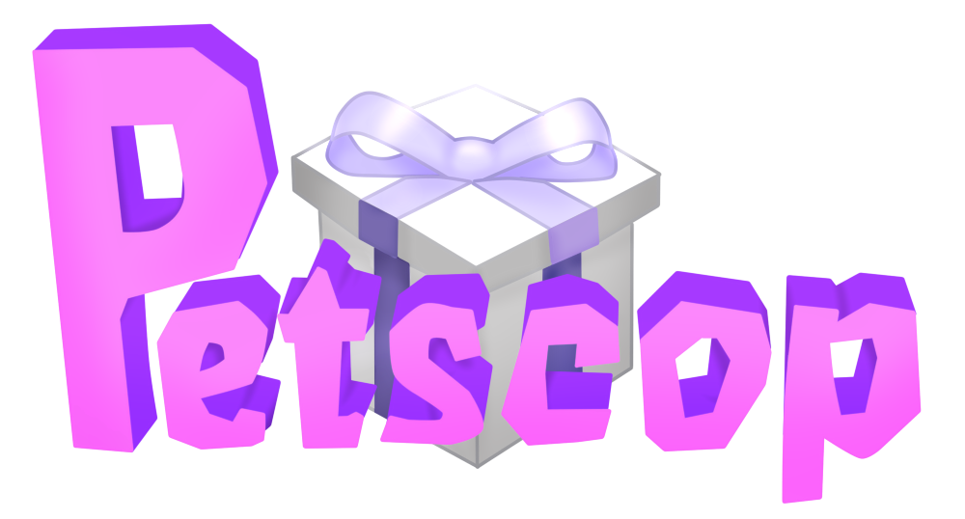

**Comprehensive Progress Document**

|  |  |  |
| --- | --- | --- |
| **Contributors**  brawlflower, thinkingobserver,Shift, DrunkCat, mp, Citee, Porto881, piglover352, Anzu, Santiago, James  Nullsharp *(original owner)*  Doc logo by [ravenlordanzu](https://ravenlordanzu.deviantart.com/art/Petscop-Title-Logo-Re-Creation-725083860) | **Petscop Links**  [**YouTube Channel**](https://www.youtube.com/channel/UCZKQv0ZFHpeIUkOtNjtq4KA)  [Subreddit](https://www.reddit.com/r/Petscop/)  [Discord Server](https://discord.gg/petscop)  **Most recent video:**  [**Petscop 24**](https://www.youtube.com/watch?v=2KsWlk79rng) | **Discord — Contact:**  **mp#4054**  For editing permissions  **mp#4054**  For additions/changes  **Document version:**  **2.24.0** |

# **Document Usage**

## **Information**

The purpose of this document is to catalogue the contents of the Petscop videos, and to collate any significant theories or findings that pertain to them.

Anything written in **BLACK** is considered a discovery or factual information that can be directly derived from the videos.

Theories are presented in **RED**. A theory will be included only if it’s backed by evidence, and will be subject to change or removal with new discoveries.

## 

## **Navigation (Table of Contents)**

Go to View ➧ check Show Document Outline to quickly navigate between sections.

This works as a Table of Contents and can be directly linked to.

## **Don’t like the formatting? Make a copy!**

If you don’t like the font or its color, or otherwise want to modify the document:

1. Log into Google.
2. From the top-bar, go to File ➧ Make a copy…

To change the text:

* **Font:** Select all text (ctrl+a) and change the font.
* **Text color:** Right click any red text ➧ “Select all matching text” ➧ Modify text color

# **Outside the Game**

*This section discusses anything outside of the game itself. This includes discussions of Paul and how he is involved with the game and the story.*

## People

### Paul Leskowitz

Paul never states his name explicitly, but he calls his game file “Paul,” and the about section refers to him as Paul on multiple occasions. The name is also used by the person playing Graverobber in Petscop 22. Paul admits that there’s a strong resemblance between himself and Carrie, and that they’re (according to his friend) the exact same age. This may imply that they’re twins or even the same person.

In Petscop 17, Carrie’s (and thus Paul’s) birthdate is stated to be November 12, 1992. This is corroborated further by the five candles that can be seen on Care’s 1997 birthday cake in Petscop 14.

The exact way Paul came to possess Petscop remains unknown, but he claims to have found it, first in the description of Petscop 1 (“The game I found”), and later in Petscop 11. In Petscop 8, Paul reveals that his mom “reportedly” had the game after 2004—he may have found it among her belongings. The third version of the about section reveals that *“the game had an interesting journey.”*

According to the about page, Paul created his Petscop videos and the YouTube channel in 2017 to share them with his friend. At some point he passes the ownership to the channel’s current proprietors, but he continues to make further videos at their urging. He has some undisclosed issues with this arrangement, but they are later supposedly resolved.

In Petscop 6, Paul says that he’s unconvinced by the game’s attempts to make him think it’s haunted, and that he’s trying to be scientific about it.

In Petscop 11 and 14, Paul seems to conflate left and right: he has trouble with the “righty-tighty, lefty-loosey” mnemonic, and gets confused while describing the layout of the Master Bedroom. This may be due to the left and right pad buttons being flipped.

Petscop 12 implies (through footage syncing) that Paul’s character is seen as the “Pyramid Head” by other players.

In Petscop 14, Paul mentions knowing someone named Jill. He remembers having a conversation with her on his birthday last year (2017), and decides to call her while recording the episode. Jill may be the person with whom he talks on the phone in Petscop 8. In Petscop 22, Paul appears to be afraid of Jill.

Also in Petscop 22, Paul and his friend plan on visiting the real-world location corresponding to the Windmill. Their goal is to take measurements and look for other landmarks that could be reflected in the game.

The Reddit account that first posted about Petscop, u/paleskowitz, is believed to be Paul’s. If so, then his surname is Leskowitz, and he’s likely Lina’s relative.

### The Proprietors (fan name) / The Family

The Proprietors are the current (in-story) owners of the Petscop channel. While their existence may be hinted at previously (by the first two versions of the about page, censorship, and Petscop 5’s description), they reveal themselves in the 3rd iteration of the channel’s description.

They claim that Paul passed the channel’s ownership to them, but he continues making videos at their request. They’ve repurposed the channel to “display the recordings within the video game "Petscop" while keeping some of their content private.” This may mean that they’re responsible for the censorship.

The Proprietors may have taken over the channel sometime between Petscop 4 and 5. The channel was probably private before then, and Petscop 5’s description uses the word “we,” as well as the phrase “I guess this is for all of you, now,” which indicates that a change may be occurring (“now”).

The Proprietors may be the family depicted in the House, as they claim to have received the Recordings “as a Christmas gift, many years ago.” Paul’s words in Petscop 22 strongly imply this to be the case. In particular, he names Jill as someone who takes interest in his playthrough, and intimidates him.

At the end of Petscop 8, Paul appears to be having a phone conversation with an unknown person who seemingly has played Petscop in the past (the game, however, is different now). This person may be one of the Proprietors.

In Petscop 14, Paul mentions both a “public YouTube” and a “family YouTube.” Though he may be referring to the same channel in both instances, it is possible that there is a private channel that is only accessible by Paul and the family/Proprietors.

### Paul’s Friend

According to the Proprietors, Paul started making his videos “to show Petscop gameplay to his friend.” Paul addresses said friend throughout the series as “you,” narrating to them and occasionally referencing their shared past.

In Petscop 2, Paul mentions that his friend will “come home next month” and will be helping to explore and figure out the game. The description of Petscop 5 says “we asked this one after the video ended,” and “we were able to ask two questions,” implying that Paul might already be with them at this point (assuming Paul is the one who wrote the description). Alternatively, he could also be collaborating with them online or by phone, or this message has been co-written by the channel’s current proprietors.

In Petscop 11, Paul says “it made sense, especially considering where I found the game in the first place, it would be tied in some way to me through you,” indicating that the Friend may also have some ties to Petscop.

In Petscop 22, Paul holds a long conversation, presumably by phone, with his friend. He refers to his friend as a puzzle genius, while also mentioning that they’re not part of the Family, to which the friend seems to object. This could indicate that Paul’s friend is the real-world counterpart of Belle, who has been described as “smart” and “not Family,” but who insists on being Tiara (who shares surname with Lina and thus presumably is a member of the Family).

Paul and his friend make arrangements to visit and measure a stone that corresponds to the Windmill, but the friend seemingly stops responding right before Belle enters the screen.

### Jill

In Petscop 14, Paul mentions knowing someone named Jill. He remembers having a conversation with her on his birthday last year (2017) during which she seemed to ignore him, and was possibly withholding the location of “the Discovery Pages” and “the disk.” Later in the episode he decides to call her.

In Petscop 17, she is stated to be Carrie Mark’s aunt.

In Petscop 22, Paul identifies Jill as one of the Proprietors and appears to be afraid of her. He mentions her showing brief interest in his friend, and suggests that if his friend caught her attention, they “wouldn’t be able to escape.”

Jill may be the person with whom Paul talks on the phone in Petscop 8.

### Lina Leskowitz

Born in 1968, disappears in 1977. Anna’s sister and Marvin’s friend who supposedly vanishes together with an old windmill. Afterwards, Marvin allegedly tries to lure her back home with a birthday party and cake. Rainer doubts this story, and believes that Marvin knows where her unmarked grave is. Rainer also claims that he found evidence that Lina was reborn as Carrie. She may be related to Paul.

She’s implied to have no eyebrows.

In Petscop, she’s represented by Lina.

She shares surname with Tiara, and may be Mike’s other aunt.

### Carrie Mark

Born on November 12, 1992, Carrie is Anna and Marvin’s daughter, Lina’s, Jill’s and Thomas’s niece, and Daniel’s cousin. She’s stated to be the exact same age as Paul, and to bear a strong resemblance to him (they may be the same person or twins), although she isn’t growing eyebrows. According to Rainer, Lina is reborn through her.

She plays Petscop (seemingly as a tester) in 1995 or before, and again later at some point after November 12, 1997 (Petscop 21).

She is kidnapped by her father on June 5, 1997, who holds her for five months in an abandoned school, until she manages to escape on November 10, 1997. She returns home on her fifth birthday (November 12, 1997).

In Petscop 11, Paul says “I remember you saying that we were... that we, we are, exactly the same age” when he talks about her. The self-correction from past tense “were” to present tense “are” may indicate that she’s still alive.

In Petscop 24, Carrie is credited as “dizzy” in the Book of Baby Names (possibly in reference to Casket 2), and an in-game message from Anna states that she helped in picking Mike’s birthday gift.

Paul claims that he has no recollection of ever meeting her, and that he didn’t hear about her disappearance.

She is represented by Care in the game.

### Marvin Mark

Anna’s husband, Carrie’s father, Lina’s friend.

In 1977, he supposedly plays an unspecified role in the event that causes Lina and an old windmill to disappear. He then allegedly tries to lure her back home with a birthday party and cake. Rainer doubts this story, and believes that Marvin knows where Lina’s unmarked grave is. At an unspecified later date, Marvin marries Lina’s sister, Anna, and together they have a daughter named Carrie.

In 1996, Rainer begins working on the 6th Generation of Petscop for him.

At some point before 1997, he appears to separate and enter a custody arrangement with Anna.

On June 5, 1997, he kidnaps Carrie, and imprisons her in an abandoned elementary school. He shows her her reflection in a vase trying to convince her that she’s deformed. He seems to remain at the school even after her escape on November 10, 1997.

He’s the first one to play the 6th Generation of Petscop, and appears to be doing so shortly after the kidnapping (he’s most likely the recipient of the Note). He then plays Generation 7 after July 10, 1997, and Generation 8 at some point after Carrie’s escape.

In Petscop, he’s represented by the character Marvin.

### Anna Mark (née Leskowitz)

Marvin’s wife, Carrie’s mother, Lina’s sister, and Mike’s aunt.

In 1977, she takes photographs both before and after the disappearance of Lina and the windmill. She later marries Marvin, and they have a daughter named Carrie.

At some point before 1997, she appears to separate and enter a custody arrangement with Marvin. She evicts Marvin, and later asks Rainer to help her in painting over the stencils (presumably made by Marvin) in her house, and leaves a note with a list of items for him.

In Petscop 24, a note from her to Mike is shown in the Book of Baby Names. This could imply that she was involved in the creation of Petscop. The note mentions that she brought him a gift in a black box.

She appears to use a black rosette (🏶) as her signature, and often precedes interpunction with superfluous spacebars.

She is represented as Anna in Petscop.

### Thomas

Carrie’s uncle.

### Daniel

Carrie’s cousin. During an Easter Egg Hunt that takes place no later than 1995, Petscop is referred to as “Daniel’s game,” which may imply that he’s Rainer.

### Rainer

According to the about page, Rainer goes missing in June “1997 and 2000,” and later gives a gift to the Proprietors “on Christmas 1997 and 2000.” Combining this with their statement that they’ve received the Recordings as a “Christmas gift, many years ago,” indicates that Rainer probably gives them either Petscop itself or footage from it.

Rainer is also signed under multiple messages within the game, one of which stating “this is my present for you. I started it in 1996, for Marvin.” In Petscop 20, he also takes credit for multiple in-game assets, and shows his ability to modify the game. This indicates that Rainer is the creator or co-creator of Petscop.

In 1996, Rainer appears to begin the development of the 6th Generation, which is subsequently played by Marvin. Judging by the existence of the Note, Rainer has a (limited) way to both contact Marvin after the latter kidnaps Care, and to make him play Petscop.

In July 1997, Rainer participates in a search for Carrie (despite supposedly being missing during that time), and works on the 7th Generation.

Based on his messages to Marvin in Petscop 20, the gameplay of Graverobber, and Care B’s description, it’s possible that Rainer dug up one or more graves (most likely Lina’s).

Paul remembers meeting Rainer at a birthday party, where Rainer spends his time with children playing video games in the basement. According to Paul, Rainer is the eldest of that group.

Rainer and Mike are speculated to be brothers or half-brothers, based on Care A’s description (“My brother didn’t want us to find him, because he knew we were all looking for Michael A”), Roneth’s description, Anna’s letter in the Book of Baby Names, and Mike being the earliest player of Petscop.

Around 1995, Rainer was likely an employee at a game company, possibly Garalina, as an early version of Petscop is used in an Easter Egg hunt that takes place in an office.

Rainer’s name in the first about page was written in quotation marks, implying that it may be a pseudonym. It may also be a reference to the poet Rainer Rilke. Rilke’s birth name was Rene, which means “the reborn,” and his mother was hoping to get her dead daughter back through him (she even dressed him in girls’ clothing during the first few years of his life). Rilke also shared a mentor with Igor Stravinsky, whose music plays in Petscop 7.

### Michael Hammond

Mike was born in 1988, and presumably died in 1995. He is Anna’s nephew and the first known player of Petscop. He provided feedback on Toneth’s appearance, and is likely Rainer’s brother or half-brother.

Within the game he’s represented by a tombstone.

### Belle

Belle is an early Petscop tester/player, who appears to have performed significantly better than others. She later plays the game again, after it loops back to the first Generation for the first time.

Belle may be Paul’s friend.

In Petscop, she’s represented by Belle.

### Testers (Petscop Kids)

During the first five Generations, Petscop was played by numerous individuals, who appear to be its testers. The most notable ones include Mike, Care, and Belle.

Since Mike apparently died in 1995, most, if not all, of the testing also had to take place in that year.

The message in Petscop 13 is likely meant for the Testers, as part of it can be seen after Belle captures Roneth:

Congratulations ... you caught every pet in Even Care (aside from Toneth, who isn’t here yet.)

You have seen everything in the game, so far, but there will obviously be more.

It’s a growing organism.

Your controller inputs will be useful, but your feedback will be even more useful.

The tests likely took place in the office mentioned in one of Mike’s recordings in Petscop 19.

On the list of recordings, in Gen. 5 of the first cycle, there’s a long segment during which the names are alphabetical, with many appearing for the first time. This may be indicative of a more formal testing phase taking place.

In Petscop 24, the Book of Baby Names is revealed to feature a list of the Testers. The list pairs each of them with a nickname or an adjective (presumably based on their gameplay), and is followed by a letter from Anna to Mike. The letter indicates that at least some of the testing took place during Mike’s birthday.

The list is preceded by a stylized text saying “Petscop Kids.” This may be a collective term for the Testers, but it also may be an earlier title of the game: on the one hand, Tiara is referred to as a “Petscop Kid” by Red TOOL, on the other hand, the same text can be seen on a screen in the School, where it isn’t followed by the list.

For a list of all names featured, along with notes and their titles given in the Book of Baby Names, [see the Long Lists Appendix](https://docs.google.com/document/d/19eERbg8QtQwGzX-bC20HeM-teT3mcjQEeNaHFyMSgps/edit#heading=h.zdz7u4h3n5n9).

## Miscellaneous

### The Note

In Petscop 1, Paul explains that he found a note with the game:

“I WALKED DOWNSTAIRS AND WHEN I GOT TO THE BOTTOM, INSTEAD OF PROCEEDING, I TURNED THE RIGHT AND BECAME A SHADOW MONSTER MAN

6/13/97

For you:

Please go to my website on the sticker and also go to roneth's room and press start and press down down down down down right start”

The date 6/13/97 is marked with faint symbols on the green calendar in the House:

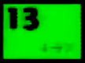

*(image enhanced for clarity; depending on the method used, the leftmost character may also appear to be a left-pointing arrow)*

The stairs referenced in the top half of the note might be the same stairs as in one of the hidden loading screens. The image appears to portray a staircase, a door straight ahead, and possibly another doorway on the right with light coming from it.

In Petscop 9, Paul discovers how to become the “shadow monster man” by walking right on the stairs to the Flower Shack Basement. It has been pointed out that this procedure resembles the secret code from the note (with menu options acting as steps on the stairs).

In Petscop 14, the website Paul sees in the Garage may be the one mentioned in the Note.

In Petscop 20, Marvin makes multiple attempts at executing the secret code, and eventually enters it correctly after consulting the controls.

The lower half of the Note is most likely written by Rainer, to Marvin. The latter is the first one to play the 6th Generation of Petscop (which Rainer supposedly develops for him starting in 1996), and Generations 1-5 already exist back in 1995, and are unlikely to feature the code or its associated content.

The upper half may be a comment written by Marvin about a bug he encounters.

In March 2019, the Note was added to the description of the first episode, presumably due to the removal of annotations from YouTube videos.

In Petscop 22, Paul’s Guardian walks down the stairs leading to the school basement. At their bottom, he turns to his right and goes through a door into a seemingly unfinished area. This causes the game to pan left in a stuttering motion.

### Save File Anomalies

In Petscop 6, Paul explains how he ran tests on the game:

[...] ‘cos I created a new file and I tried to be scientific about it, and went and did all the same things that I did this time and the same things did not happen. None of the things happened. None of the oddities occurred, like the figure in the mirror room for example. So there’s a bit of randomness in it, and it’s interesting how it doesn’t really seem to care if you see everything, I guess.

This could be the result of RNG, or it could be an indication that these events are caused by an entity inside the game. Another possibility is that the anomalous events have a trigger or triggers which Paul misses on his second run, such as a specific file name.

In Petscop 10, the game crashes after Paul opens both cages in Amber’s room and tries to leave. After a reboot, the load menu shows two of the save files with an “PANICSV possible corruption” error. Paul loads the file and finds that the cage doors are still open. “PANICSV” may indicate that the game goes into a panic mode after crashing, and tries to save as much progress as it can. What’s unusual is that both the main save and the backup save are corrupted, while the “test” save is unaffected. This might indicate that Paul makes the backup after the game crashes. Alternatively, it has been suggested that the two files may be linked.

In Petscop 13, Paul creates another new save file on which he captures all pets in Even Care.

In Petscop 14, Paul’s first save is renamed to “strange situation,” (a possible reference to a psychological procedure of [the same name](https://en.wikipedia.org/wiki/Strange_situation)) and his other two appear to be deleted. Loading the remaining save places the player in front of the House during Care’s birthday party.

### Censorship

Near the end of Petscop 7, in the room selected by inputting Care’s face with Mike’s eyebrows onto the easel, the first censored object appears:

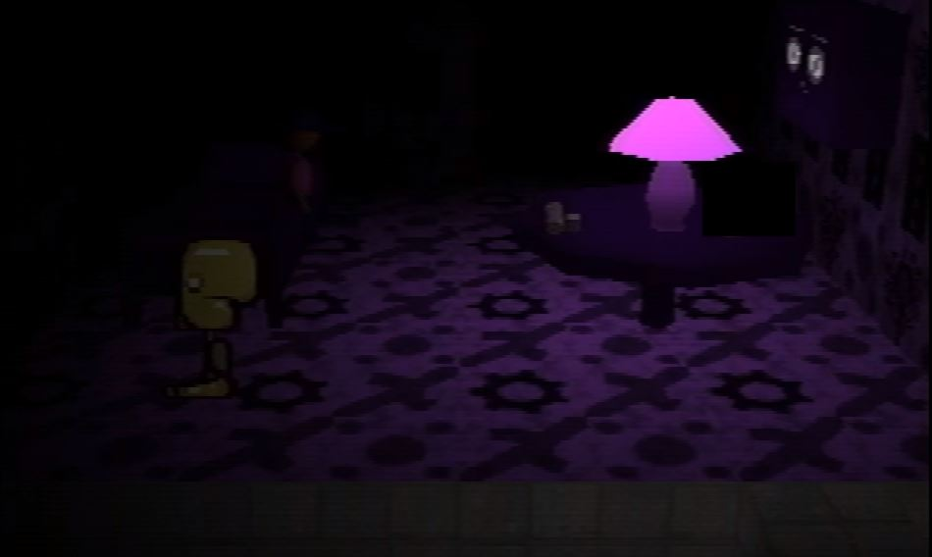

Shortly afterwards, a message is presented to the viewers:

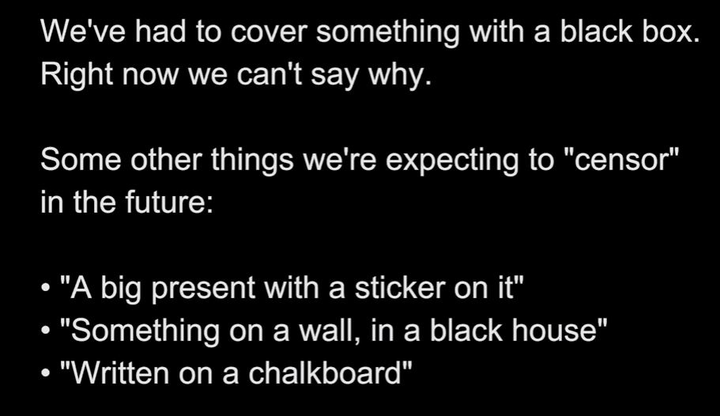

In Petscop 9, another censored object emerges out of a gift box, which is presumably the “big present with a sticker on it” referenced in the message. At first, it appears to be a small, upside down, spinning, black pyramid, but it quickly expands and turns bright red. The censor box then obscures the center of the (still spinning) object.

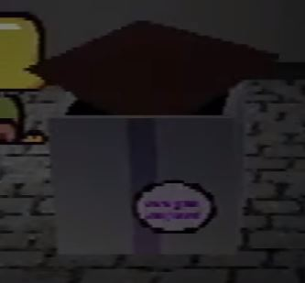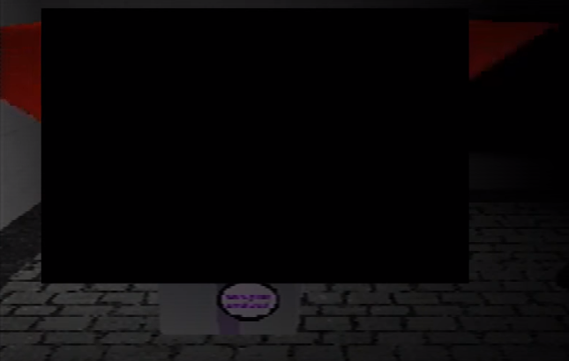

In Petscop 10, a censor box appears after Paul asks Red TOOL “Where was the windmill?”

In Petscop 12, a cut prevents the audience from seeing a message from Belle’s Captor.

In Petscop 13, a fragment of the audio is suppressed around 6:18, amidst knocking sounds:

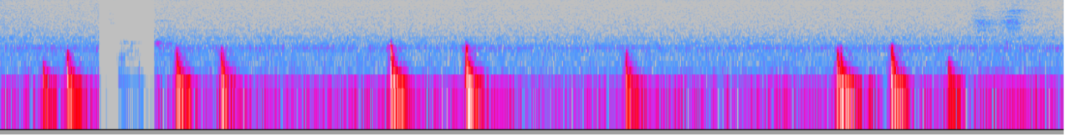

[Enhancing the fragment](https://clyp.it/nbgxgrbo?token=929c19e70648e4455a1163dea517ca19) reveals Paul saying something, possibly “stop” or “what’s that.” The fragment may also hold an additional silent knock.

In Petscop 14, a fragment of the wall in the Master Bedroom is censored, until Paul paints over it. This appears to be “something on a wall, in a black house.”

In Petscop 16, a phone number is censored, but a part of it can be seen briefly:

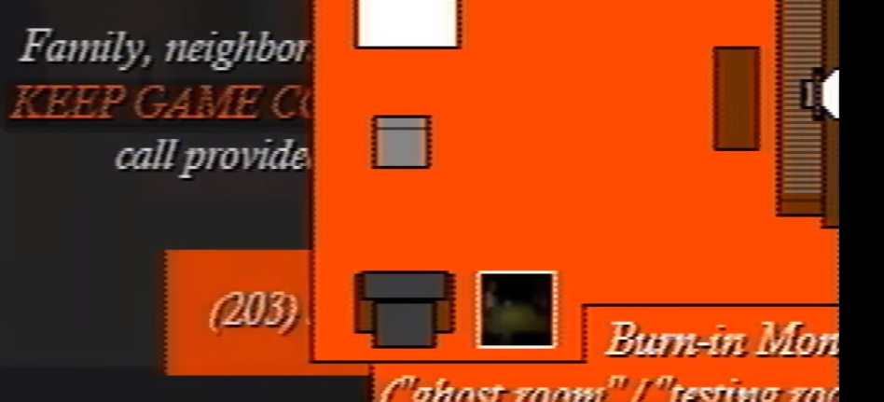

(203) is one of the area codes for the southwest Connecticut region, signifying that some of the plot may be taking place in that vicinity.

In Petscop 20, most of the censored objects are revealed to be the Caskets.

In Petscop 22, the scene from the end of Petscop 10 is repeated and continued, but Red TOOL’s answer is still censored. Paul then talks about it with his friend, and their conversation suggests that the TOOL displays a set of coordinates, which appear to point to a rock⁠—which Paul believes to be a real-world counterpart to the Windmill⁠—and a second set of numbers⁠—presumably directions that need to be followed from the rock.

In Petscop 23, text on the blackboard in the Surveillance Room is censored.

### Profile Picture and Channel Description

On approximately June 8, 2017, the profile picture (a cropped frame from Petscop 2) on the Petscop channel was changed.

Old profile picture: New profile picture: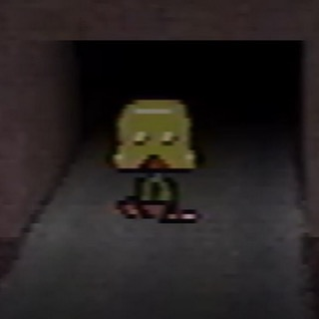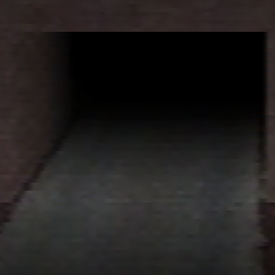

*(**The tunnel* *remains lit in the new version, despite there being no player character there to act as a light-source)*

On approximately June 24, 2017, the previously blank channel description was changed to the following:

"Rainer" gave this gift to us on Christmas 1997 and 2000. It was the single longest day of our lives. We were all certain he was dead at the time. He had been missing since June 1997 and 2000.

We're not as concerned about these things now.

Please enjoy the recordings! We do. :)

On September 10, the About page updated once more:

"Rainer" gave this gift to us on Christmas 1997 and 2000. It was the single longest day of our lives. We were all certain he was dead at the time. He had been missing since June 1997 and 2000.

We're not as concerned about these things now.

For now, there is nothing to do. We are waiting patiently for Paul! When the time comes, we will turn on the light.

The second update was likely a message to the community to not treat the series as an ARG or look for clues outside the Petscop channel.

On December 24, 2017, the profile picture returned to its original variant, and the about section changed once more:

Everything we wish to say is below:

The purpose of this YouTube channel is to preserve and display the recordings within the video game "Petscop" while keeping some of their content private.

They were first given to us as a Christmas gift, many years ago. The game had an interesting journey, before and after that day.

Paul created some additional recordings in 2017 as a way to show Petscop gameplay to his friend. He created this account in order to upload those additional recordings in video format. He later passed ownership of the channel to us, but continued to record himself at our strong suggestion. Though he had issues with the arrangement, these have finally been settled.

Please enjoy the recordings in Petscop! We do. :)

This suggests the existence of older, as of yet unseen, Petscop videos.

On April 1, 2018, the last line of the description changed for about 30 minutes before reverting to the previous version:

Please enjoy the recordings in Petscop! We do. :(

This may have been an April Fools Day joke by the creators of the series.

On June 27, 2018, the about section got appended:

Update for 6/27: Paul is OK. His work is bearing fruit, and there will be a public compilation video of his "Attempts". He appreciates that people care about him so much.

This addition was subsequently removed on July 17, 2018, after Petscop 14 came out.

In Petscop 14, Paul mentions both a “family” and a “public” YouTube channel. It’s currently unclear whether or not those are the same. It’s possible that one of them is fictional and only exists in-story.

On October 30, 2018, the about section was changed:

Recordings of a video game.

The channel’s profile picture was also changed:



[*Brightened image*](https://cdn.discordapp.com/attachments/351727301396004864/506857409575124993/unknown.png)

The image depicts the garage: part of the monitor located there can be seen in the corner. The object in the picture seems to be a car due to its similarity to other car models ([comparison](https://media.discordapp.net/attachments/351727301396004864/506863141431541760/Untitled.png)), and its being in the garage. Furthermore, the shadows visible in the garage in Petscop 14 appear to match with the object (presumably its model didn’t load), and their outline suggests wheels ([comparison](https://cdn.discordapp.com/attachments/351727301396004864/506877987526934568/garage.gif)).

On January 26, 2019, the about section was changed:

Some select "Petscop" recordings.

In a way, recordings have the power to raise the dead. They're kind of scary.

Currently hunting for hidden content.

On April 2, 2019, the last line got replaced:

We finished our long Easter egg hunt.

On April 4, 2019, the channel icon changed once more:



On April 21, 2019, after Petscop 21 was uploaded, the channel icon returned to the original one featuring a Guardian in front of the tunnel.

On September 1, 2019, the last line was replaced:

Thank you for watching. : )

### The Recordings

The Recordings are the original Petscop recordings given to the Proprietors “as a Christmas gift, many years ago,” presumably by Rainer. A scene seemingly depicting this event might be playing out in Petscop 11, within the House.

They’re likely a subset of the recorded player inputs that can be played out through Demos and the Sound Test Menu.

### Timeline

**1968** - Lina Leskowitz is born

**1977** - Lina and the windmill disappear, Marvin supposedly tries to lure her back

**19??** - Marvin and Anna get married

**1988** - Mike is born

**November 12, 1992** - Paul and Carrie are born

**1995 at the latest** - Petscop development begins

**1995** - Mike dies

**1996** - Rainer begins working on something (Gen. 6) for Marvin

**Before 1997** - Marvin leaves the house and enters a custody arrangement with Anna

**June ??, 1997** - Rainer goes missing

**June 5, 1997** - Marvin kidnaps Carrie

**June 13, 1997** - the Note is written

**July 5/6, 1997** - Rainer and others search for Carrie and almost get lost

**July 10, 1997** - Rainer writes a message for Gen. 7

**November 10, 1997** - Carrie escapes

**November 11, 1997** - Carrie’s whereabouts are unknown

**November 12, 1997** - Carrie returns home

**December 25, 1997** - Rainer returns with the recordings

**~1999/2000** - beginning of the timer seen by Belle in Petscop 12

**June ??, 2000** - Rainer goes missing

**December 25, 2000** - Rainer returns with the recordings

**After 2004** - Paul’s mother acquires Petscop

**March 11, 2017** - the channel is created

**April 8, 2017** - u/paleskowitz (Paul) posts Petscop on Reddit

**November 12, 2017** - Paul and Jill have an argument about the “disks” and Discovery Pages

*(see* *Video Summaries* *for the upload dates of specific episodes)*

### First Mentions of Petscop Online

The first known public mention of Petscop was on April 8, 2017, in the only post made by a throwaway Reddit account named “paleskowitz” ([Link](https://www.reddit.com/r/creepygaming/comments/6488lt/videos_of_a_mysterious_unfinished_psx_game_from/)). Inclusion of the name “Leskowitz” strongly suggest this being an account made by the creators of the series—in-story it likely belongs to Paul. Notably, the title of the post says “There’s something hiding in it.” (The Mystery flair has been added by a moderator, not by the poster.) At the time of the post, only Petscop 1 through 4 had been released.

The earliest mention of Petscop on 4chan was 2 days after the aforementioned Reddit post, on April 10, 2017 ([Thread Archive](https://boards.fireden.net/v/thread/373432182)). This post was most likely made by someone who saw the Reddit post, but it’s possible the creators of Petscop were also using 4chan to promote the web series.

### Video Summaries

The summaries do not go into details, and serve only as a reference and memory aid.

|  |  |  |
| --- | --- | --- |
| **Title** | **Upload date** | **Episode highlights** |
| [**Petscop 1**](https://youtu.be/6e6RK8o1fcs) | Mar 12, 2017 | Intro—Paul plays through Even Care  The note with the game; Paul inputs the code  The Newmaker Plane and the door |
| [**Petscop 2**](https://youtu.be/teJDdkWHAdw) | Apr 1, 2017 | Door opens on its own, Paul enters  Basement and Office; states of Care  Hallway with pictures: house, school, windmill  Mike’s grave, flower shack  Red TOOL, Windmill  Quitter’s Room, Quitter desync |
| [**Petscop 3**](https://youtu.be/FqyhmoMdeC8) | Apr 2, 2017 | Child library, testing out the rooms  Mike’s face: tweezers/tuning fork and TOOL  Care’s face: crayons and TOOL, first note  Wall note: shoot in head/child picked next |
| [**Petscop 4**](https://youtu.be/IwaRKux9eR8) | Apr 7, 2017 | Paul explains the black camera  Windmill base  Marvin runs by |
| [**Petscop 5**](https://youtu.be/hta3dc5qDNw) | Apr 11, 2017 | Paul asks Red TOOL questions  First appearance of Pink TOOL |
| [**Petscop 6**](https://youtu.be/c_zCl8GV_dE) | Apr 20, 2017 | Windmill watching: Marvin spawns blocks and items  Paul catches Toneth, and discovers new pet slots  Red TOOL questions  Ghost/AI speech |
| [**Petscop 7**](https://youtu.be/sTDv4sgwios) | Apr 29, 2017 | Stravinsky’s Septet plays in Quitter’s room  Pink TOOL asks for Paul  Library only accepts people  Care with Mike’s Eyebrows’s room: CRE blocks and a **censored item on table**  Censorship explanatory message |
| [**Petscop 8**](https://youtu.be/XPDbQMGFUL8) | May 9, 2017 | Paul chases Marvin from picture to picture  Phone conversation: “After 2004 my mom had [Petscop]” |
| [**Petscop 9**](https://youtu.be/nogEDJu2Z4c) | May 24, 2017 | First DEMO sequence (Odd Care)  **Sync with Petscop 2**  Paul becomes the Shadow Monster Man, goes inside the Windmill, and uses white TOOL  Lina’s room: TOOL & windmill  Wall note: Windmill disappears (1977)  Gift room: green key and **red pyramid censor**  Paul goes to Odd Care, sets treadmill to -1 (game crashes), and catches Care NLM  Care NLM dropped off at Child Library and picked up |
| [**Petscop 10**](https://youtu.be/RAM0bcJnijg) | May 31, 2017 | Paul is back in Odd Care, and opens the cages  Game crashes, PANICSV  Other side of Quitter’s room  Red TOOL questions (month/year) — **“Where was the windmill?” Censor** |
| [**Petscop 11**](https://youtu.be/nXHUw2nw6aA) | Dec 25, 2017 | Paul searches for Tire—“where is house?”  Frozen House: unlocked with the green Key, opens on its own later  People appearing/disappearing inside the House  Two Calendars (1997/2000)—Dec 25th  Bathroom scene 1—Paul approaches the block  DEMO (Road clock / School scene)—“Pall,” phonetic language, green TOOL, combination lock  Bathroom scene 2 **(sync with earlier)**  Time changes: June 5, 1997  Paul finds Care A; Marvin captures Care A  Paul captures Care A, and reads her description  DEMO (Needles Piano) |
| [**Petscop 12**](https://youtu.be/y82EsETuMbM) | Jan 4, 2018 | **Completely Belle gameplay**  **Sync with Petscop 10**: Belle copies Paul  Belle freed message (messages from Captor begin)  17 years message  Belle isn’t family, and her features aren’t in the Library  Belle finds Marvin / **Sync with Petscop 11 School Demo**  Quitter’s Room song = Stravinsky’s Septet, 2nd movement  Belle was supposed to become Tiara (and was named so prematurely) |
| [**Petscop 13**](https://youtu.be/2ZqR5StCDt0) | Mar 11, 2018 | Completely a DEMO, but Paul is still talking  Frozen House, presumably June 5, 1997  Paul uses a bucket to capture Teal TOOL  Teal TOOL (now black) is used to disassemble the machine outside Care’s room  Paul makes a new save to replicate the bucket method with Roneth  Paul captures Roneth  Paul captures the rest of pets  Game completed message: growing organism, recorded inputs |
| [**Petscop 14**](https://www.youtube.com/watch?v=OPzYMFdyKQQ) | Jul 17, 2018 | DEMO—Windmill puzzle for Marvin  Paul manipulates DEMO recordings  Disks on table in master bedroom  **Censor on a wall, in a black house**  Care’s birthday party  Jill  Computer in garage—Petscop Discovery Pages? |
| [**Petscop 15**](https://www.youtube.com/watch?v=PiH04RGXYKo) | Jul 18, 2018 | DEMO recording—inside the school  GiRL  Marvin and Belle in the classroom  Nifty—Draw Mode |
| [**Petscop 16**](https://www.youtube.com/watch?v=BmTyTN-J6ZU) | Oct 31, 2018 | Garage with a car  Warning with a censored phone number  Burn-in Monitor |
| [**Petscop 17**](https://www.youtube.com/watch?v=Ew4HcmqPWhw) | Apr 21, 2019 | Sound Test menu  Room Impulse  **Carrie’s story**  Lina’s grave, Marvin and the cake story |
| [**Petscop 18**](https://www.youtube.com/watch?v=Zp-AIcnBSXg) | Apr 21, 2019 | Extra Stuff  Sprite history, unused/unseen sprites |
| [**Petscop 19**](https://www.youtube.com/watch?v=bwjvp_HJ62c) | Apr 21, 2019 | All Recordings  Fragments of multiple early playthroughs  Easter Egg hunt |
| [**Petscop 20**](https://www.youtube.com/watch?v=gRpCY8fr070) | Apr 21, 2019 | **Marvin’s gameplay**  In-game notes from Rainer  **Caskets** |
| [**Petscop 21**](https://www.youtube.com/watch?v=5pq0NeOMEGw) | Apr 21, 2019 | Care’s Guardian dances to “The Sign” by Ace of Base |
| [**Petscop 22**](https://www.youtube.com/watch?v=iJtIcSyqYa4) | Sep 2, 2019 | Real-world Windmill counterpart  Orange car accident  Room Impulse in School  Graverobber |
| [**Petscop 23**](https://www.youtube.com/watch?v=P-nUhmeo87I) | Sep 2, 2019 | “Pall” in Computer Room and Surveillance Room  Note to Tiara  School Basement |
| [**Petscop 24**](https://www.youtube.com/watch?v=2KsWlk79rng) | Sep 2, 2019 | Book of Baby Names  Letter to Mike |

# 

# **Surface Game**

*This section discusses the surface-level of the game (up until the secret code is entered in Roneth’s room).*

Petscop is a seemingly unfinished Playstation 1 game accredited to a company called Garalina. The version played by Paul is copyrighted at 1997, but early builds (“Generations”) of the game were played in 1995 at the latest. The game may have been originally called “Petscop Kids.” The name “Garalina” may be a portmanteau of “Garage” and “Lina.”

The gameplay revolves around catching creatures known as “Pets.” Despite calling them “Pets,” the surface game uses words such as “somebody” and “someone” when referring to them. This could hint at a connection between Pets and humans/children. According to the sign near the beginning of the game, Petscop was meant to have 48 Pets total, but during Paul’s gameplay only 6 Pets were shown present in Even Care. It’s possible the original game planned on having 8 levels (or “homes”) with 6 Pets each.

The meaning of the word “Petscop” is unknown. One theory postulates that it’s a compound of “Pets” and “cop,” as the goal of the game is to capture Pets, seemingly against their will.

Another theory points out that the word “scop” has ties to meanings such as scold, scoff, abuse, derision, and mock ([Wikipedia](https://en.wikipedia.org/wiki/Scop#Scop.2C_scopf.2C_and_relationship_to_scold)). If Pets are related to humans or children, this could be a reference to the child abuse and adoption themes present in the game. Yet another interpretation connects the game to old Anglo-Saxon poets known as “scops.”

The menu of Petscop, aside from regular options (Resume Game, Options, Pets, Quit Game), also contains an option called “Book of Baby Names.” There is no explicitly stated purpose of this option. It could be a reference to adoption, where new parents will often rename their children. In Petscop 6, Paul demonstrates that “Book of Baby Names” doesn’t do anything upon being selected. He guesses that at some point he will be able to name his Pets, and the Book of Baby Names will give him name suggestions. The contents of the Book are eventually revealed in Petscop 24.

## Characters

### Guardian

Guardian is the player’s avatar in Petscop. Every player sees themself as a Guardian, but they appear to see others as modified versions of it (see Multiple Players).

There is no consensus as to what the character sprite is portraying, or whether the character sprite is relevant to the story.

The Guardian has some resemblance and parallels with Pen.

In Petscop 18, a sprite sheet reveals that the player character is called “Guardian,” while also showcasing its previous versions. One of those versions appears in the School Demo sequence in Petscop 11, while another (without any animations) can be seen in early Generation recordings in Petscop 19. The name may be a reference to legal guardianship and adoption.

### Toneth

Toneth first appears together with Randice in the picture located near the entrance of Even Care. The picture’s description states that they’re friends, and Toneth’s name is written in red in it (see Color Theory).

In Petscop 6, Toneth appears while the Shadow Monster Man is assembling blocks into messages. Later, Paul catches Toneth by walking into him. It’s unclear if Toneth was intentionally spawned by the Shadow Monster Man, or if it happened due to the glitches which occurred during that scene. 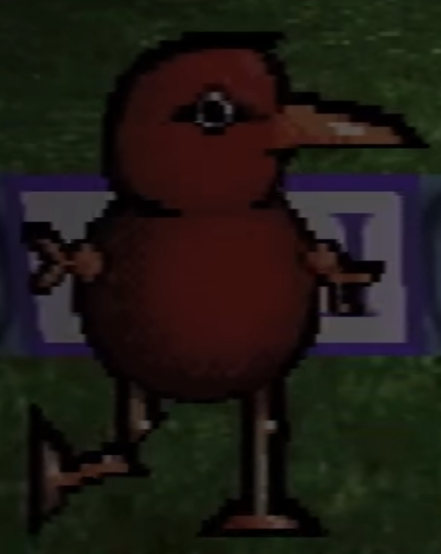

A few seconds after Toneth’s capture, a faint tone plays. It appears to be a simplified, tone-shifted version of the “CAUGHT” sound ([isolated audio](https://clyp.it/h3hch5t2?token=715ef5b56325035377029ad5a3a44c19) / [comparison](https://clyp.it/np4zok1b?token=83afa67ac7dcd2ece2ddc111ca0584bb)). It can only be heard in the right speaker, indicating that it may be coming from something far to the right. Paul doesn’t seem to notice it, and doesn’t try to follow where it’s coming from.

Toneth’s in-game description reads as follows:

(Enter a description here)

---

- A bird. I think I forgot what birds look like.

- “Funny stupid blob monster” says Mike. That’s what it is.

- Painter. Painting puzzle.

- Catch Randice first(?)

- Has broken leg for some reason. I already hung him on a wall, too late to take it back. It makes me think about the dog actually. Because when the car hit him I thought “at least it will be over soon.” He survived it, and I was the only one who still wanted to put him down. A dog is an innocent *(the message gets cut off here)*

- When that dog wags its tail and it it appears happy, it’s not real.

- I guess that’s toneth then. toneth toneth toneth toneth toneth toneth toneth toneth toneth toneth toneth toneth toneth toneth toneth toneth toneth. The end. It’s yucky outside.

The description indicates that Toneth might be a painter, and that a painting puzzle would be required to catch him. In Petscop 19, an easel can be seen in one of Even Care rooms during one of the early Generations—it could be related to the original intended way of capturing Toneth.

In Petscop 13, in Roneth’s pet description, it is revealed that Roneth is Toneth’s baby half-brother. Part of Roneth’s description (“Because he’s younger, he gets to learn from all of Toneth’s mistakes. That’s why he always looks both ways.”) may also suggest that Toneth suffered his leg injury due to being hit by a car.

Petscop 13 also confirms that Toneth wasn’t properly added into the game:

Congratulations ... you caught every pet in Even Care (aside from Toneth, who isn’t here yet.)

Seemingly the same message begins to play out at the end of Petscop 19, in a Gen. 5 playthrough. In Petscop 14, Paul mentions that the message he actually sees is different, indicating that the Petscop 13 Demo may be playing his inputs in a different generation. Taken together, it suggests that the message about Toneth’s not being in the game is no longer present in later Generations, and may no longer be true for them.

In Petscop 18, it is revealed that the earliest design of Toneth doesn’t have a broken leg.

In Petscop 20, Toneth is the only Pet Marvin has in his menu. Since Marvin’s Gamepad Language voice is based on a dog bark, it’s possible that Toneth’s description is meant for him, or that Rainer is drawing a parallel between Marvin and the dog.

In Petscop 22, “Paul” is also written in red, just like Toneth’s name. This could imply a connection between Toneth and Paul (or the intended player).

### Randice

Randice is the only Pet without a face. He is first seen in the picture along with Toneth, where his name is written in green. Marvin’s quotes are also written in green, possibly implying that the two are connected (see Color Theory). Randice is later seen in a garden-like room, where he’s being watered by Wavey. As long as Randice is watered, he teleports away from the player when approached.

After Wavey is trapped in the bucket, Randice appears to flinch and wither away, possibly dying, after which the player can catch him.

In Petscop 19, Randice’s description is revealed:

Randice is a flower.

He does need water, but not as much as he thinks.

You shouldn’t worry.

If you are considering Randice, you should adopt Wavey as well.

Wavey knows how to trick Randice.

There are two anomalies on the left wall of Randice and Wavey’s room:

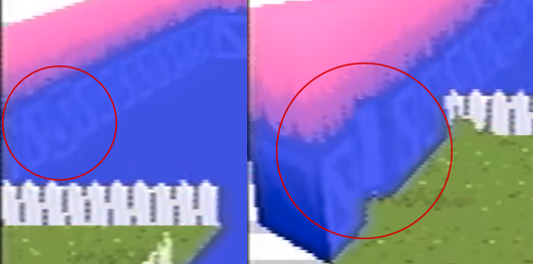

One of the wall tiles appears to have inverted coloring in comparison to the others (left), and there’s a triangular opening next to the grass patch (right). In Petscop 19, the anomalies are absent from Gen. 2 footage, but Mike can be seen repeatedly walking into and clipping through the wall in the same spot as the opening—it’s possible that it is added in a later Generation as a reference to that.

In Petscop 13, Paul notes that Randice and Wavey’s room is the counterpart of the House due to their similar layouts and presence of the bucket. (The symbol block in the bathroom of the House also matches with the symbol in the background of the room.) Paul then finds out that—just like in the House—the bucket can be taken outside the room, and used for capturing Roneth.

In Petscop 17, in a recording of Mike, a Gen. 2 version of the room is seen. It uses simpler textures, and a large easter egg is placed within it. When the egg is collected, a text box appears that suggests that the game is currently located in an office.

The two plots Randice moves between differ in depth, with one extending to underneath the level (this does not occur anywhere else in Even Care). This extension is missing in Gen. 2 footage seen in Petscop 19, indicating that it’s a later addition. The extension of dirt beneath the right plot may line up with the bathroom, and possibly the garage. This could imply a connection between Randice and the house and perhaps the bathroom specifically. A loading screen from Petscop 14, which appears when Paul enters the garage, shows that the dirt extension seems to continue.

### Amber

Amber is the first Pet shown in the Pets menu after being caught.

Her description reads:

Amber is a young ball.

She’s afraid to leave home. If her home is good, this is not a problem.

She is very heavy, and that makes her life a little harder, as well as yours.

What’s the safest place you can put her in? You should start thinking about that.

In Amber’s room there’s also a trophy with a description that may suggest that Amber is being encouraged (or even conditioned) to stay in her cage:

It’s a trophy, “awarded to our Amber for being a real champ yesterday and today.”

“She hasn't left her cage once!"

This may also imply that Amber has body-image issues which make her reluctant to leave her home. The reference to her heaviness might also imply that she is carrying some sort of psychological “weight.”

Amber’s name is written in blue. Anna’s quotes are also written in blue, which may imply that the two are connected (see Color Theory).

Amber is found locked in a cage, and if the player pulls a switch to open the cage, she jumps into another one. Paul traps himself inside the cage, after which she jumps into the cage with him and is caught. The cages reset after he exits and re-enters the room.

In Petscop 13, subtle changes become apparent in Amber’s room:

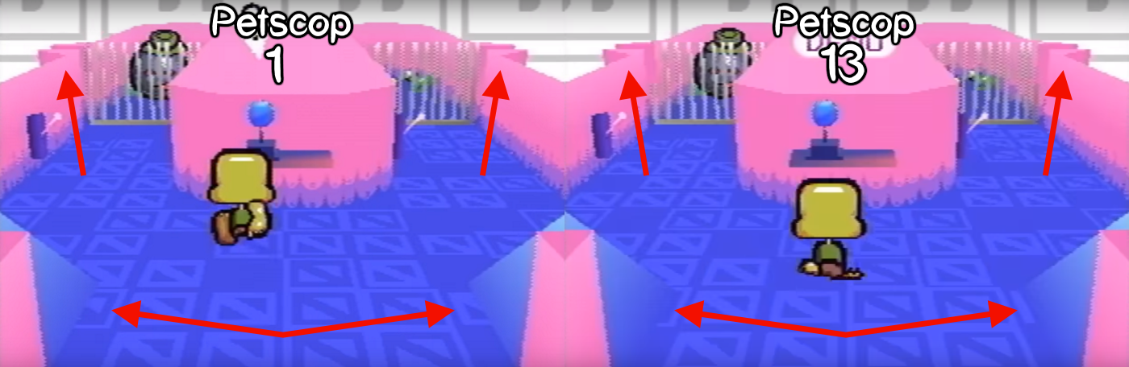

These changes are absent from Odd Care, and present in Gen. 4 and 5 footage in Petscop 19. They may first occur in Petscop 1 after Paul enters the code.

Amber may be named after a playtester named Amber, who seemingly traps herself inside the cages in Petscop 19 (Gen. 5, “amber2” recording).

In Petscop 23, a fragment of Amber’s description appears as the description of the newly created egg.

### Roneth

Roneth is much taller than the other Pets or the Guardian. He has a head similar to Toneth’s, a blue jagged middle, and a bean-like bottom. He has been noted to resemble a Japanese toy called a [Kurukuru (spinning) chime](https://images-na.ssl-images-amazon.com/images/I/416ym2LZbJL._SX425_.jpg) (くるくるチャイム).

In Petscop 1, Paul says that he could not find a way to catch Roneth, as he runs away when approached, and rises into the sky upon reaching the end of his room.

In Petscop 13, Paul manages to capture Roneth by using the bucket from Randice and Wavey’s room and imitating his method for capturing Teal TOOL. He proceeds to read his description:

Roneth is Toneth’s baby half-brother.

Because he’s younger, he gets to learn from all of Toneth’s mistakes.

That’s why he always looks both ways.

He doesn’t get into trouble. You won’t have to watch him all the time. He’s good.

Some people postulate that Roneth appears to be a mixture of Toneth and Randice. It has the same head as Toneth (his half-brother), and a body similar to Randice’s. Due to this, some speculate that Roneth and Randice may be related. Others, however, point out that Roneth’s middle part doesn’t look like a stalk to them, and that Roneth’s color scheme (except for the head) is similar to Amber’s.

Because the method of capturing him seems to parallel the capture of Teal TOOL, it is possible Roneth and the color teal are connected (see Color Theory).

### Pen

Pen is found floating above a room-long, piano-like keyboard. She has no legs and hovers above the ground. She appears to have a string hanging from her abdomen, and holds a white orb in her right hand. Her hands have six fingers.

In order to catch her, the player must solve a puzzle revolving around musical intervals. When the player steps on the piano, two clones are created at an octave apart (i.e from C to C on the piano, D to D, etc). Using a treadmill, the player can change Pen’s location, starting from the far end of the keyboard. The correct solution is 7 as that is the number of white keys needed to go up an octave on a piano (C->DEFGABC).

She appears to wear a brown beanie or possibly a yarmulke. Her hands also resemble a weighted scale.

In Petscop 7, Pen’s description is revealed:

Pen is an aspiring mathematician.

She’s entirely deaf. She doesn’t even know what sound is, let alone music.

I don’t know what she’s doing here.

As acknowledged by her description, it’s seemingly contradictory that a deaf character is found in the piano room. Her being an aspiring mathematician is also unexpected, although her puzzle does require a small amount of math to solve (Paul seems to just brute-force it). Pen’s description and puzzle may be a hint that the music at the beginning of Petscop 7 has a hidden message or meaning behind it.

Pen has some resemblance and parallels with the Guardian. They have similar green skin, and whereas Guardian lacks arms, Pen lacks legs. Pen’s eyes are closed, Guardian’s eyes are open. Pen’s mouth is closed, Guardian’s mouth is open. Pen is deaf, Guardian can hear (if it’s assumed the game is experienced through Guardian’s perspective). Pen has six fingers, while the Guardian appears to have only four toes. Pen is female, and Guardian may be male.

Because Pen’s treadmill puzzle is connected to Care NLM’s daisy, the two characters may be connected. This would also connect Pen to the color yellow (see Color Theory).

Pen’s treadmill puzzle may be an early hint at the concept of syncing (see Synchronization and Timelines).

Pen’s hand is similar to the one seen in the Sound Test menu, except for the extra finger.

### Wavey

Wavey is found in the same room as Randice. Wavey is a rain cloud and follows Randice wherever he goes. In order to capture him, the player must push a bucket underneath him. Wavey then ends up pouring himself into the bucket, and becomes trapped, and his face can be seen on top of the water.

Wavey may be a reference to depression, as it’s typically associated with rain clouds, as well as crying, or rain. Wavey also appears to be unhappy.

Rainer may also have a connection with Wavey: due to his name, and his association with Marvin, who shares the color green with Randice (see Color Theory).

Wavey, Roneth, and Teal TOOL can all be captured into a bucket.

In Petscop 18, a seemingly unused sprite of Wavey jumping while in his water form can be seen.

In Petscop 19, Wavey’s description is revealed:

Wavey is a cloud.

He is afraid of everything. He is especially afraid of freezing.

According to him, he is never the same person for more than a few seconds.

Wavey’s fear of freezing may be connected with the chilly fog in Care’s Room in the House.

## Locations

### Gift Plane

The Gift Plane is Petscop’s starting area and where Even Care is located. It appears mostly as a white space with a single road and a few large gift boxes placed on poles. Paul believes that it’s unfinished, as the road ends after Even Care.

A pink sign outside the Gift Plane gate reads:

The Gift Plane has closed indefinitely, and all personnel have left.

If you are unaware, the Gift Plane provided homes to over a hundred young Pets.

Unfortunately, we have failed to remove all of the Pets from their homes.

48 pets remain here, at the time of writing.

We would strongly encourage you to visit our 8 homes and find some friends to take with you.

Every Pet is uniquely valuable. You should have no problem finding somebody that you love.

- The Gift Plane staff

The Gift Plane has been compared to heaven due to its cloudlike floor, friendly atmosphere, and the large gate through which it’s entered (reminiscent of the Pearly Gates of Heaven).

The number of remaining Pets is the same as the number of unique names visible in All Recordings.

It is possible that the Gift Plane and Even Care are representations of an orphanage due to the way the messages on its signs are worded.

The word “Gift” is referenced by Michael Hammond’s grave, both by its inscription (“Mike was a gift”) and the gift-like shape of its headstone. It is also referenced in one of the iterations of the channel’s description, which states “‘Rainer’ gave this gift to us on Christmas 1997 and 2000.” The recurring theme of Christmas and birthday parties may also be relevant to the name Gift Plane.

There appear to be parallels between the Gift Plane and the Newmaker Plane.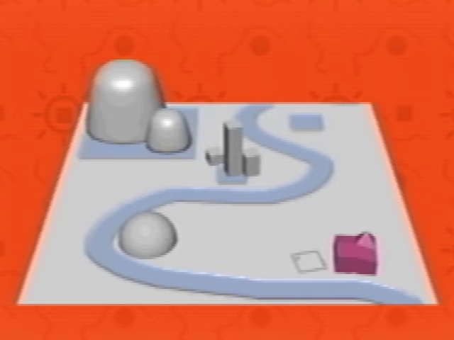

In Petscop 14, Care's birthday party shares visual cues with the Gift Plane.

In Petscop 17, the list of sounds references a Work Zone—possibly a different area on the Gift Plane.

In Petscop 18, a potential map of the Gift Plane is shown in “Extra Stuff,” under “08 gift_plane_map.”

### Even Care

Even Care is the first, and possibly only, level of the Gift Plane. Amber, Pen, Randice, Wavey, and Roneth are all caught here. The opening area resembles a reception office, with a desk, chairs, and a small table. Two signs are located in the hallway leading to the Pets’ rooms. The first reads:

When you’re choosing a Pet, find somebody that you like.

You don’t have to love them right away.

The second reads:

Don’t be discouraged if they run from you! They really do want a home.

They’re afraid. Show them that there’s nothing to be afraid of.



Theories regarding the name “Even Care”:

* Relation to the character Care. The level itself has flower imagery (a symbol related to Care), as well as the flower Pet Randice
* Reference to the phrase “do you even care?” or “I don’t even care”
* Reference to the number of petals on the flower in the “Loves me, loves me not” game. If the flower has an even number of petals, then it will land on “loves me not,” just as it does for Care’s daisy, which has 16 petals.
* A declaration that all Pets inside will receive the same (even) amount of care.

In Petscop 13, Paul sees a message upon capturing all pets:

Congratulations ... you caught every pet in Even Care (aside from Toneth, who isn’t here yet.)

You have seen everything in the game, so far, but there will obviously be more.

It’s a growing organism.

Your controller inputs will be useful, but your feedback will be even more useful.

This may indicate that Petscop was undergoing playtesting, and there were plans to develop it further. The phrasing “growing organism” may imply a form of procedural growth, or be a figure of speech. The final line indicates that controller inputs are being saved.

In Petscop 14, Paul explains that the message was different when he played, and that it got changed in the Demo (likely due to its being played in a different Generation). He is forced to use the demo footage, which is based on his recorded movements, with his voice overlayed, because he loses his own version of the gameplay footage.

*(See* *Maps* *for a full map of Even Care)*

# **Secret Game**

*This section discusses the secret portion of the game, after Paul inputs the code in Roneth’s room.*

## Characters

### Michael Hammond (AKA Mike)

Mike is first introduced in Petscop 2, when Paul interacts with a tombstone under the Newmaker Plane with a face on it:

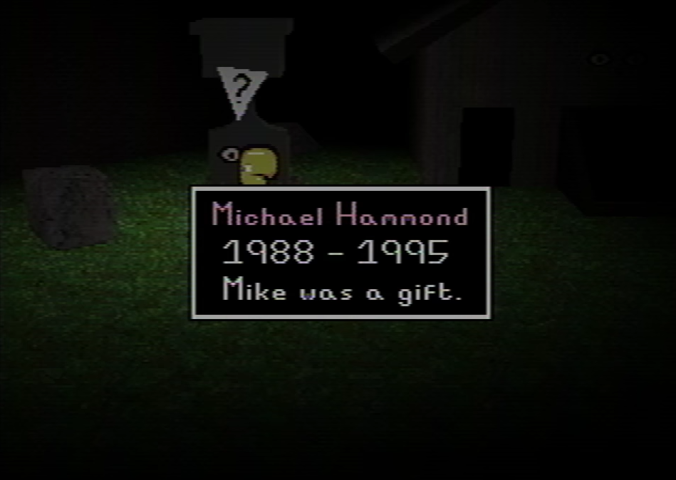

The name “Michael Hammond” is written in a light pink hue. The time frame specified suggests that Mike was either 6 or 7 years old when he passed away. Paul reacts to the inscription by saying “That’s a dead kid.”

The face on Mike’s tombstone appears to change multiple times. Primarily, the eyebrows seem to disappear and reappear as the player walks around the area. This is probably a graphical glitch due to pixel rounding, but the theme of eyebrow removal is prominent within the game (see Care’s Bedroom/Care for further details).

Mike is then referred to again in Petscop 3, when the player recreates the face from the tombstone on the canvas in the Child Library:

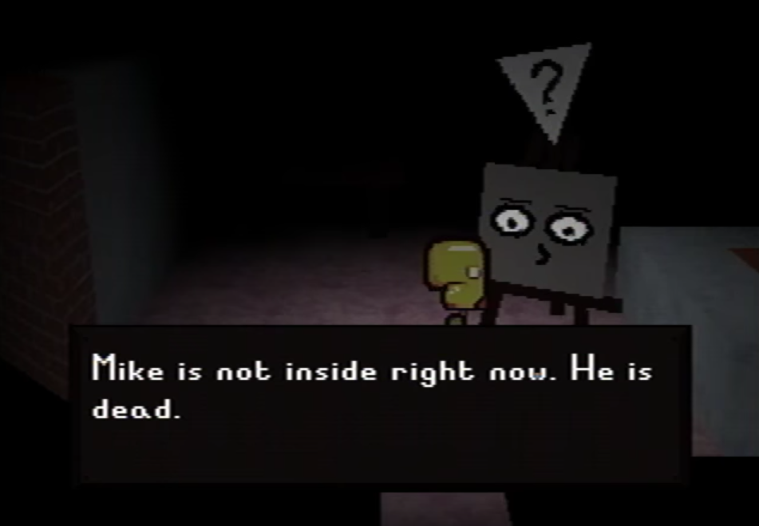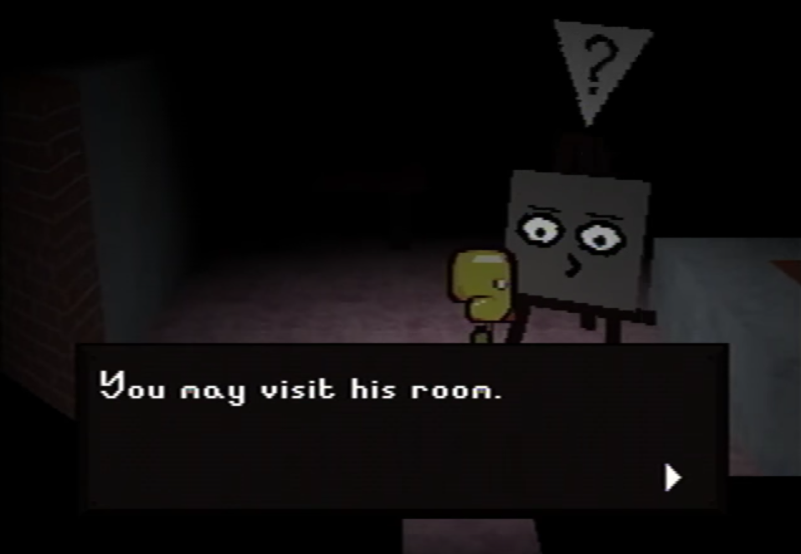

After a few minutes, Paul enters the room that opens for him (see Mike’s Bedroom).

Mike is later referenced in Petscop 6, when Paul reads the description of Toneth: “‘Funny stupid blob monster’ says Mike. That’s what it is.” Based on his tombstone, Mike died at the age of six or seven. As Toneth’s description is probably written by a developer of Petscop, Mike may be that developer’s relative. This might mean that Mike’s tombstone is in the game as a memorial, and it might explain the sudden dark turn the game takes after the secret code is entered. It could also explain why the original game was never finished.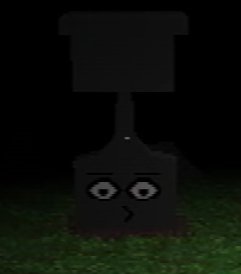

Mike is referenced again in Petscop 11 in Care A’s description:

My brother didn’t want us to find him, because he knew we were all looking for Michael A.

The name Michael A may imply that he has various “states” in the same way Care does. It’s also possible that Mike may be Rainer’s brother, and that he didn’t want to be found due to no longer being “Mike A.”

In Petscop 19, it is revealed that real-world Mike was among the earliest players of Petscop.

In Petscop 20, Marvin examines Mike’s grave, and the resulting text box stays on his screen for an extended amount of time.

In Petscop 24, a letter from Anna to Mike is shown towards the end of the Book of Baby Names. In the letter, Anna begins by commenting on how many friends attended Mike’s party, and she suggests it was thanks to Mike’s big brother (Rainer). She then tells Mike that he should thank his other aunt (possibly Lina), if he sees her. Afterwards, she wishes him a happy 7th birthday, and mentions her gift for him: a black box, the contents of which were co-picked by Carrie. She ends by signing the letter as his auntie, and with a post scriptum advising him to not shake the box.

It has been proposed that Mike’s birthday party may be posthumous, just like the one Marvin supposedly held for Lina. Mike’s 7th birthday would need to take place in 1995, which is the year he died in. Anna’s letter also mentions the possibility of him seeing his other aunt: this could be her sister, Lina, whom he could presumably see in the afterlife (Anna also mentions that not everyone can see the other aunt, which may be a connection to Lina’s epitaph: “They didn’t see her”). Furthermore, a black box, possibly connected to Anna’s gift, can be seen emerging from one of the graves in Graverobber.

### Care

Care is a child with long brown hair and no eyebrows (a trait she shares with Lina). She is first mentioned in a phone call Paul receives in the Office in Petscop 2: “Care left the room.” The office also contains a note pinned on the wall with three faces and the words A, B, and NLM.

Later in the same video, Care NLM is found underneath the Flower Shack on a dirt pedestal with what looks like a stem behind her. The stem leads up to the top part of the shack, which contains a white daisy with 16 pluckable petals. After removing the petals, Paul finds that Care NLM is now on ground level, but her face and movements are seemingly glitched and he is unable to catch her.

NLM most likely stands for “nobody loves me,” due to the connections to Daisy-Head Mayzie, the Flower Shack, and the phrase being later used in attributed dialogue in the note in her Child Library room.

Care’s name and presumed dialogues are written in yellow (see Color Theory).

In Petscop 3, the note in Care’s Bedroom states that she doesn’t grow eyebrows.

There is a disorder called trichotillomania that can be caused by traumatic experiences in childhood. This disorder is defined as “a compulsive desire to pull out one's hair.” Some speculate that Care may only appear not to be growing eyebrows, because she plucks them out due to suffering from trichotillomania.

In Petscop 6, Paul discovers that there are 4 more pets in the Pet menu, three of whom are later found to be Care A, B, and NLM.



In Petscop 9, Paul manages to catch Care NLM after entering -1 into the treadmill in Odd Care and returning to the Flower Shack Basement. He then reads her description:

Care NLM escaped from the school’s basement and wandered the Newmaker Plane for days.

To catch her, you had to lie, but it may not be a lie forever.

You’re the Newmaker. You can turn Care NLM into Care A, and close the loop.

Care being trapped in the school basement ties in with the note in her room. The treadmill in Odd Care directly correlates with the petals of the flower (see Synchronization and Timelines), so by entering -1, Paul may be telling Care that she is loved (“you had to lie”) even though the flower ran out of petals on “they love me not.” “Close the loop” may refer to the [cycle of abuse](https://en.wikipedia.org/wiki/Cycle_of_abuse), or simply to returning Care to her A form.

In Petscop 11, Paul finds Care A at the house inside a bedroom with an AC unit installed on one of its windows. She is shown sitting on the bed, where she continually shivers and flickers blue, presumably due to the cold air in the room. A sound identical to the C note on the Needles Piano can be heard periodically. Paul is unable to catch her at first, as a translucent cube appears around her when approached. After entering the closet, Paul is locked in and, at around 6:15 in-game time, views a scene where Marvin breaks into the room through the window and catches Care A. The message “Care left the room” (same as in the Office) is displayed, and the scene resets to before her capture (except for the clock in the room), and the closet door opens. Paul then finds a ladder outside the house next to the window. Using it, he is able catch Care A in the same way as Marvin did. He then reads her description:

When the emergency began, you were all looking for Care A.

I told you all, we would never find Care A. When Care A goes missing, she goes missing forever.

My brother didn’t want us to find him, because he knew we were all looking for Michael A.

I’m back. This is my present for you.

I started it in 1996, for Marvin.

If you think they’re worth any effort, see if you can save Care B, or Care NLM. Care B is in the school, of course.

Fuck you all, and fuck me as well. Merry Christmas. Check your bathroom now.

- Rainer

Upon opening the Pets menu, it is shown that Care NLM is no longer present in her slot, even though her name still appears. This could mean that Paul puts Care NLM back inside the Child Library sometime between Petscop 9 and 11.

In Petscop 14, Paul appears to take the role of Care as he attends her birthday party on November 12, 1997. The party takes place in the Living Room and only Care and her mother seem to be present. There are five candles on the cake, with it being her 5th birthday.

As Paul explores the party room, Care’s mother appears to be having a conversation with her daughter. She asks Care why is she hiding her face (implying that Care is in her NLM state), and assures her that she still recognizes her due to her eyes and nose. This exchange suggests that Care NLM is hiding something under her hands: tears, bruises, scars, or eyebrows have been proposed.

Later in Petscop 14, Paul attends the party once more, and enters the master bedroom. This appears to have consequences similar to controlling a Demo clone, as the Mother comments that Care has walked into a door. Care seems to be unresponsive to her surroundings, and instead attempts to talk to Jill. Her mother appears to not know who Jill is, and she assures Care that only the two of them are currently in the room. Paul then comments that Care’s words and behaviours are based on his own during his 2017 birthday party. This might be further cemented by the voice sound used while Care is speaking, which is unusually deep and somewhat masculine.

In Petscop 17, the Room Impulse is used to retrace Care’s steps between the car tunnel (and presumably the School) and the House, and various details about her real-life counterpart are revealed in the process.

The final two sounds on the Sound Test list are named after Care, and are presumed to be samples of her real-life voice.

In Petscop 19, it can be seen that Care (Carrie) plays early versions of Petscop—she doesn’t seem to be doing well, but she’s presumably only two or three years old at the time.

In Petscop 20, additional information about real-world Care is revealed. Furthermore, the Caskets have multiple connections with Care’s in-game portrayals.

In Petscop 21, the real Care (Carrie) uses her Guardian to [dance to “The Sign” by Ace of Base](https://www.youtube.com/watch?v=8F-S1MT-QdM).

In Petscop 23, “Pall” finds Care B in the School Basement, in a small room next to the Pit. He reads her description:

Care B is scared and pounding on the door.

I open it. It's so dark that I can't see her.

So I pull her out, and the light hits her face.

And they won't even give me a picture of her now.

They're all scattered in graves.

And I'm a piece of shit. Here I go.

*(The description is concluded by an animation of a shovel.)*

The first part could suggest that Rainer rescued Carrie from the School, although at other times, the game’s wording indicates that she escaped on her own. The ending indicates that Rainer dug up an unspecified number of graves.

Not long afterwards, “Pall” places Care B (referred to as a “baby”) into the Machine which transforms her into a red-and-yellow-striped egg.

Paul and the real world person represented by Care may be twins or even the same person. Care is also a child (either biological or adopted) of Marvin and Anna.

### Belle

Belle is first addressed as such in Petscop 12. She looks exactly the same as the Guardian, but is seen as Quitter (fan name, pictured on the right) by other characters. Belle’s name is written in purple, same as Tiara’s (see Color Theory). The name Belle may be a reference to Candace Newmaker’s favourite doll.

Her appearance in her Quitter form is reminiscent of the earliest designs of Pets and the Guardian, as seen in Extra Stuff.

In early episodes, most of the time she mirrors Paul’s movements, but for a few seconds in Petscop 2 she seems to desync from Paul after he walks behind a bookcase (see Synchronization and Timelines).

In Petscop 7, she stops mirroring Paul and can’t be seen at all while the [second movement of Stravinsky’s Septet](https://www.youtube.com/watch?v=ijSmRoPzMaY&t=172) plays. After the song concludes, she instantly reappears, and once again reflects Paul’s movements. Furthermore, once the song is complete the note on the wall is answered with “COME HERE.” This reply may have been achieved using Draw Mode. Because the color and font are the same, it appears that whoever was playing the music and writing on the note may also be an entity that speaks through Pink TOOL.

In Petscop 10, Paul is able to enter the left (unreflected) side of the Quitter’s Room, and Quitter appears on the right (reflected) side of the mirror. This confirms that she is not confined to either side of the mirror, and neither is the player.

Movement of Belle’s Guardian early in Petscop 12 syncs with movements of Quitter in Petscop 10, implying that they’re the same character.

The “Do you remember being born?” note in her room further connects her to Tiara, as she is quoted speaking about rebirthing.

Her face appears in one of the hidden loading screens in Petscop 1. It seems to be vertically squashed, and partially obscured by what could be hands or a glitch effect.

Belle’s perspective is first seen in Petscop 12 in the Quitter’s Room, which, judging by her piece count of 0, may be her starting location. Once Pyramid Head enters the other half of the room she begins reflecting his movement, seemingly after getting teleported to match his position (the time on the clock doesn’t change, indicating that it likely isn’t a footage cut). This event matches perfectly with movements of Paul and Quitter in Petscop 10, implying the two occurences to be the same situation seen from different perspectives.

Belle then leaves the Quitter’s Room and runs into Pyramid Head, who disappears when they walk into each other. Pyramid Head might be “leading” Belle out of the room, as their movements match until they collide. Afterwards, Belle begins to explore under the Newmaker Plane, and periodically receives messages left for her by a currently unidentified person. She receives the first message right outside the Quitter’s Room:

Hi Belle.

You’re free!

I left these messages for you to look at, in case you were ever rescued.

So, while you walk around, looking for something to do, I’ll come up periodically.

When the messages run out, I’ll be out of your hair forever and ever.

In the area with Mike’s grave and the shed, she receives a message with timers:

You’ve apparently been running Petscop nonstop for 553758221 seconds, or 153822 hours.

That looks dubious to me. What do you think?

The numbers provided equate to 6,409.25 days, or 17.56 years. Depending on when exactly this information is given, Belle may have been running the game since late 1999, June 2000, or sometime in between. The messages continue near Good Grief and Alas:

Are you still sitting on a chair?

Can you still look around the room? Is there still a room?

This may imply that Belle is trapped within the game.

Another message appears outside the Child Library:

This is the Child Library.

You’re not family, so I didn’t add your traits to the face system.

That means I didn’t add your eyes, or your eyebrows, or your nose.

Belle eventually emerges onto the Newmaker Plane, where she sees Marvin and receives the message “Don’t get lost.” Marvin appears to be unaware of Belle’s presence, and repeats his movements from Petscop 11 demo. This may indicate that the two events are happening at the same time, but only Marvin is visible from both perspectives. Alternatively, Marvin may be following a pre-programmed path. It may also imply that the place where Belle sees Marvin is where the School may appear under the right circumstances.

The two of them may be experiencing the game in different Generations. Since Petscop 12 is a Demo, the viewers may also be seeing something else than what Belle does.

Afterwards, while Belle is wandering the Newmaker Plane, further messages appear. The first is “Happy birthday Belle!” followed by a textbox that only displays the word “I’m” before the video cuts to a different shot (see Censorship). The second message reads:

I'm calling you Belle because that's who you are.

You might be confused as to what happened.

I was overeager before, and started calling you Tiara prematurely.

I created a space in the menu for you, still unused now.

Then I put you inside the machine, and played the second movement of Stravinsky's Septet on the Needles.

I played it wrong, but that would have been okay.

If you hadn't given up halfway, you would be Tiara. This is not what happened, and now I'm gone.

This seems to imply that Belle underwent a procedure that was supposed to turn her into Tiara—or possibly allow Tiara to be reborn as her—but she quit halfway through. Her being placed in Quitter’s Room may be a punishment for that.

The [second movement of Stravinsky’s Septet](https://youtu.be/ijSmRoPzMaY?t=2m52s) is the music which plays in Quitter’s Room in Petscop 7, while Belle is briefly missing.

The space created for Belle/Tiara may be the last, empty slot in the Pets menu.

At the end of Petscop 12 Belle appears to bring up the game’s pause menu. It features a “demo recording” message, and lacks the “Quit Game” option, which may be another indication that Belle is trapped inside the game. The demo from Petscop 13 (played by Paul), however, also lacks the “Quit” button.

In Petscop 15, Belle (seen as Quitter) appears together with Marvin in a classroom in the School, where she demonstrates the ability to use the Gamepad Language (her messages are accompanied by a bell-like sound) and knowledge of how to access Draw Mode. She is not as fluent with the former as Marvin (suggesting less practice time), and may have been using the latter to communicate as Pink TOOL. Marvin refers to her as “Bell” during this encounter, but she rejects that name and insists on being “Tiara.”

In Petscop 19, Belle can be seen playing early Generations of Petscop and performing significantly better than the other players shown. The very first recording after the first “family” one is labeled with her name (“belle4”).

In Petscop 22, Paul notes Belle’s absence from her room, and refers to her as “the Tiara character.” Later on, after Paul’s Guardian gets hit by a car, Belle enters the screen and keeps glancing towards her left.

In Petscop 23, Belle is likely the author of the secret message advising “Pall” to push the bed against the hidden door in the Ghost Room (notably, room #4 already has a bed in that spot, suggesting that it may belong to her). She later appears to express sympathy for “Pall,” and to provide him with the locker code: 9 2 19. Both messages are delivered with Draw Mode.

Towards the end of Petscop 23, she makes another appearance in the Machine Room, where she seemingly brought the other 500 Pieces for the Machine.

In Petscop 24, the Book of Baby Names credits Belle as “smart.”

#### Tiara Leskowitz

Belle claims to be Tiara (Petscop 15), although her Captor disagrees (Petscop 12).

Tiara is first mentioned in the note in Care’s room in Petscop 3:

Tiara says young people can be psychologically damaged “beyond rebirthing.”

Tiara’s name and presumed dialogues are written in purple. Belle’s name also uses this color (see Color Theory).

The second and third times Tiara is mentioned are in the questions asked to the red TOOL in Petscop 5:

“Who is Tiara?”

Answer: Petscop kid very smart

“Remember being born?” *(the full question "Do you remember being born?" didn't fit)*

Answer: I'm not Tiara

There is a connection between Tiara and Belle. The note on the wall in the Quitter’s Room asks “Do you remember being born?” When Red TOOL is presented with this question, it redirects it to Tiara, which could indicate that she’s linked to it. This connection is further reaffirmed by Petscop 12 in its syncing with Petscop 10, and confirmed in Petscop 15, where Belle insists on being called Tiara.

Red TOOL’s answer, “Petscop kid very smart,” is most likely calling Tiara a very smart Petscop kid, probably as a commentary on Belle’s performance during the tests. Notably, the Book of Baby Names opens with the words “Petscop Kids” and credits Belle as “smart.”

In Petscop 11, during one of the school demos, Marvin states that “Tiara plays bad music too,” when “Pall” fails to play the Needles Piano to his satisfaction.

In Petscop 12, Belle’s Captor states that Belle was supposed to become Tiara:

I was overeager before, and started calling you Tiara prematurely.

I created a space in the menu for you, still unused now.

Then I put you inside the machine, and played the second movement of Stravinsky's Septet on the Needles.

I played it wrong, but that would have been okay.

If you hadn't given up halfway, you would be Tiara. This is not what happened, and now I'm gone.

The described procedure is strikingly similar to what Care B undergoes in Petscop 23. The passage also implies that at least some mentions of Tiara may pertain to Belle—they may even be the same person.

In Petscop 15, Belle openly states that she’s Tiara, but Marvin introduces her as “Bell” (“Belle” displays as “Bell” due to the inner workings of the gamepad language).

In Petscop 19, a recording labeled “tiara” can be seen right before ones labeled as “FUCK-FUCK-FUCK” and “family2.” It has been speculated that most or all the recordings starting from “belle4” (Gen. 1) up to “family2” (Gen. 15) may be of Belle, with “tiara” being the one where her Captor calls her Tiara prematurely, and “FUCK-FUCK-FUCK” the one where he realizes the mistake.

In Petscop 22, Paul refers to Belle as “the Tiara character.”

In Petscop 23, inside the locker “Pall” finds a letter addressed to Tiara Leskowitz:

Your New Life Letter

The Name: TIARA LESKOWITZ

Your Message:

You are off to school today. I will miss you. I love you so much. I will miss you so much when you are set off to school for the day. I will be waiting for you when you get home. I will be on a lawn chair in the driveway waiting for the bus to drop you off. Every day I am so happy to see you come home and tell me what you learned. I hope everybody treats you with love and respect.

Love you forever NO MATTER WHAT,

MOMMY

The surname “Leskowitz” is shared with both Lina and the Reddit account u/paleskowitz. This may suggest that Tiara is related to both Lina and Paul, and thus possibly a member of the Family. The wording of the letter suggests that Tiara was a child at the time, and the title, Your New Life, indicates a change of identity, possibly related to rebirthing. The title may also be a reference to the lyrics of “The Sign” by Ace of Base (“I got a new life”).

With the letter there’s also a pink-and-purple egg, similar to the one obtained by putting Care B into the Machine.

It has been proposed that Belle underwent a process meant to transform her into Tiara, but the attempt wasn’t entirely successful. The specific nature of this transformation remains unclear, although a possible goal could be turning her into a “Family” member by exposing her to the Caskets. It likely involved placing Belle in the Machine and playing on the Needles Piano.

### Red TOOL

Red TOOL is a large object (or possibly an entity) discovered by Paul under the Newmaker Plane. The exact nature of Red TOOL’s shape, as well as the shape of all the TOOLs, is currently unclear, but speculations have included awls, piano tuners, and pickaxes. When interacted with, it provides an interface for inputting questions, which it then attempts to answer.

The answers provided by Red TOOL share traits with automated responses: they are instantaneous and often default to “I don’t know.” It’s possible that it can only answer pre-programmed questions. In Petscop 5, Paul asks it both “Tiara?” and “Who’s Tiara?” and it responds with “I don’t know,” but when it’s asked “Who is Tiara?” it answers with “Petscop kid very smart.”

The answers also appear similar to Casket 4. This may indicate that all of Red TOOL’s answers are prepared in advance and written on chalkboards, while Pink TOOL fetches its replies from a blank chalkboard that can be scribbled on with Draw Mode.

**Red TOOL responses:**

Questions to which Red TOOL answers “I don’t know”:

What?, Care?, Mike?, Michael?, Who is Care?, Who's Care?, Who is Mike?, Who's Mike?, Who is Michael?, Tiara?, Who's Tiara?, Where are you?, When am I?, What is NLM?, NLM?, Newmaker Plane?, Who is Newmaker?, Newmaker?, What is Petscop?, Petscop?, How to see windmill?, See windmill?, Windmill?, What is this?, bababababab?, !?, ??, Who is Marvin?, Who's Marvin?, Marvin?, Did you find Lina?, Who is your boss?, Where is the windmill?

Petscop 2:

*(**Paul* *looks at the windmill)* — A: “Keep watching the windmill”

Petscop 5:

Q: “Who is Tiara?” — A: “Petscop kid very smart”

Q: “Who am I?” — A: “Newmaker”

Q: “Where am I?” — A: “Under the Newmaker Plane”

Q: “Who are you?” — A: “TOOL” *(with a crude drawing of TOOL)*

Q: “Remember being born?” — A: “I’m not Tiara”

Petscop 6:

Q: “Where is my house?” — A: “You’ll never go home”

Q: “Where is the school?” — A: “You can’t go back in time”

Petscop 10:

Q: “What month is it?” — A: *A red calendar floats down from above and animates back and forth*

Q: “What year is it?” — A: *The red calendar continues to animate back and forth*

Q: “Where was the windmill?” — A: (*TOOL’s answer was covered by a* *censor**)*

Petscop 20:

Q: “What year is it?” — A: *A green calendar floats down from above and animates back and forth*

### Pink TOOL

Pink TOOL appears to be an alternative state of Red TOOL. In contrast with Red TOOL, Pink TOOL may potentially be sapient. It takes much longer to answer Paul’s questions, and its responses indicate a living person on the other side.

Pink TOOL’s style of writing may be the result of using Draw Mode (possibly on a blank chalkboard texture).

It appears that Pink TOOL has been ignoring the questions asked by Paul. This could be because the person speaking through it does not receive Paul’s queries, or just doesn’t care (or is unable to answer). Alternatively, it could just be a trick to make the game seem like it’s haunted.

**Pink TOOL responses:**

Petscop 5:

Q: “Who are you?” — A: “TURN OFF PLAYSTATION”

Q: “Why?” — A: “MARVIN PICKS UP TOOL HURTS ME WHEN PLAYSTATION ON”

Petscop 7:

*(on the note in* *Quitter’s Room**):* “COME HERE” *(same color and font as Pink TOOL)*

A: “I LOVE YOU NEWMAKER PLEASE SHOW MARVIN WHERE HIS HOUSE IS”

Q: “Who are you?” — A: “GO THERE AND HE’LL FOLLOW YOU HIS DAUGHTER IS THERE”

Q: “Remember being born?” — A: “ALSO WANTS 1000 PIECES FOR “MACHINE BEYOND SCHOOL BASEMENT STAIRWAY””

It has been suggested that another character or characters may be speaking through Pink TOOL:

* Lina, due to the scene which plays out in the Windmill
* Tiara, due to Paul’s belief that he should ask Pink TOOL if it remembers being born (a question found on the wall in Quitter’s Room, and redirected to Tiara by Red TOOL)
* Belle, due to Pink TOOL’s activation after the melody sequence in Petscop 7, and her knowledge of how to access Draw Mode

Notably, in Petscop 22 Paul refers to Belle as Tiara, thus merging the latter two possibilities and greatly increasing their likelihood.

### Blue TOOL

On the walls in TOOL’s room there are multiple crayon drawings of an otherwise unseen Blue TOOL. In Petscop 14, similar drawings are also present under the slice of cake at Care’s birthday party.

According to Color Theory, blue is associated with Anna. 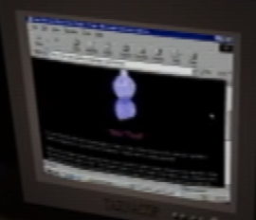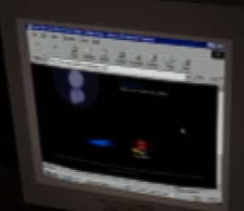

A box of crayons is found in both of Care’s rooms, and on a shelf in the Flower Shack. This may indicate that Care is the one who made these drawings of Blue TOOL, possibly as a representation of her mother.  
In Petscop 14, Blue TOOL is seen on the Website in the Garage. There appear to be two sections on it there: a short introduction, and then a longer article.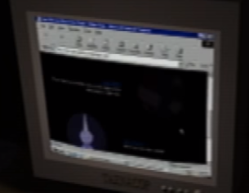

Blue TOOL may be the same as Teal TOOL.

### Green TOOL

In Petscop 11’s demos, Petscop 15, and Petscop 23, Green TOOL accompanies “Pall” within the school.

“Pall” and Green TOOL do not move at the same time, indicating that only one of them may be controlled at a time. This is reminiscent of a control scheme used in old FPP games: Green TOOL may function in a way similar to a mouse cursor. Alternatively, Green TOOL may be periodically taking over and assuming control.

In Petscop 23, Green TOOL is used to collect the Pieces from the christmas-tree-like structure in the Computer Room. It also disappears after the 500 are deposited into the Machine.

Green is associated with Marvin and Randice in Color Theory.

### Teal TOOL (Black TOOL)

In Petscop 13, Paul encounters Teal TOOL on the road outside the House, far to the left. The TOOL appears to be moving away from his character, until it passes under a black gate and rises from the ground.

Paul exploits Teal TOOL’s movements to trap it inside a bucket, upon which it turns black (as a result of falling into a bucket of black paint). Paul then uses the bucket to bring Black TOOL inside the House, where it dislodges 15 pieces from devices on the table in the living room, similar to how White TOOL dislodged pieces from the Windmill.

Teal TOOL’s movements, and the way of trapping it, closely resemble Roneth’s. The symbol block near the gate towards which Teal TOOL escapes also matches the background in Roneth’s room in Even Care.

Teal TOOL may be the same as Blue TOOL.

### Newmaker

The term “Newmaker” reoccurs throughout the videos:

* When Paul asks Red TOOL “Who am I?” it replies “Newmaker”
* Red TOOL answers the question “Where am I?” with “Under the Newmaker Plane”
* The Newmaker Plane is referenced in the note in Care’s room
* Rainer signs himself as “Newmaker” under one of his notes
* Care NLM’s description mentions the Newmaker Plane, while also calling the reader a Newmaker.

The capitalisation of Newmaker implies that it is a proper noun. This could mean it’s referring to a name, a title, or a place. In Petscop 9, the note in Lina’s room is signed “Rainer, Newmaker.” This seems to indicate that “Newmaker” may not be a name, but rather a title.

It may also be a reference to Candace Newmaker, although it is still not clear whether game is referencing Candace or anyone in her family directly, or rather using her story as an analogy or a clue (see section: Candace Newmaker Connection).

The secret portion of the game may be developed specifically for this “Newmaker.” Whether Newmaker is meant to refer to any player, or a specific/intended one is unknown.

### Pyramid Head (fan name)

In the Quitter’s Room in Petscop 12, the player character’s (presumably Belle’s) movements are mimicked by a character with a red, pyramid-shaped head with a missing piece, rather than by the Quitter avatar.

Its movements match Paul’s movements in the Quitter’s Room in Petscop 10 (see Synchronization and Timelines). This could imply that other players see Paul’s avatar as Pyramid Head. Alternatively, it may be the default way in which other players are seen. When the player leaves the room and walks towards the other room entrance, Pyramid Head appears outside as well, and it disappears when they walk into each other.

In Petscop 17, multiple Pyramid Heads can be seen through the Room Impulse feature. Each of them executes a simple movement loop, and a gauge can be used to highlight and select them (the latter turns their appearance into a standard Guardian). The one that’s eventually chosen proceeds to recreate backwards Care’s journey back from the School.

In the second half of Petscop 22, a Pyramid Head can be seen briefly before turning into a Guardian, indicating that the scene is viewed through Room Impulse, and likely a direct continuation of Petscop 17.

### “Pall”

“Pall” looks exactly the same as the Guardian.

“Pall’s” first named appearance takes place in Petscop 11, during the Demo sequence. First, he talks with Marvin using the Gamepad Language, and then he proceeds to explore the school with Green TOOL. Near the end of the episode, “Pall” reunites with Marvin in a classroom, where he’s instructed to play the Needles Piano. “Pall’s” performance appears to be going well initially, but he then starts to make mistakes, and is told to stop by Marvin.

During Petscop 11 “Pall’s” piece count goes from 394 to 425. Paul ends Petscop 14 at 394 pieces, possibly indicating that the “Pall” footage is from further into his playthrough (although 394 may be the expected amount of Pieces a player should have at this stage).

“Pall” appears again in Petscop 15 and Petscop 23, and continues to explore the School.

In Petscop 23, Marvin asks for “Pall’s” location, and is pointed to one of the Ghost Rooms (the same one as in Petscop 16) in response. He then appears to pay “Pall” a visit, indicating that “Pall” is playing in a real-world counterpart of that room.

Based on the phonetic inner workings of the Gamepad Language, it’s likely that Marvin was trying to say “Paul” instead of “Pall,” as the two sound alike.

### Marvin Screen Shot 2017-05-09 at 7.07.59 PM.png

Marvin has the same body as the Guardian and Belle, but his head is different. He may also be the following characters:

* The Shadow Monster Man
* The husband mentioned in the note in Care’s room
* The person who wrote the top part of the note that Paul received with the game
* Belle’s Captor (or his real-world counterpart) due to his connection with rebirthing

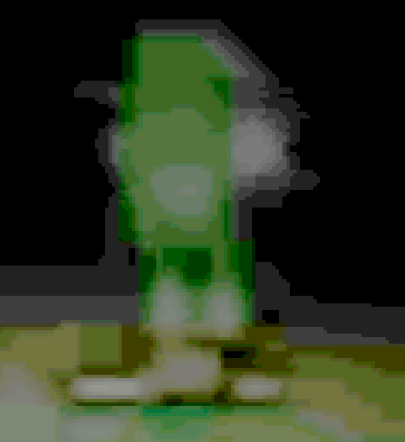

Marvin first appears towards the end of Petscop 4 (see left). He is barely visible, and he flees into the darkness when Paul moves closer.

Marvin is first introduced in Petscop 5. After Paul asks why he should turn off the Playstation, Pink TOOL responds “MARVIN PICKS UP TOOL HURTS ME WHEN PLAYSTATION ON.”

The phrase “MARVIN PICKS UP TOOL” could mean that Marvin is using TOOL to hurt the person who’s speaking through the Pink TOOL, but it’s also possible that “picking up TOOL” is unrelated to how they’re being hurt. This message might also be referring to the smaller TOOL-like objects found in some of the bedrooms, as their purpose is still unknown. Some speculate that the white TOOL in Petscop 9 is used to stab Lina, but it could also be freeing her from the gears.

Marvin’s only hurting the speaker when the Playstation is on could indicate that the people in the game might not exist as long as the Playstation is off.

Petscop 7, through Pink TOOL’s messages, reveals more about Marvin:

I LOVE YOU NEWMAKER PLEASE SHOW MARVIN WHERE HIS HOUSE IS

GO THERE AND HE’LL FOLLOW YOU HIS DAUGHTER IS THERE

ALSO WANTS 1000 PIECES FOR “MACHINE BEYOND SCHOOL BASEMENT STAIRWAY”

These answers strongly imply that Marvin and the Shadow Monster Man are one and the same. It also strengthens the possible connection between Marvin and the husband mentioned in the note in Care’s room: Marvin has a daughter, and he is looking for his house. The “HE’LL FOLLOW YOU” is similar to the message given by the Shadow Monster Man in Petscop 6: “I WILL FOLLOW.”

In Petscop 8, Marvin emerges from where the Tunnel. His movements appear to be pre-recorded, much like demo recording playback, as he ends up running into a wall where a hallway used to be. Alternatively, he may be using the same technique as Paul in Petscop 14, and controlling a parallel Demo version of himself, or he may be experiencing the game in a different Generation. Along the way, he stops in front of the picture of the school and runs around in circles. He also stops in front of the picture of the house and does the same thing. He then runs into a wall where a passage to Road Map should be, and runs around in circles again. Finally, he runs up an invisible staircase until he is off screen. Marvin appears to be trying to tell Paul something during this encounter. Since Shadow Monster Man—presumably Marvin—is looking for his house and the school, he may be telling Paul that the house and school in the pictures are his.

[Tracking](https://www.youtube.com/watch?v=UHhx300E3HA) (YouTube) indicates that, after running into the wall, Marvin is most likely circling in front of Casket 2, and runs up the same stairs he uses to descend in Petscop 20.

Marvin makes multiple appearances in Petscop 11. He shows up in the House where he bursts through the window and kidnaps Care A. It’s possible that the House used to belong to him, and that Care is his (potentially adopted) daughter. The green calendar in the house features some days marked in green (Marvin’s associated color), in a pattern reminiscent of a custody arrangement. After June 5, the day on which Marvin kidnaps Care, all days are marked green until November 10. This, according to Paul, matches the time frame during which Carrie is missing. It’s therefore speculated that the green days represent time Care spends with Marvin.

He also appears during the Petscop 11 Demo sequences, where he first holds a short Gamepad Language conversation with “Pall.” He seems to be much more apt at using this system than “Pall” is (he can even walk and type at the same time). They then proceed to enter the school, where eventually Marvin tells “Pall” to play the Needles Piano, and criticizes “Pall’s” performance. Some speculate that Marvin may be a music teacher.

Notably, the sound Marvin makes while using the Gamepad Language is derived from a dog bark (“dog1.xi”—see Sound Effects and Fonts).

Marvin makes a brief appearance in Petscop 12, where Belle finds him near the Newmaker Plane entrance originally used by Paul in Petscop 2. He seems to be oblivious to Belle’s presence, and instead repeats his movements from Petscop 11 demo. This may indicate that the two events are happening at the same time, with different elements of the scene visible to different participants (e.g. due to them seeing the game in different Generations), or that he’s following a pre-programmed path.

In Petscop 14, Marvin (looking just like the Guardian, without his signature head) appears in a Demo sequence taking place in the Master Bedroom. He interacts with a windmill figure, which prompts a series of dialogues about a door “puzzle.” Marvin then proceeds to repeatedly run into the green bed, possibly trying (and failing) to push it together with the blue one.

In Petscop 15, Marvin appears in a Demo sequence set in the School, where he introduces Belle, who in turn teaches the player about Draw Mode, but only after Marvin leaves the room.

In Petscop 20, multiple recordings of Marvin are shown. In his first one (“marvin”), which is also the very first one of Gen.6, he begins a new game and call his Guardian “MVM” (presumably short for Marvin Mark). He enters Even Care where he attempts to open a door, but is informed that it’s locked. Notably, as opposed to Paul, he isn’t told that he can’t open doors.

Soon afterwards, the footage cuts to Roneth’s Room. While there, Marvin unsuccessfully attempts to capture Roneth, and then walks into the walls four times. Presumably, he is trying to enter the code from the Note, but as the left/right controls are flipped, he doesn’t know which one is the correct “right”: the button that moves his Guardian right, or the one that’s on the right side on the pad. He makes attempts with both, but neither works, as he also fails to execute the “start” part correctly (no menu shows up during his attempts). He eventually opens the menu, checks the controls, unsuccessfully attempts to change them, and proceeds to enter the cheat code correctly. The music stops, and when he subsequently leaves Even Care, he finds himself in front of a brick building on the Newmaker Plane.

The next few Gen. 6 recordings show Marvin wandering the Newmaker Plane without finding anything. Eventually a Gen. 7 recording begins to play, with Marvin once again standing in front of the brick building. Messages from Rainer begin to display, timestamped at July 10, 1997, in which he advises Marvin not to get lost, mentions participating in a search for Carrie during the previous weekend (July 5 and 6, 1997), comments that the brick building should be a familiar landmark, and suggests that Marvin should look for an unmarked grave (presumably Lina’s grave). After some time, Rainer also provides Marvin with a speed increase so that he can “search faster”—judging by Petscop 8, Marvin retains this boost indefinitely (but he doesn’t seem to have it in his Demo footage). Afterwards, Marvin continues to wander the Newmaker Plane.

It’s been proposed that Marvin gets lost on the Newmaker Plane in Gen. 6, and fails to find anything there, and that Rainer creates Gen. 7 to address this issue by providing him with hints on where to go—which would indicate that Rainer already knows the location of the grave, and is simply using it as a landmark. Alternatively, Rainer may only be trying to create such an impression in an attempt to trick Marvin into revealing where the grave is. Either way, the Gen. 7 update suggests that Rainer and Marvin have a way of passing the game back and forth between themselves.

In the next recording, labeled as taking place in Gen.8, Marvin is seen in front of an entrance leading beneath the Newmaker Plane. When he approaches it, an interaction prompt is displayed, and the door soon opens, suggesting that Marvin may have the ability to open doors. Marvin descends down the stairs and arrives at Road Map where he finds and examines the Caskets. The Caskets trigger messages from Rainer that reveal aspects of Marvin’s situation:

* Marvin is living at an abandoned primary school
* Rainer, at Anna’s request, helped paint over the stencils in the House (presumably made by Marvin)
* Care has already escaped and returned home, thus the recording takes place after November 12, 1997.
* While imprisoning her in the school, Marvin shows Care a distorted reflection of hers in a vase, and attempts to convince her that she’s deformed.

Marvin then proceeds to the right, to a section labeled as “Places,” where he examines an image depicting a bench in front of a large window. This is most likely an external view at the Party Room. He then proceeds towards the area where Paul chases him in Petscop 8: except there is now a passage to the left (in the same spot where he runs into a wall in Petscop 8), and no passage to the right (where the Office is).

Marvin proceeds to explore more of the area under the Newmaker Plane. He finds and examines Mike’s grave, with the description staying on his screen for an unusual amount of time. He then encounters Red TOOL which he asks “did you find Lina?” (he appears to almost ask “Did you dig…[her up]?”) and “who is your boss?” both of which get answered with “I don’t know.” He then asks “what year is it?” which gets answered with a Green Calendar (1997) he can’t interact with.

Towards the end of Petscop 20, Marvin interacts with the screen behind Red TOOL. Aside from showing the Windmill, the screen also features controls for turning the camera and changing its height. Marvin first raises the camera to a point significantly above the Windmill, where voices of children can be heard. He then lowers it underground, clipping it through the ground and causing visual anomalies, until it reaches his own level. He then turns it around to reveal one of the white cubes. Marvin then opens the menu and Pets submenu, which shows that he still has no pieces, and that he’s in possession of Toneth.

Since Toneth’s description mentions a dog, and Marvin’s Gamepad Language voice is derived from a dog bark, it’s possible that there’s a deeper connection between the two. E.g. Toneth’s description may be meant for Marvin, or Rainer may be implying that Marvin and the dog are similar.

In Petscop 23, Marvin meets “Pall” in the Surveillance Room, and asks for his location. After “Pall” points out one of the Ghosts Rooms, Marvin responds with “Here I Come,” but his character doesn’t move on the screen. “Pall” appears to be disturbed by this, and after a moment stops typing in the middle of a word. This may indicate that real-world Marvin visited “Pall’s” real-world location.

Later on, Marvin and Belle are waiting for “Pall” in the Machine Room. Marvin instructs “Pall” to put “baby” (Care B) into the Machine and play the Needles Piano. Marvin becomes angry when “Pall” does it wrong, and seemingly tries to take the Piano away from him, to no avail. He then leaves the room.

#### Shadow Monster Man

First seen in Petscop 6, Shadow Monster Man has the same body shape as Marvin. The direction of his head does not appear to change. He’s likely what the note Paul receives with the game references (see The Note). He remains a silhouette the entire time he’s on camera, despite being surrounded by objects that appear to be lit.

In Petscop 6, this character creates 3 messages in front of the camera:

WHERE IS MY HOUSE

WHERE IS THE SCHOOL

I WILL FOLLOW

While these messages are being created, the character makes multiple misspellings, and spawns multiple game objects (including Toneth—notably, Marvin is revealed to have Toneth in Petscop 20).

The spawned letters are most likely textures from the floor of Computer Room, with the exception of ‘O’ which is a rug texture from one of the Child Library rooms. It’s possible that the Computer Room doesn’t have an ‘O’ texture, or that it’s blocked, because a christmas tree made of Pieces is standing on its spot.

The questions asked suggest that this character is lost in the Newmaker Plane, and perhaps intends to follow Paul in the hopes of finding a way back home. As of Petscop 7, it is implied this character is Marvin, and that he has a daughter (later revealed to be Care/Carrie).

The house and school that Shadow Monster Man refers to are probably the buildings in the framed pictures seen in Petscop 2 that are seen later in the videos:

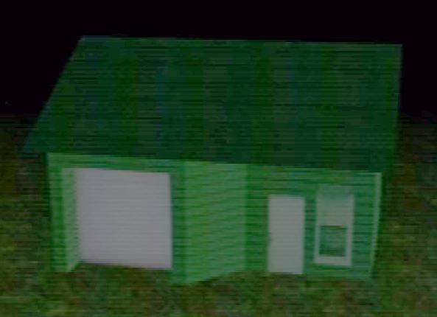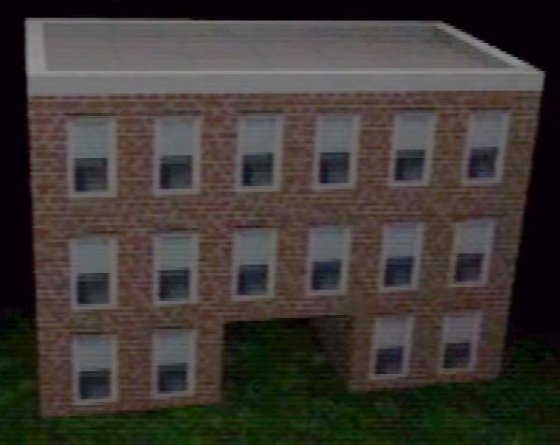

It may be important to note that the picture with the school building plays a low, possibly foreboding, sound when Paul looks at it.This might be the same school referenced in the note in Care’s Room.

Later in the episode, in response to the questions “where is my house?” and “where is the school?” Red TOOL replies with “you’ll never go home” and “you can’t go back in time” respectively.

This character also seems to cause an unusual pink screen to appear. The black object in the center resembles a CD. Directly after this screen, the character begins spawning map tiles as if he was a developer of the game. The screen may indicate the loading of a debug or map editor mode that allows the character to manipulate the game. This might be an indication that this character has a deep knowledge of the game’s code.

### Rainer

In Petscop 9, Paul finds a note signed by “Rainer, Newmaker” in Lina’s Room (Rainer may also be the author of the previous note found in Care’s Room).

As of Petscop 11, the in-game Rainer appears to be based on a real world character of the same name.

During the Christmas 1997 and 2000 scene in the House, an unseen character, who’s presumed to be Rainer, enters the house, leaves the family a present, and excuses himself to the bathroom. This is likely a reenactment of a real world situation during which Rainer gave the old Petscop recordings to the Proprietors.

Later on, Paul finds a note from Rainer in Care A’s description:

When the emergency began, you were all looking for Care A.

I told you all, we would never find Care A. When Care A goes missing, she goes missing forever.

My brother didn't want us to find him, because he knew we were all looking for Michael A.

I'm back. This is my present for you.

I started it in 1996, for Marvin.

If you think they're worth any effort, see if you can save Care B, or Care NLM. Care B is in the school, of course.

Fuck you all, and fuck me as well. Merry Christmas. Check your bathroom now.

- Rainer

This note indicates that Rainer may be the author of the Recordings he gifts, and possibly also of the Petscop game itself.

A proposed course of events postulates that Rainer enters the House after being gone since June, gives the family the recordings to watch, and excuses himself to the bathroom while they play it. What he does in the bathroom is unknown, although suicide has been suggested. The recordings then presumably end with Care A’s description telling the family to check their bathroom.

Right before Paul brings up Care A’s description, he sees a menu message saying “I’ll come out in a minute. Keep playing.” This is probably another message from Rainer to the family, but it could also be from Marvin to the player (or even to the audience), as Marvin does show on the screen a minute later.

In Petscop 20, Rainer leaves multiple messages for Marvin:

* his messages in Gen. 7 show that he knows of Marvin and Lina’s backstory, and either knows where Lina’s grave is or is trying to trick Marvin into revealing that information;
* the notes he leaves on the Caskets in Gen. 8 indicate that he now knows that Marvin is living at an abandoned school, and is aware of at least some details of Care’s time there. He also reveals that he helps Anna in painting over the stencils—an events that may be referenced in Petscop 14.

In Petscop 23, Care B’s description suggests that Rainer freed her from a locked dark room. This may imply that he aided her escape from the School Basement. He also complains about not being able to even see her photos, and possibly declares an intent to dig-out graves.

### Belle’s Captor (fan name)

The person who attempts to turn Belle into Tiara, presumably imprisons her in the Quitter’s Room, and leaves in-game messages for her. He appears to be a developer of Petscop, and claims to be gone now.

The identity of this person remains unconfirmed. The Captor is generally believed to be Rainer, but some point out that Rainer seems to be an outsider to and possibly also an opponent of the practice of rebirthing, while Belle’s Captor seems to engage in it. A real-life counterpart of Marvin is another option due to the notes found in Child Library.

The recording labeled as “tiara” may be the one in which the Captor calls Belle “Tiara” prematurely. The following “FUCK-FUCK-FUCK” recording is likely where he realizes his mistake.

It has been proposed that Rainer was impressed by Belle’s performance during the testing phase of the game, and as a result decided to transform her into a new person called Tiara. As opposed to Belle, Tiara may be a “family member,” possibly due to exposure to the Caskets.

### Lina

Lina appears for the first time in Petscop 9, when Paul enters the Windmill. She’s semi-transparent and rotates slowly atop the contraption made out of cogs and Pieces, and disappears together with the latter when Paul uses White TOOL.

Later in Petscop 9, Paul uses her face (which, just like Care’s, doesn’t have eyebrows) to enter her room in the Child Library. In there, he finds a passage to the Party Room, and a note vaguely describing some of the Windmill incident.

In Petscop 17, Lina’s grave is found through the use of Room Impulse. The selected Guardian walks backwards across the Newmaker Plane, following a path similar (but not identical) to the one Paul took in Petscop 11 to reach the House, until a dialogue box prompts the player to ask “What happened to her?” (the text input interface is triggered by circular walking similar to what’s seen in Petscop 11). Doing so raises a grave topped with one of the Pieces, with Lina’s face upon the tombstone. The grave is marked:

Lina Leskowitz

1968 - 1977

They didn’t see her.

It’s likely that Lina is Paul’s relative, if his surname is indeed Leskowitz.

The epitaph may suggest a car accident. In Petscop 22, Paul’s Guardian gets ran over by an orange car (similar to the one seen in the Garage) while in the Shadow Monster state. This event might be a reference to Lina’s death, and Paul’s character may have been hit due to being darkened out and thus not being seen.

She is the in-game counterpart to Lina Leskowitz.

### Anna

Anna is first mentioned in Petscop 3, in the note Paul finds in Care’s room: she’s referred to as the wife, and expresses concern over Care’s not growing eyebrows.

She’s mentioned again in Petscop 9, in the note found in Lina’s room, this time in the context of the Windmill incident. The note establishes that she is present there (and taking pictures), that Lina is her sister, and that she marries Marvin.

In Petscop 11, Anna can be occasionally seen near the sink in the Living Room, and she comments on Rainer’s unexpected return.

In Petscop 14, Anna welcomes Care home (likely she’s the one who organizes a party for Care, probably taking inspiration from the story about Marvin and Lina), and consoles her about her appearance. Later in the episode, she expresses concern at Care’s unusual behaviour, when the latter mimics Paul’s words and actions from 2017.

Petscop 24 features a letter from Anna to Mike. In this letter, she often precedes interpunction with spacebars, and signs it with a black rosette (🏶). The note left in the House in Petscop 11 shares those traits, indicating that it too was written by Anna.

## Locations

### Newmaker Plane

The location where the entirety of the Secret Game takes place. It appears to be a flat, dark, mostly empty plain of grass.

If the Gift Plane is a representation of Heaven, then the Newmaker Plane could be Purgatory. Both the Newmaker Plane and some representations of Purgatory are mostly empty space.

The name Newmaker Plane could imply that the/a Newmaker controls, created, or is in some other way affiliated with the area. Since Rainer signs one of the in-game notes as “Rainer, Newmaker,” it could also mean that Rainer considers himself associated with it.

The Newmaker plane is atypical for a video game environment, as it involves large areas of empty space, and requires the player to wait for extended amounts of time (e.g. while waiting for a room in the Library, or during the Windmill watching scene). This quality has been described as “realistic,” and may indicate that the Newmaker Plane is supposed to be a simulation.

In Petscop 22, Paul and his friend discuss correlating locations on the Newmaker with real-world landmarks. A similar idea is suggested to Marvin by Rainer in Petscop 20. This suggests that the unusual scale of the Newmaker Plane is the result of staying true to real-life distances.

In Petscop 23, the sky over Newmaker Plane turns blue shortly after the Machine is used.

The Newmaker Plane appears in one of the hidden loading screen images in Petscop 2.

A screenshot of the Newmaker Plane is used as a banner by the YouTube channel, but only the (completely black) top sliver of it is usually visible.

### Office

The Office is where Paul receives the phone call informing him that “Care left the room.” It’s also the location of the A/B/NLM note (see Care).

The message from the call appears again twice in Petscop 11, coupled with an alarm that goes off whenever Care A is carried out of her bedroom (first by Marvin, later by Paul). It’s therefore possible that the device in the House contacts the Office.

The Room Impulse menu seen in Petscop 17 suggests that it may be Anna’s office.

It may be an in-game representation of the office hosting the Easter Egg hunt mentioned in Petscop 19.

### Flower Shack and Basement

Next to Mike’s grave, there is a shack with two entrances: one to the ground level, and one to the basement. Care’s face is drawn above the basement entrance. The ground level contains a giant, white daisy that has broken through the floor from the basement, a hoe and shovel (which appear again in the Garage), and crayons on a shelf. The basement houses Care NLM, who kneels directly in front of the daisy’s stem, although the stem of the daisy also gives the appearance of a noose around her neck. Care NLM and the stem sit on a grass pedestal, which lowers after the petals of the daisy are plucked.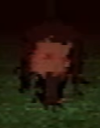

In Petscop 9, Paul descends the stairs into the basement, but instead of going all the way down, he makes a right turn near the bottom. As a result, the Guardian clips through the wall, becomes completely black, and gains the ability to enter the Windmill. This is likely what the Note from Petscop 1 was referring to. It has been proposed that descending the staircase applies a darkening effect to the character sprite, and clipping out of it prevents the game from clearing it—this would explain why reentering the stairs restores the original appearance.

Care and the Daisy bear a visual resemblance to Casket 1. Care’s distorted form may be based on how she sees herself while looking at the vase.

### Quitter’s Room

The Quitter’s room has the appearance of a pair of mirrored bedrooms that are split by a large, mirror-like wall. On the opposite side of the room, Quitter (Belle) can be seen mimicking most of Paul’s movements. In Petscop 2, when Paul walks behind a bookshelf in the room, the reflection temporarily goes out of sync. In addition, the beeping sound heard when the door opens in the Newmaker Plane plays.

This sound could indicate that these two events are connected. The same entity that opens the door may also influence the reflection. At first glance, the reflection seems to follow the player's movement at a delay. However, when watched closely, it can be seen that Quitter is making movements that Paul doesn’t originally make, almost as if a second player is controlling it.

“Quitter” may be a reference to Candace Newmaker’s story. In the transcript of her death video, one of her “therapists” repeatedly called her a quitter ([source](http://www.ratbags.com/rsoles/comment/candace.htm)).

The note on the wall says “Do you remember being born?” with a line on the bottom to indicate it’s meant to be filled in. This may be a reference to the rebirth theme found throughout the game. As for who this note was intended for, it’s unclear. It could be talking to the player directly, or it could be meant for whoever is on the other side of the mirror. This message may also be connected to Tiara.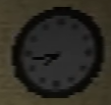

In Petscop 2, the clock on the wall shows around 7:45 (or 4:15 if it is reflected horizontally). It does appear to work, as the time on it changes as the videos progress. In Petscop 7, the clock shows approximately 4:30 (or 7:30 if reflected). The significance of these times is unknown. Playstation 1 does not appear to have an internal clock, so the clock in this room might not reflect the real time, but rather just a passage of time starting from a specific point. The room that the player first enters from the Newmaker Plane also appears to have images of clocks on the wall.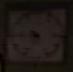

In Petscop 7, Paul is heard shuffling through papers as his character stands in the upper right corner of the room. The [second movement of Stravinsky’s Septet](https://www.youtube.com/watch?v=ijSmRoPzMaY&t=172) starts playing from the opposite side, and Quitter disappears for its duration. The music plays for almost a minute, and once it stops, Quitter instantly teleports back into place as Paul’s reflection. Paul checks the note and finds the empty line is now filled with “COME HERE” and a zigzag line in pink (see Color Theory). This appears to be a modification of the paper’s texture achieved via Draw Mode.

In Petscop 10, Paul is able to access the other side of the Quitter’s Room for the first time. The room appears to be the same, save for the symbol block on the bed (see Odd Care) and that Quitter now appears on the other side of the mirror.

In addition, the Quitter’s room can be seen from above in one of the hidden loading screen images in Petscop 2.

In Petscop 12, Belle walks around the Quitter’s Room at the beginning of the demo, and appears to be trapped in it. Once the Pyramid Head enters the room, she seems to be teleported to match his position—the time on the clock doesn’t change, thus making a footage cut unlikely.

In Petscop 22, Paul revisits the room (which he calls a “cage puzzle”) while talking with his friend, and expresses disappointment over its content. He mentions that the “Tiara character” is gone, which the friend finds obvious.

### TOOL’s Room

The room where Red/Pink TOOL stands (see Red TOOL and Pink TOOL), and where the player can ask it questions. Objects of note found inside include drawings of Blue TOOL, several written notes which seem to be illegible (although one of them resembles Casket 4), a row of potted plants, and a large screen that shows the spinning windmill (see Windmill).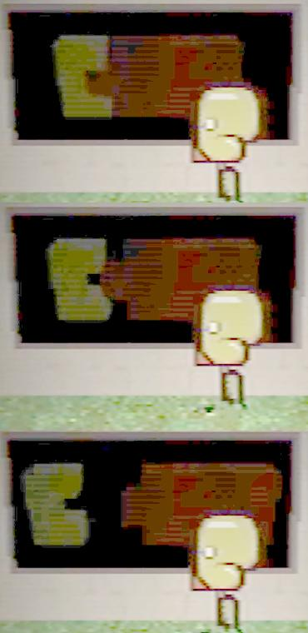

Furthermore, there’s a barely visible animating object in front of this room. It animates between the three frames (shown on the right) when Paul first walks past it. This object can also be seen continuing to animate in Petscop 6, Petscop 7, and in Petscop 12.

The smaller object appears to be yellow, which is the color associated with Care. This shape might purposefully look like a C to further hint at some kind of connection with Care.

In Petscop 22, the animation is revealed to be the logo of a board game called “Accident.”

The drawings inside the room appear to slightly move around between Paul’s visits ([comparison gif 1](https://i.imgur.com/0UZ82VZ.gifv), [comparison gif 2](https://i.imgur.com/i3vsBuS.gifv)).

### The Tunnel

The Tunnel is first seen in Petscop 2 when Paul explores the area beneath the Newmaker Plane for the first time. Blue and red cars periodically emerge from the Tunnel, but seemingly never when the Guardian is on the road.

In Petscop 8, Marvin emerges from the Tunnel and leads Paul to the Places area.

In Petscop 11, in a demo sequence, the viewer (presumably inside a car) is dropped onto the road and moves into the Tunnel. The sequence with the Clock then plays out, and the scene eventually proceeds to the School. This implies that the School can be reached by going through the Tunnel.

Petscop 17 ends with the Guardian walking backwards into the Tunnel.

In Petscop 22, Paul’s Guardian walks in front of the Tunnel while in the Shadow Monster state, and is ran over by an orange car. Shortly afterwards, Belle walks onto the road, and begins glancing to her left.

Later in Petscop 22, another Clock sequence plays out (as a Demo), and once again leads to the School. The presence of the Gauge and a Pyramid Head imply that the scene is viewed with Room Impulse, and likely a direct continuation of Petscop 17.

A screenshot of the Tunnel from Petscop 2 (both with and without the Guardian) is often used as the icon for the YouTube channel.

### Good Grief and Alas

This message is seen on the wall of the hallway leading to the Child Library in Petscop 3. It is likely a reference to the Dr. Seuss book “Daisy-Head Mayzie” originally published in 1995. The book is about a girl who grows a daisy out of her head. Eventually she picks the petals off the flower and realizes they do love her. Things do not go the same way for Care.

### The Child Library

The Child Library is a building which contains a lobby section with the face easel, and numerous bedrooms. On its outside wall there is a hole in which a child can be placed—this activates a mechanism similar to a foundling wheel.

Inside, a face can be assembled on the easel, which causes the room to violently shake for several minutes. As the quaking is happening, rooms appear to be rapidly falling past the door at the back. When it stops, a bedroom can be entered. Paul enters several different bedrooms throughout the videos, most notably Mike’s (see Mike’s Room), Care’s (see Care’s Room), Lina’s (see Lina's Room), and Care-with-Mike’s-Eyebrows’s (see Care-with-Mike’s-Eyebrows’s Room).

The total number of easel combinations has been calculated as 288,000, but since some combinations (the ones without one or both eyebrows) can be identical, there are only 233,280 distinct faces possible. Petscop 12 reveals that the facial features used in the Library belong to members of “the family.” This may mean a literal family, or a figurative one.

In Petscop 7, Paul discovers (possibly after being informed about it by a third party) that a Pet can be placed in the hole in front of the Child Library by accessing the Pet menu in front of it. He’s then informed that the Child Library will only accept “people” and not any of the original six Pets.

The name “Child Library” may imply that children are stored in the bedrooms to be borrowed. Once the borrowers are done with a child, they may drop it in the child return slot, where it is returned to its bedroom.

The Child Library could also be a metaphor for the adoption/foster care system.

In Petscop 9, Paul drops Care NLM into the return slot which results in a message:

You’ve decided to leave Care NLM.

If you change your mind within 6 months, you can take Care NLM back.

What month is it, anyway? What year is it?

Afterwards, Care NLM appears in her bedroom crying on her bed. Paul then catches her again.

In Petscop 12, a text box appears when the player (Belle) approaches the Child Library:

This is the Child Library.

You’re not family, so I didn’t add your traits to the face system.

That means I didn’t add your eyes, or your eyebrows, or your nose.

#### Generic Children’s Rooms

The children’s bedrooms—besides Mike’s, Care’s, Lina’s, and Care with eyebrows’s—do not seem to contain much useful information. The children sitting on the beds appear to have unique features: their gender and age/height appear to differ, along with some possibly wearing various hats. Most of them have toys on their table, ranging from (unsolvable) Rubik’s Cubes to Gameboys. Every room has the same dark passage to the right of the back wall. As for whether these children are just mannequins or representations of real children is unknown.

In Petscop 7, Paul inputs Mike’s face without eyebrows into the easel, and he enters the following bedroom as a result:

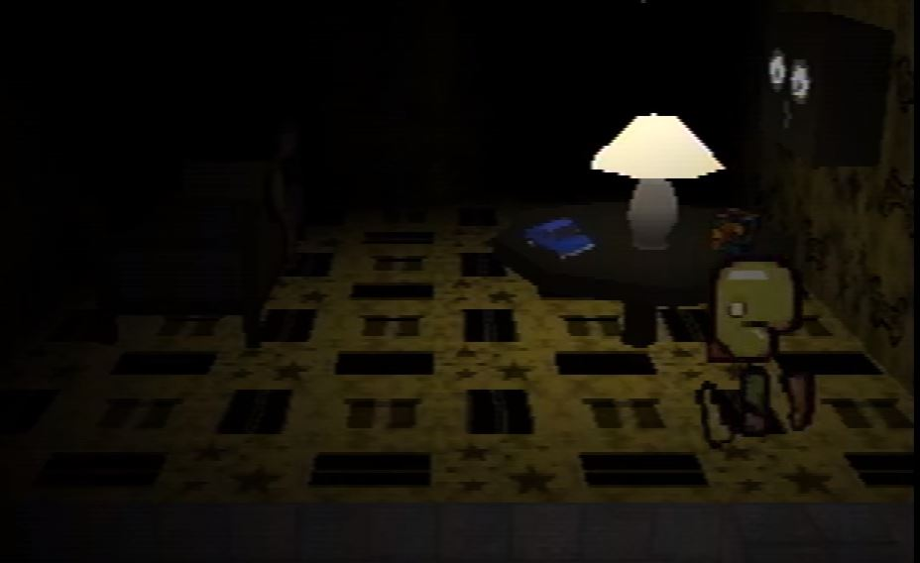

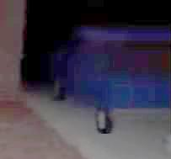

The things of note in this room include the blue car on the table, and the roads and gift boxes on the carpet. The gifts can be associated with Mike due to his tombstone and the epitaph upon it: “Mike was a gift.” The roads and car might be related to Toneth’s description, in which Mike is mentioned. The description tells the story of a dog being hit by a car. 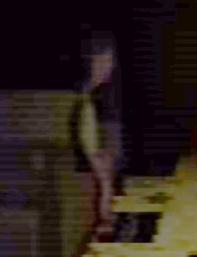

The toy blue car looks similar to the blue car seen driving past in Petscop 2 (right).

There is also a mannequin/child sitting on the bed in this room.

#### Mike’s Room

In Petscop 3, when Paul enters the face found on Michael Hammond’s Gravestone onto the canvas, a message displays:

Mike is not inside right now. He is dead.

You may visit his room.

Inside the room: On the table:

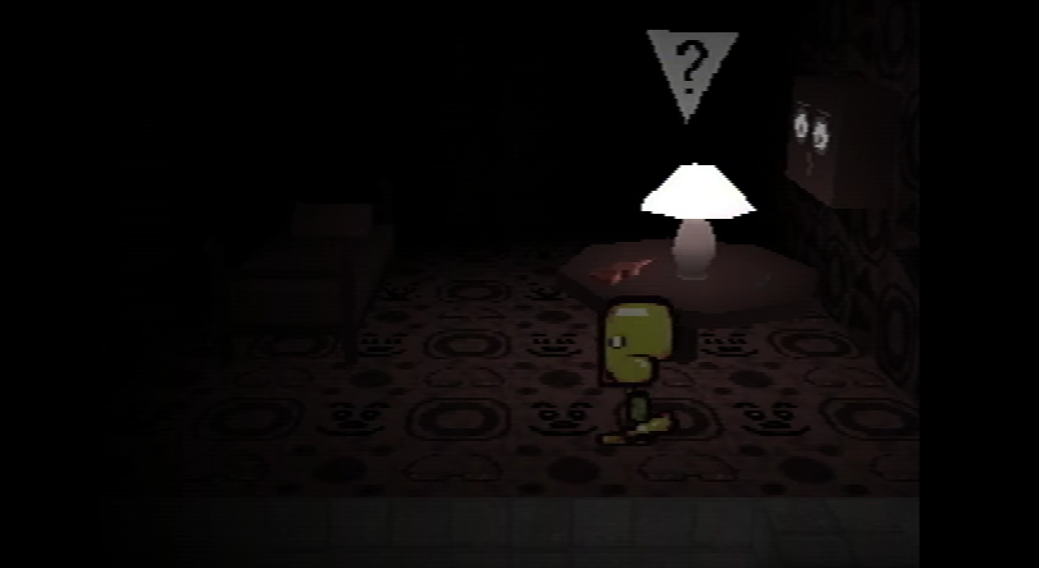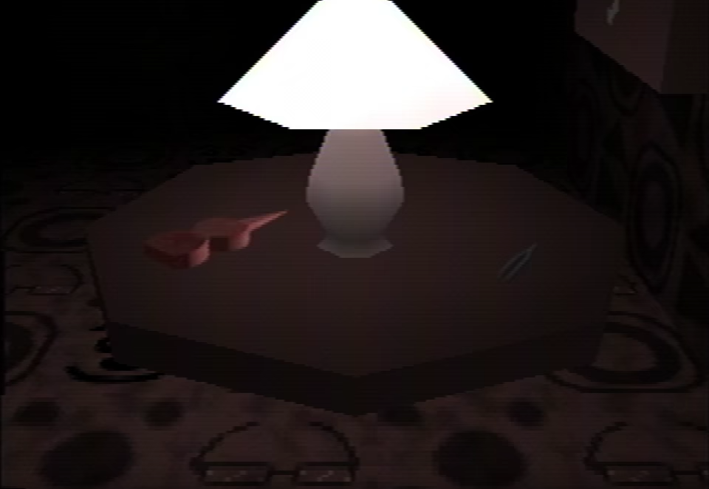

Sitting on this table is a small version of Red TOOL and what appear to be tweezers. The tweezers may have some importance, due to the importance of eyebrows in the case of Care. It’s also noteworthy that Paul doesn’t seem to recognize what the tweezers are.

The object on the right might also be a tuning fork.

Eyeglasses can be seen on the floor, which might be an indication that Mike wears glasses.

#### Care’s Room

In Petscop 3, when the face on the shed (Care’s face) is entered, a message displays:

Care is missing.

You may visit her room.

Inside the room: On the table:

A box of crayons and a small Red TOOL are found on the table. The crayons may be connected to the drawings of Blue TOOL. Similar crayons are also seen in the shack, Care’s room in the House, and in a loading screen. A paint roller similar to the one from Petscop 14 can be seen as a part of the carpet’s pattern.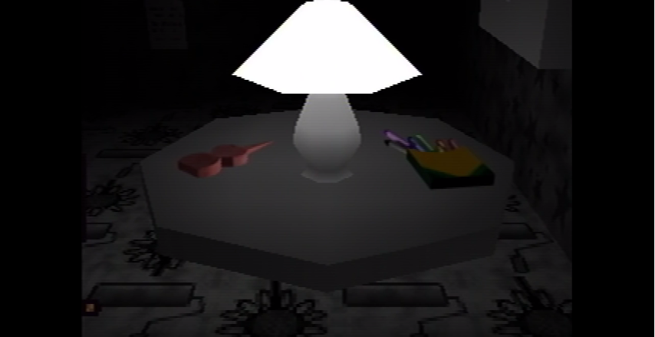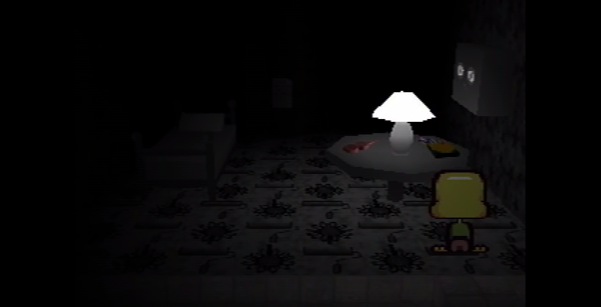

A note is found on the wall of the room:

Your wife says, “Care isn’t growing eyebrows.”

You say, “That’s a puzzle.”

You’re secretly very excited to hear this news.

You’re in the bathtub thinking about her.

I have a guess at which child you’ll pick next.

When you find her room, the passage to my right will lead to her.

She'll appear from the darkness limping, and I'll shoot her in the head.

Tiara says young people can be psychologically damaged "beyond rebirthing."

A young person walks into your school building.

They walk in with you. You're holding their hands.

They come out crying into their hands, because nobody will love them, not ever again.

“Nobody loves me!”

They wander the Newmaker Plane.

Thoughts and interpretations for each of the lines:

1. Anna seems concerned when she notices Care isn’t growing eyebrows. If Care (or someone else) is plucking her own eyebrows, then it seems like the wife is not aware of it (see Care).
2. Marvin acts as if he doesn’t know why Care doesn’t have eyebrows.
3. He actually does seem to know why, and he takes pleasure in it.
4. This further emphasizes that he thinks about what he’s doing to Care all the time, almost obsessively.
5. He may be moving on from Care to another child (perhaps adopting a new one?).
6. This could refer to Lina.
7. This may be a metaphor rather than a literal message. Or, perhaps, the writer of the note aims to foil its recipient, possibly by mercy-killing the next victim
8. Tiara appears to be speaking like a therapist.
9. This part of the note seems to tell a separate story. The young person is likely Care, because of the yellow “Nobody loves me!”
10. The plural “hands” seems unusual, but it’s unclear if it’s significant.
11. Care comes out crying, possibly because of her eyebrows.
12. This connects Care to the A/B/NLM note, as well as the Dr. Seuss story.
13. This line seems to connect with Care’s description, where she escapes the school’s basement and wanders the Newmaker Plane.

A sequence in Petscop 11 appears to partially mimic the events described in the note:

* First, Paul enters the bathroom and approaches a white cube suspended above a bathtub.
* Next, a hidden loading screen shows a woman, possibly limping, who’s standing in a doorway.
* Finally, Marvin leads “Pall” into the school

#### Care-with-Mike’s-Eyebrows’s Room

In Petscop 7, Paul enters Care’s face with Mike’s eyebrows onto the easel, and enters another room.

Inside the room: On the table:

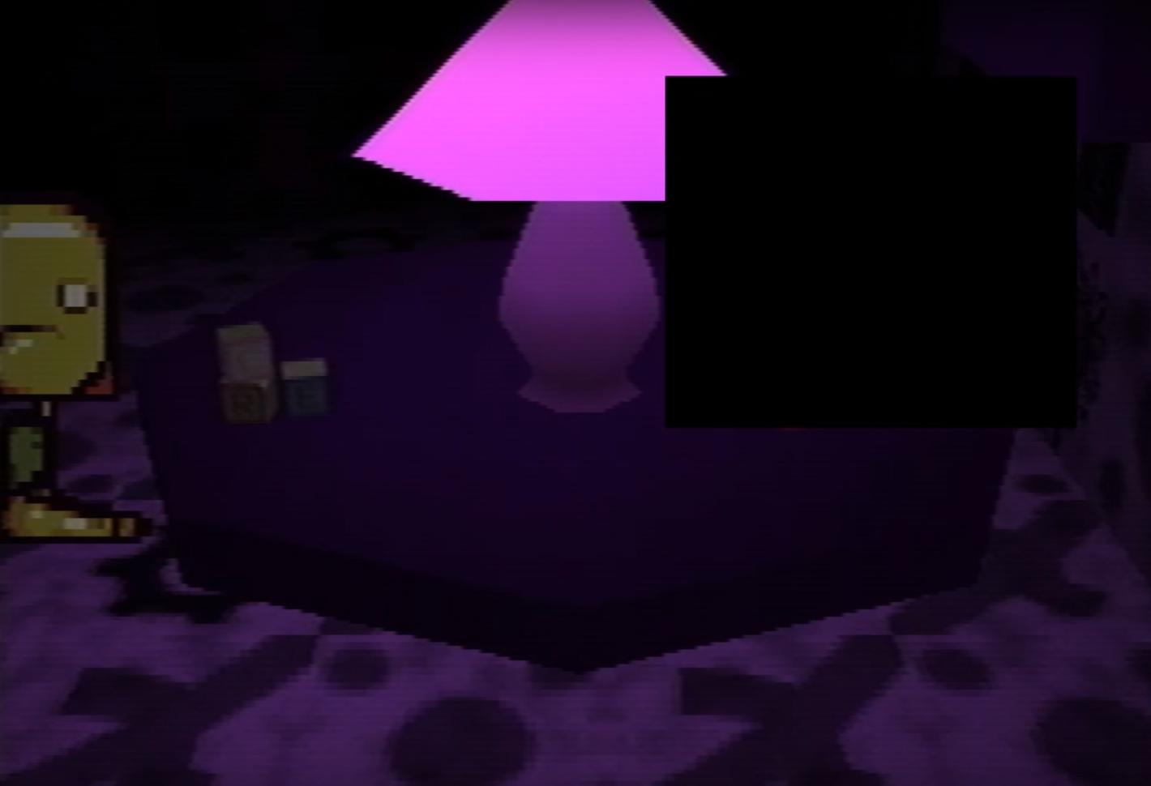

The objects depicted on the floor and wall may be flower related (a common theme for Care). The dark objects on the floor look like they may be gears, but they could also be flowers or the sun. The longer objects could be flower stems. The room also appears to have roads on the wall, similar to the roads in the room of Mike without eyebrows.

Care with eyebrows’s room also has a mannequin/child on the bed who appears to wear a blue baseball cap. It’s not clear whether it has hair or not. It also seems shorter than Mike without eyebrows.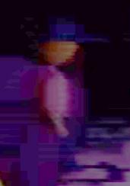

This room is the only shown so far to have a colored lamp shade.

On the left side of the table, there are three toy blocks spelling “CRE.” Whatever is on the right side of the table is censored in the video, but a sliver of red pixels can still be seen. For more discussion on the censored items in Petscop, see Censorship and Caskets.

While exploring this room Paul appears to be unsure as to whether it’s a regular Child Library room, or one with special significance. Towards the end of his visit he utters a silent “Oh my god,” which could be a reaction to the censored object, or just a sign of frustration.

In Petscop 11, Paul states that he found his room in the game. He later mentions a girl in real life who went missing and was found on the same dates as Care in the game (as implied by highlighted dates on the calendar). He notes that he and this girl are the exact same age and she bears a strong resemblance to him (see Twins Theory). If said girl is Paul’s twin, and Care is meant to represent her, then it’s possible that Care with eyebrows’s face is meant to be Paul’s face.

#### Lina’s Room

Upon putting Lina’s face on the easel in Petscop 9, the following message appears:

You found her.

You may visit her room.

“You found her” is most likely connected to the note in Care’s room: “I have a guess at which child you’ll pick next. When you find her room, the passage to my right will lead to her.”

Inside the room: On the table: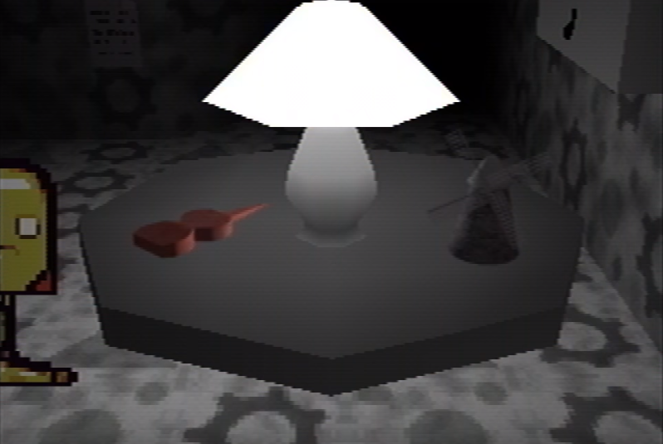

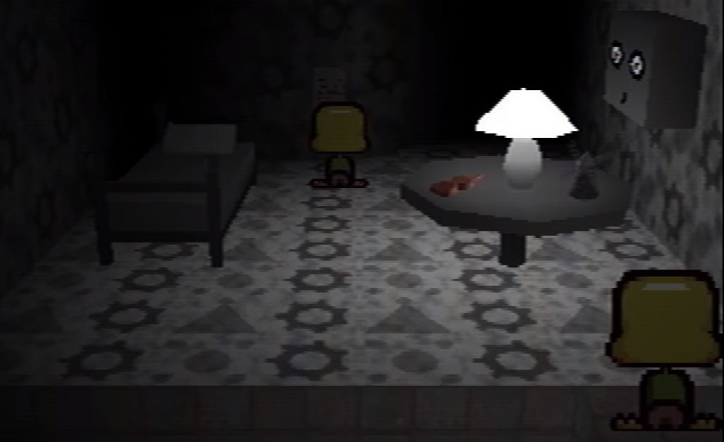

The shapes on the walls and floor may be gears, windmills (the circle with four dots), and the teal, cone-shaped piece. There is a windmill on the table (similar to the one seen in the Master Bedroom in the Demo in Petscop 14), along with the same red TOOL as seen in some of the previous bedrooms. Upon entering the room, another player character can be seen reading (or possibly writing) the note. It then exits the room in identical way as Paul exits it a couple minutes later (see Synchronization and Timelines). There is a note on the back wall:

You must have guessed, but I was looking through your things.

I found that picture of you from 1977, standing in front of an old windmill with your friend.

You went there, and it was a bad idea. Your friend and the windmill both disappeared into thin air.

Her sister was holding the camera. She took another picture minutes later; just you, no windmill, and no friend.

You married her sister, and years later, your friend was reborn as your daughter.

Your wife won’t admit this is true, but I know it, because I found the evidence.

Your friend never returned with you, and the windmill was gone. I went to see it myself. Where is it? What did you do?

- Rainer, Newmaker

If the note above is a continuation of the one found in Care’s Room, then it may be concluded that Care is—or was supposed to be—the lost friend reborn (and also a daughter of her sister). Notably, both Care and Lina lack eyebrows, which may be a sign that the former is the latter reborn.

Upon entering the passage in the northeast part of the room, a loading screen appears that resembles the triangular Piece (which also serves as the top of Lina’s grave). It also resembles a party hat. After the loading screen, Paul ends up in the Party Room.

### The Windmill

This section refers to the windmill on the screen in TOOL’s room, the windmill in the picture frame, and the placeholder windmill seen in Petscop 4.

When Paul first talks to Red TOOL, it tells him to “keep watching the windmill.” When Paul does this nothing seems to happen aside from two sound effects being played.

The windmill in the picture frame and the windmill on the screen in TOOL’s room are reversed (i.e. their blades are mirrored). Furthermore, the windmill on the screen is rotating in the wrong direction compared to a real one (the poles of the blades should be leading the sails—even if the windmill was reflected horizontally, it would still be rotating in the wrong direction).

In Petscop 6, Paul decides to watch the windmill for a long time. After 2 hours and 39 minutes, a dark figure walks behind the windmill (see Shadow Monster Man), and after a few seconds, the windmill starts spinning the opposite way. Now, the windmill is spinning the way a real windmill should (with the poles leading the sails). The windmill also starts to produce a constant humming sound, as if it is generating power.

In Petscop 4, Paul finds a camera that seems to be pointing to where the windmill should be, but instead he finds there a transparent floating platform that moves back and forth. Assuming that this camera is transmitting directly to the screen in TOOL’s room, there is something causing the windmill to only be visible to the camera. In Petscop 6, after the player watches the windmill for around 4 hours, the windmill suddenly vanishes, and leaves behind the same transparent floating platform Paul sees earlier. The humming sound continues to play even when Paul goes back to the surface.

It’s noteworthy that the camera changes colors from black to red sometime during Paul’s extended windmill watching session. This may indicate that only the black colored camera can see the windmill, possibly implying a connection with the Shadow Monster state (e.g. maybe only things in shadow mode can interact with the windmill).

In Petscop 9, Paul figures out how to become the shadow man, and upon exploring the Newmaker Plane, he finds that he is now able to see the windmill. After walking behind the windmill, he is able to enter it.

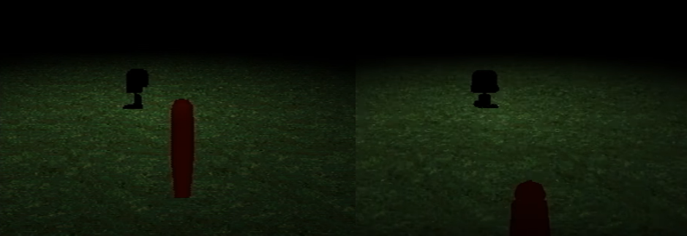

Inside, there’s a sign with Lina’s face, a translucent girl (with the same face) who’s hovering over a device made out of pieces and a couple of gears, and a white TOOL. When Paul uses the white TOOL, it is plunged towards the girl and the machine, and Paul collects 50 pieces. The humming sound begins to play afterwards, and the gears are free from the pieces and turn in the opposite direction than before.

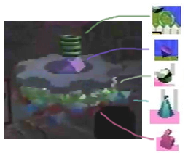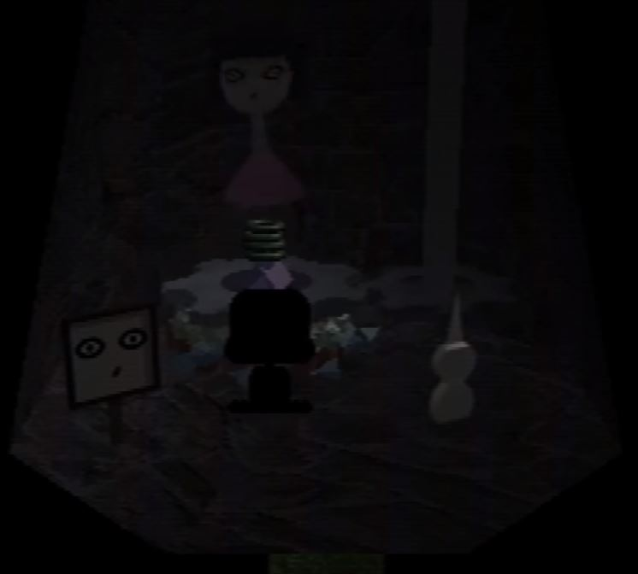

The girl appears to be more of a hologram or a ghost than a physical object. After Paul uses the white TOOL, the windmill starts rotating in the right direction. Upon entering the girl’s face into the easel at the Child Library, he enters Lina's Room.

In Petscop 14, there’s a figure of the Windmill on a nightstand in the Master Bedroom, but only in the Demo sequence featuring Marvin.

In Petscop 20, Marvin is able to operate the camera: he can change its height and rotation. He rises it above the windmill, where the sound of talking children can be heard, and then through and below the ground, where it reveals a symbol cube.

In Petscop 22, Paul and his friend speculate that the Windmill may be an in-game counterpart to a real-world stone.

Graverobber uses a miniature Windmill as a game mechanic.

### Party Room

A black and white room that Paul can enter from Lina’s Room. It resembles an outdoor area with trees, a picnic table (the picnic table is barely visible on the right), two large presents, a pinwheel, and a bench. In this room, Paul receives a green key from the present on the right. He opens the present on the left to reveal an upside down, red pyramid that is partially censored (see Censorship and Caskets).

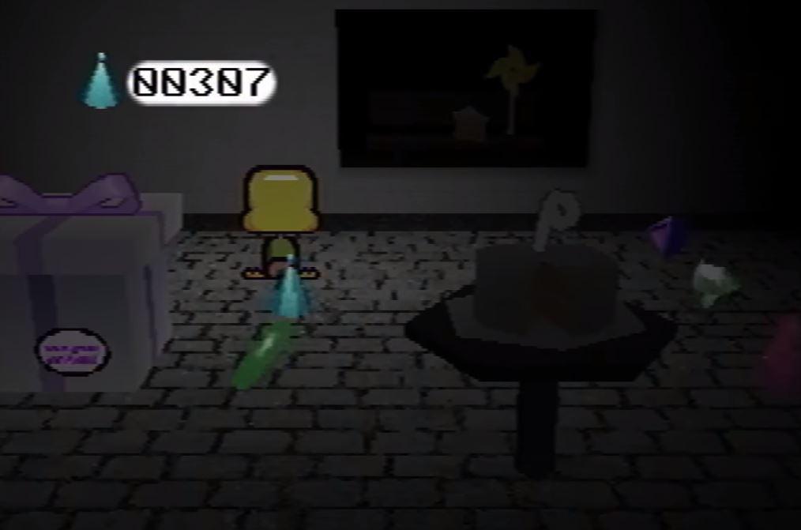

Through a window, a bench with a slice of the cake on it can be seen, along with a yellow pinwheel. A birthday party is taking place in this room, as there is a cake with a backwards “9” on it.

On the left side of the room, Paul finds and enters a small cube-shaped building, which turns out to contain another present. Upon opening it, loading screen appears with a choir-like sound (which is speculated to signify Generation change). Paul then appears on the Newmaker Plane, right next to the entrance to Odd Care.

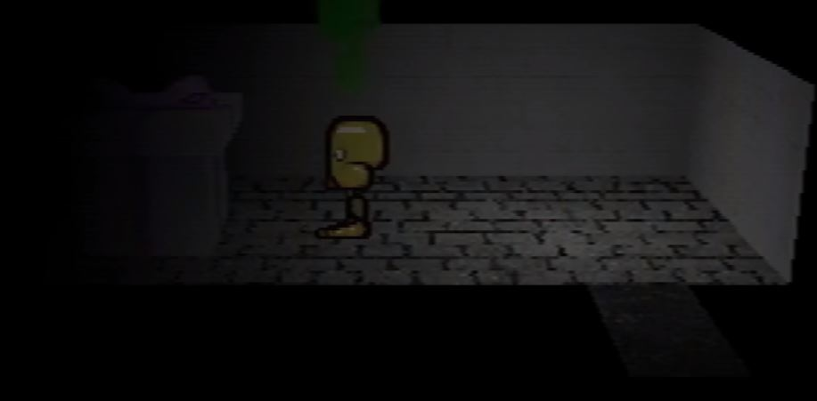

In Petscop 17, it is revealed that Marvin supposedly holds a birthday party for the missing Lina, and waits for her on a bench, and tries to lure her back with a slice of cake. This is almost certainly the event the Party Room represents, given that Lina turns 9 in 1977, and that a bench with a cake slice is visible through the window.

In Petscop 20, an image on the wall right past the Road Map appears to show an outside view of the Party Room, but without the cake or the pinwheel on the bench.

### Odd Care (fan name)

Odd Care is first introduced in the demo that plays after waiting at the Petscop main menu. Odd Care is differentiated by new background music, newly open/closed doors, the lack of a piano in Pen’s room, and its connection to the Newmaker Plane. It also has several pieces to collect. The pieces collected during the Demo sequence are missing when the same areas are visited in-game.

The treadmill in Pen’s room appears to be connected to the number of petals on the flower in the Flower Shack. Paul uses this to catch Care NLM.

The cages in Amber’s room appear to be connected to the doors leading to either side of the Quitter’s Room. The cages in Odd Care do not reset when player leaves the room, as their Even Care counterparts do.

Since it features connections with the Newmaker Plane, which itself appears to be a Gen. 6 addition, Odd Care is probably newer than Even Care. It may be an altered copy of it, or what Even Care becomes in a higher Generation (possibly the 9th).

### The House

The house is first shown in a picture on the wall under the Newmaker Plane in Petscop 2. It appears as entirely green with a white garage door, window, and front door. The house is mentioned again in Petscop 6, when the Shadow Monster Man spells out the question “Where is my house?” In Petscop 7, Pink TOOL mentions it again in the line “I LOVE YOU NEWMAKER PLEASE SHOW MARVIN WHERE HIS HOUSE IS.”

In Petscop 11, Paul finds the house next to a road and a sign that reads “This is a frozen house, captured three times, exactly as it was.” The house appears different from in the picture, as its walls are black rather than green. Paul is able to use the green key to unlock the door, but is unable to open it as the Guardian doesn’t know how to open doors. After walking to the road and then back to the house (during which a few quiet tones can be heard, similar to the tones heard after catching Toneth), Paul finds the door open. Upon entering the house (and later, leaving it), a hidden loading screen is shown.

In Petscop 14, the road near the house displays three yellow signs: a picture of Care A; a picture of a birthday cake with a missing slice, which also has a yellow balloon and a blue balloon tied to it; and an arrow. There are also three arrow-shaped stepping stones that lead to the door.

In Petscop 18, there’s a simplified (or possibly outdated) model of the House in the Extra Stuff menu.

In Petscop 22, Paul speculates that locations on the Newmaker Plane can be found by following real-world directions and landmarks. It’s possible that he’s using this technique when he finds the House.

*(See* *Maps* *for a full map of the House)*

#### Living Room

The living room is the first room upon entering the house. When it is first shown in Petscop 11, there is a TV on the far wall with a couch in front of it, a small kitchen and refrigerator on the left wall, a small table against the nearest wall, a Christmas tree with four presents beneath, and two calendars on the wall (one green and one gray). The house also has four doors, all of which are initially closed. There are three people in front of the TV, a person in front of the kitchen sink, and a person in front of the tree, all of whom seem to randomly appear and disappear as Paul walks around.

Paul examines the calendars, which appear to show two different years. The years shown may be 1997 (green) and 2000 (grey), the same as the ones mentioned in one of the iterations of the channel’s about section. The navigation buttons for flipping pages appear to be reversed in comparison to a PS1 pad. Both calendars show December 25 with a bouncing number and Christmas tree animation. The green calendar also shows highlighted days, which start the year as every other day, turn to weekends-only after February 10, turn to everyday starting June 5, and end completely after November 10. This may indicate Marvin’s custody and kidnapping dates for Care, since Marvin is associated with green in Color Theory. As Paul continues to walk around, text boxes pop up that read:

“Where have you been? Why were you gone for such a long time?

“Is that a present? Who is it for?”

Can I use the bathroom?

“Of course.”

In Color Theory, blue is associated with Anna. Given the context, it’s likely that the Guardian represents Rainer in this scene. Since the white text lacks any quotation marks, which implies that the player character itself is speaking, this conversation might be taking place between Anna and Rainer.

The bathroom door then opens and Paul enters. After exiting, the house changes. The gray calendar, Christmas tree, and people are gone, one of the doors is open, and there is now a white bucket on the ground and two objects on the table surrounded by vibrating pieces (see below). Paul checks the remaining green calendar to find that the number on the June 5 date is now animated. There is also a note on the wall:

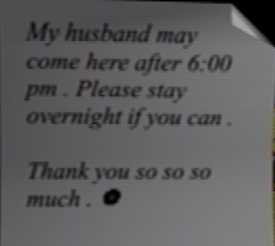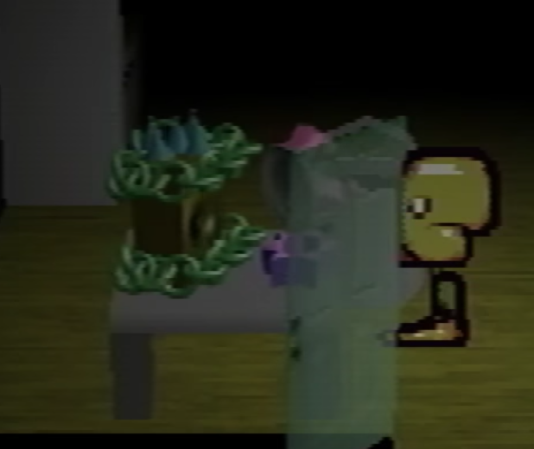

The symbol after the note is likely a black rosette (🏶), indicating that the note was written by Anna.

In Petscop 13, Paul discovers that he can take the bucket outside the House, where he uses it to capture Teal TOOL. This covers Teal TOOL with black paint. He then uses the TOOL to dislodge 15 pieces from the aforementioned device on the table. Later in the video, he also speculates that the House and Randice and Wavey’s Room are counterparts. This is reinforced in Petscop 14, when the background of the house has the same symbol as Randice and Wavey’s Room with inverted colors.

##### Strange Situation—Care’s Birthday

After the “strange situation” file (a possible reference to a psychological procedure of [the same name](https://en.wikipedia.org/wiki/Strange_situation)) is loaded in Petscop 14, the house changes once again to the scene of Care’s birthday party. Upon entering the living room, the player character now has a rainbow party hat and a yellow balloon. A series of text boxes with Anna’s dialogue appear:

“You made it. Happy birthday!”

“Why are you covering your face?”

“... Oh.”

“Of course I recognize you.”

“Those eyes. That nose. That’s still you.”

The specific mentions of “eyes” and “nose” may reference the Child Library, which relies on inputting eyebrows, eyes, and noses. The eyebrows aren’t mentioned, which might be due to Anna speaking to Care. However, considering Anna asks why she’s covering her face, and appears perturbed after Care’s face is seemingly revealed, it might also indicate that Care *does* have eyebrows now (see Paul and Care).

On the other hand, in Petscop 22, the person called into the Game Room is said to have a “very big boo-boo” on their face. If this person is Care, then it could suggest that she’s covering a bruise or an injury on her face.

Where the Christmas tree once stood, there is now a table with several presents underneath and a cake on top of it. The cake is missing a slice and is decorated with five candles, which indicates that this is Care’s 5th birthday party. The missing slice is on another table, where the pieces used to be. There are three drawings of Blue TOOL under the slice and a blue balloon attached to the table. Interacting with this table triggers a dialogue:

“Go ahead and have a slice.”

“Oh, don’t worry about those.”

On the calendar wall, the left calendar is green while the right one is red—just like the one shown by Red TOOL in Petscop 10. Both calendars indicate that the date is November 12, and have a small birthday cake animation. After viewing the green calendar, more dialogue appears:

“I sure hope you’ve realized by now.”

“It doesn’t matter how long you’ve been gone. It doesn’t matter how much you’ve changed.”

“You aren’t lost. Stop wandering and come home.”

The last line may be connected to previous mentions of Care wandering the Newmaker Plane.

Paul then examines the red calendar. He notes that it is either for the year 1995 or 2017. Considering how Paul’s conversation from his birthday in 2017 mirrors the one in in the master bedroom, and how Red TOOL showed a similar calendar when asked about present date, it may be more likely that the red calendar is indeed 2017. However, considering the theories on synchronization and timelines, it could be representing both at the same time. Afterwards, Paul proceeds to enter the now-open Master Bedroom.

Later in the episode, the party scene occurs once more, but it’s cut short when Paul enters the Garage.

The overall look of the party scene—including white dialogue boxes and symbols scrolling in the background—is reminiscent of the Gift Plane.

The balloons may represent the characters associated with the same colors: yellow for Care, and blue for Anna.

In Petscop 17, the party variation of the house appears once more when Room Impulse is used with “house” and “Gen. 10” as its settings. It’s therefore possible that Strange Situation takes place after a Generation change, probably to Gen. 10.

#### Bathroom

When Paul first enters the bathroom, an FMV of the camera zooming into the TV is played, and accompanied by a short jingle. Inside the bathroom, the bathtub has a ramp and a symbol block above it. The symbol corresponds to the background in Randice and Wavey’s Room in Even Care, meaning the two locations might be connected (see Plane Parallels). Later, Paul is shown entering the bathroom again, matching his exact words and movements from before. The FMV plays again, but this time shows a zoom out rather than a zoom in. The bathroom is also missing the ramp and the symbol block. Paul then comments that he “could have sworn” he did in fact see a symbol block (see Synchronization and Timelines).

Petscop 20 describes an incident in which Marvin tries to convince Carrie that she’s deformed, and her seeing her undistorted reflection in the bathroom mirror after returning home.

#### Care’s Bedroom

The leftmost door in the Living Room leads to a bedroom with a dresser with crayons on top (though one purple crayon is on the ground), a yellow bed, a closet, a clock and AC unit in the window. (When the House is viewed from the outside, its walls do not seem to leave any space for the closet.) Care A is found in this room, sitting on the bed and shivering. The room is filled with a fog until the AC is dislodged.

In Petscop 11, Paul becomes trapped in the closet, and witnesses as Marvin bursts in through the window (dislodging the AC in the process), kidnaps Care, and leaves the room (which triggers an alarm and the same “Care left the room” message as first seen in the Office). The scene then resets (except for the clock), and Paul proceeds to repeat Marvin’s actions.

(For more information on Care A’s capture, see Care.)

#### Master Bedroom

Petscop 14 opens with a demo recording taking place inside this room, set on a bright green background. The walls are a darker green, and there are two beds, one blue and one green (see Color Theory), each accompanied by a nightstand. A selectable series of CDs in frames is on the left nightstand (next to the blue bed), and a miniature windmill on the right one. Text is displayed when the player character (identified as Marvin by Paul) interacts with the right nightstand:

This windmill vanished off the face of the earth.

Here’s a similar puzzle. For you, Marvin:

There are two pictures of a door.

In the first picture, the door is closed.

In the second picture, taken later, the door is open.

Nobody opened the door. The door did not open itself.

The door, in fact, did not open at all.

What happened?

Though the door to this room remains closed during normal gameplay, it is open during the demos. Paul determines that the movements during some of the demos is actually recordings of his own inputs, and uses this knowledge to make the demo player character enter and navigate the room.

The Master Bedroom is slightly changed in its second and further appearances: the bright green background is now black, the half of the wall behind the blue bed is now painted black, and the right nightstand is gone along with the windmill. Above where the windmill was, there is now something on the wall covered by a censor bar (see Censorship and Casket 3).

Paul interacts with the left nightstand, which brings up an array of 15 framed discs. The frames can be selected and rotated, but the effects of this, if any, remain unknown. Pre-selecting the middle frame results in a slightly different sound and highlight (blue) when compared to the others.

The discs may represent the 15 Generations of Petscop. The 8th disc being distinguished may mean that the Demo is playing the inputs in Gen. 8 version of the House.

After 22 attempts, Paul is able to push the bucket from the living room into the master bedroom and approach the censored part of the wall. The bucket appears next to him and produces a black paint roller, which he uses to paint over the censored section of the wall. This produces a grey key from inside the bucket, which Paul then uses to open the locked door to the garage. This is followed by a cut and a reboot (with the Garalina logo rotated by 45 degrees), and Paul’s save files are replaced with a single one labeled as “strange situation.”

Later, after Paul loads the “strange situation” file for the first time, the master bedroom door opens. Entering it causes the yellow balloon and party hat on the player character to hit the door and disappear. Inside, the room is darker than before, and the following messages appear:

“Care! Are you okay?”

“You ran straight into the door! Did you think it was open? … Aw, poor baby.”

Paul looks around the room, and then selects the framed CDs, which are now all black. After deselecting, more text boxes appear:

“Where is the disk? Where are the discovery pages?”

“What are you talking about? What disk? Discovery pages?”

“... Jill, stop fucking ignoring me. Get in here and show me where that disk is.”

“Jill.”

“No, Care, this is Mommy. This is your mommy. Sweetie, I’m right here in front of you. There’s no one else here.”

“What are you looking at? What’s over there?”

“... Care, can’t you hear me? Can’t you see me waving? Snap out of it. Care! Where are you going?”

(see Color Theory)

Potentially of note is the use of the word “disk,” which generally means a floppy or external hard drive (magnetic storage), rather than “disc,” which means an optical CD. This could be either a slight grammatical oversight or an indication that they are speaking about an actual hard drive rather than a compact disc.

Paul later notes how this exchange seemed to be based on a conversation he had on his birthday in the year 2017. It’s possible that his actions from that time controlled Care’s behaviour, similarly to how he can control the Demo characters.

The game freezes when Paul attempts to leave the master bedroom. He later loads the “strange situation” save again, and (eventually) attempts to reenter the room, but an empty text box appears and the game freezes once more.

#### Garage

In Petscop 14, after loading the “strange situation” save for the second time, Paul enters the garage of the house. There is a hidden loading screen depicting the pillar of dirt from Randice and Wavey’s room.

The garage’s interior is a pre-rendered image, with the art assets—other than the walls—taking additional time to load, for a moment displaying only as bright shapes. Shadows visible in the back imply the presence on an unloaded car model ([comparison](https://cdn.discordapp.com/attachments/351727301396004864/506877987526934568/garage.gif)), presumably the same one as in one of the channel’s pictures and Petscop 16. Other than that, the Garage doesn’t house any vehicles: instead, it contains only a set of gardening tools, a desk with an old-style PC, and an overturned yellow chair. The chair’s color may suggest that Care used this computer.

Paul walks towards the computer and interacts with it, prompting a close-up to appear:

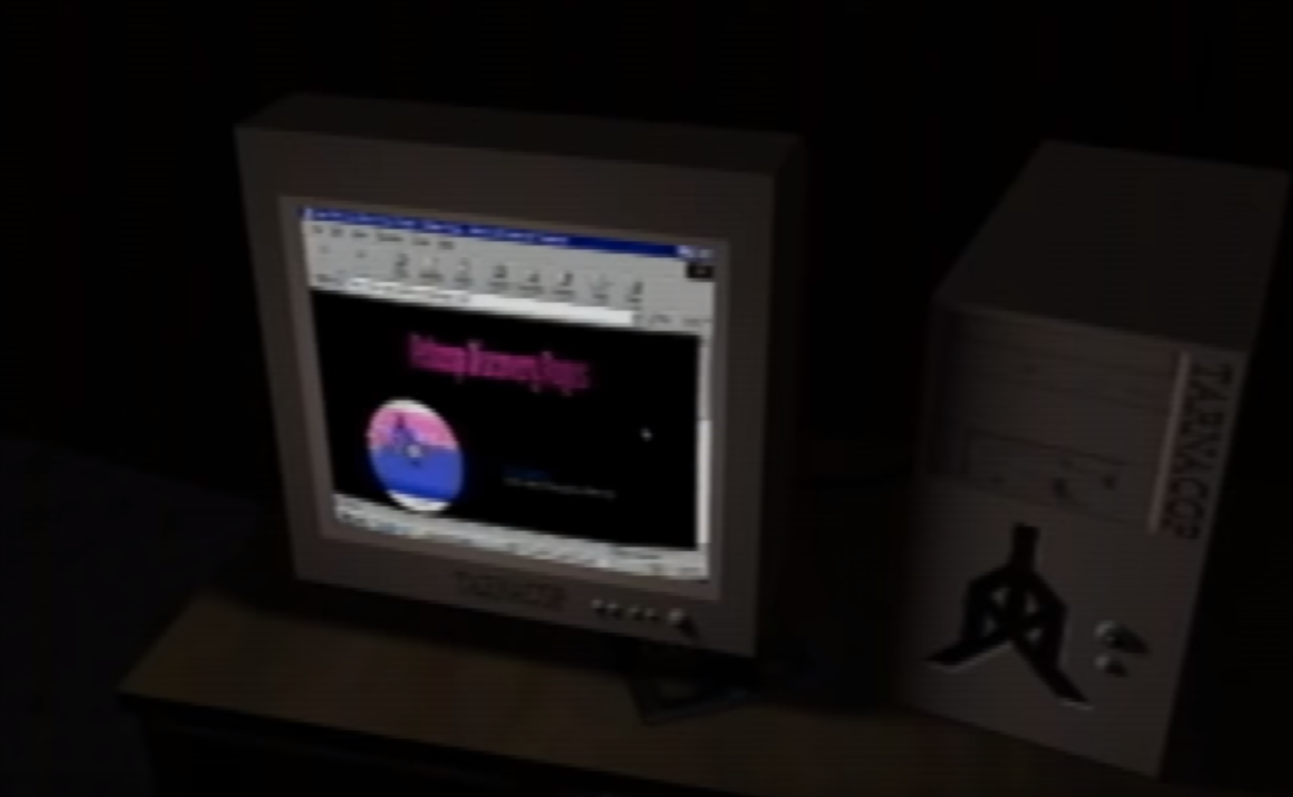

The tower case is marked with an unknown symbol, and the word “TARNACOP” is embedded onto it. The latter has been speculated to be Romanian for “Pickaxe,” while the former bears resemblance to wall-corners in Even Care. Alternatively, it has also been proposed that the symbol may be a combination of "Ice,” "Estate," and "Day" runes, possibly in reference to the “frozen house” message from earlier.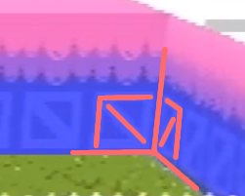

It has also been noted, that the computer resembles a Playstation Devkit, which, in turn, was sometimes referred to as “TOOL.”

There seems to be a jewel CD case underneath the right hand side of the monitor. A keyboard can be seen under the top surface of the desk, but no mouse is present.

The computer appears to be running a version of Windows 98, with Internet Explorer open.

Paul recognises the open page as “The Website.” This is presumably a callback to the note in Petscop 1: “*Please go to my website on the sticker.”*  The website appears to be titled “Petscop Discovery Pages.” (The Discovery Pages are referenced earlier in the episode: “Where is the disk? Where are the discovery pages?”)

*(To the right: a potential reconstruction of the title)*

Paul recognizes a section of the site as the “Your Child page.” He also states that he wishes he could read it, implying he knows about some content of the website, but hasn’t found a way to read the text. An image of a Blue TOOL scrolls down the page, as Paul states that he has no idea what’s going on anymore. This could suggest that he wasn’t aware of the Blue TOOL section. The screen finishes on an image of the player character standing in front of the park bench in front of the school, as shown in Petscop 11 ([gif comparison)](https://media.discordapp.net/attachments/301463720570388481/520283400599240705/ezgif-2-dd18a1512bdd.gif).

Afterwards, Paul steps away from the computer, and spends a few seconds walking around the Garage, before leaving it.

The Garage appears again at the beginning of Petscop 16, and it’s where the player is while viewing menus and recordings in Petscop 17, 19, and 20. A large part of its interior is covered by an empty text box, and what [appears](https://media.discordapp.net/attachments/351727301396004864/506863141431541760/Untitled.png) to be a red or brown car is parked in it (this may be the same car the runs over Paul’s Guardian in Petscop 22). A fragment of this scene is also used as one of the channel’s icons.

The Garage bears some resemblance to the Flower Shack due to its shape, and the presence of similar gardening tools in a similar position.

A loading screen with a view from within the garage is shown at the end of Petscop 23, as the demo ends and returns to the title screen.

### The School

Just as the House, the School is first shown in a picture on the wall under the Newmaker Plane in Petscop 2. It appears as a three-story brick building with a large opening, a white roof, and 16 windows. An ominous tone plays when Paul examines the picture, implying that something bad happened there. The school is mentioned again in Petscop 6, when the Shadow Monster Man spells out the question “Where is the school?” In Petscop 7, Pink TOOL mentions it in the line “ALSO WANTS 1000 PIECES FOR “MACHINE BEYOND SCHOOL BASEMENT STAIRWAY.” In Petscop 9, Care NLM’s description states that “she escaped from the school’s basement.” Petscop 11 also mentions the school in Care A’s description, which states that “Care B is in the school.”

In Petscop 11, the School appears during the two demo scenes. After Marvin speaks with the player in front of a bench on the Newmaker Plane, he leads them into the school building behind them. Upon entering, a hidden loading screen displays of what appears to be a green face with the Needles Piano next to it.

In Petscop 12, when Belle finds Marvin near the Newmaker Plane entrance originally used by Paul in Petscop 2, he makes the exact same movements as in front of the School in Petscop 11.

Inside the building, the camera fixes behind the player character and can be turned and rotated to see any part of the room, unlike the fixed direction camera used in the rest of the game. The screen, however, is filled with a brick texture that limits the view to a square shape. There is also a Green TOOL on the screen, similar to a point and click cursor. As the player moves around, some objects and textures disappear at certain angles. The player also appears to be smaller than normal, especially when compared to the pieces on the ground. This could indicate that this area is unpolished, or that the character represents a small child in this scene. The interior of the school appears mostly gray with large staircases, several pieces littering the floor, and walls lined with lockers, closed classroom doors, and windows.

In Petscop 17, it is mentioned that Marvin keeps Care in the school for five months, until she eventually manages to escape.

In Petscop 20, the description of Casket 4 states that the (elementary) school is abandoned, and occupied by Marvin.

During the first demo scene, the player explores and collects pieces. The player also stops several times and the Green TOOL begins to move around the screen. Eventually the player encounters and uses a single-dial padlock placed on one of the lockers.

The dial is first turned to the left and changes directions at 39, 12, 23, 33, 29, 7, and 38. The Green TOOL then activates and continues moving the lock, changing directions at 18, 8, 14, 8, 13, 7, 12, 8, 13, 8, 12, and stopping at 2. However, based on how the lock works in Petscop 23, no numbers are actually selected.

#### First Classroom (Needles Piano)

In the second demo scene, the player finds an open classroom door. Upon entering, a hidden loading screen displays an object that looks similar to a piano with a PS1 controller inside of a ring attached to it.

The classroom itself has a green chalkboard on the wall and a desk with notepads, paper, a pencil cup, and name plate on it. Marvin stands near the desk and a small yellow house is displayed in the bottom left corner on the chalkboard. Marvin uses controller inputs to say “Play Music For Baby She Will Become Melody,” and then gives the player the Needles Piano. The player responds with “Thanks” and begins playing a song, to which Marvin comments “Lovely” twice. After a while, the player begins playing more cacophonously and the notes, notation, and needles piano turn red. Marvin types out “She Tripped And Fell And Is Lost,” and then “Stop.” The player stops and types out “Sorry.” Marvin replies “Tiara Plays Bad Music Too, Do It Right Next Time.” The player replies “Sad.” Marvin replies “OK Pall.”

—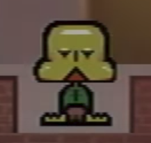

Petscop 15 features another demo recording of the school. The player character goes up the stairs, and encounters two hallways littered with pieces. In the first two attempts to walk down the left hallway, the player character is forcibly pulled back to a picture on the wall next to the staircase. The picture resembles a loading screen from Petscop 11, and the word “GiRL” (in floating, colorful text) appears in front of it when it’s approached.

The Guardian also displays an unusual face texture and has a slightly modified sprite while being pulled back to the picture. This turns out to be an older (fourth) design, as shown in Extra Stuff.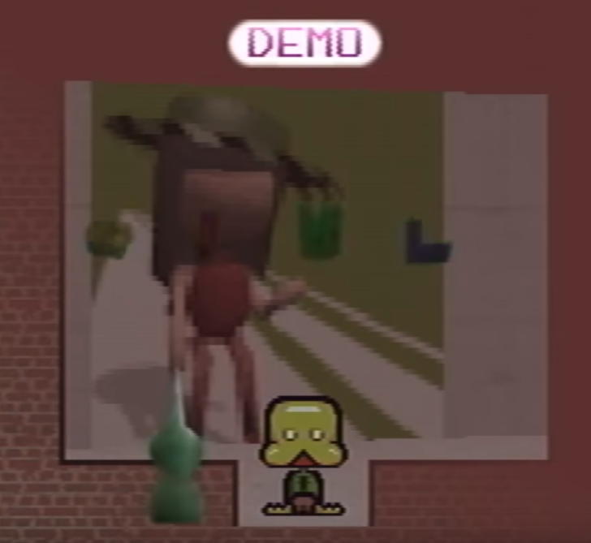

#### Second Classroom (Draw Mode)

On the third attempt at going down the left hallway, the player character enters an open door, and appears inside a classroom with Marvin standing next to a chalkboard. There are two rows of desk chairs, with one in the first row and three in the second. The player character uses the Gamepad Language, and the message “Not in Table” appears. This may be an error message resulting from an attempt to write out the name “Marvin,” which may be completely absent (including homonyms) from the game’s dictionary (i.e. a word table).

Marvin replies “Sit Here For The Present” and the player character complies. The use of the word “present” may be an intentional play on words, as it can mean “Sit here for now,” “Sit here to receive a gift,” or, considering the theories on synchronization and timelines, “Sit here to see the present, rather than the past.” After a time, Belle and Marvin emerge from behind the chalkboard and Marvin types “This Is Bell.” Belle types “I Am Tiara Not Bell” and then, once Marvin leaves, “Press Nifty.” The player character replies “What Nifty” and Belle responds “No Player One Press Nifty.”

After a brief pause, a texture editor appears and the player character uses a controllable pencil to draw random lines, and then the word “Hi” on the chalkboard texture (this may be how Pink TOOL’s messages are created). Exiting the editor reveals that the marks have all been applied to the game. It seems likely that Belle was requesting the player to press the button combination corresponding to “Nifty” on the other controller.

—

In Petscop 22, Paul reaches the School, most likely by using the Room Impulse tool (and possibly in a direct continuation of the events from Petscop 17), as the Gauge is on the screen, and a Pyramid Head is selected at the beginning of the scene. He explores the ground floor, briefly interacts with the locker, and proceeds upstairs.

He tries to explore the first floor, but just as “Pall,” he’s continually pulled towards the image of a woman in a green hat. The “GiRL” text and its associated sound, however, do not appear for him. After a few attempts he walks into the image, and enters the Game Room.

#### Game Room

The room is furnished with two chairs, a table, and a shelf. Once inside, Paul is addressed by an unidentified person (presumably the woman from the image). The speaker apologizes for pulling him out of class, and mentions his catching up, presumably on school work. This is unexpected, as, according to Rainer, the School should be abandoned. Furthermore, if Paul is playing the role of Care in this scene, it’d imply that she had schoolwork to catch up to at the age of four (almost five).

The speaker assured Paul that she only wishes to talk, and asks him to pick a board game from the shelf. His choice is between Graverobber, Checkers, Rotation, and Accident—the last one sharing its logo with the animation outside of TOOL’s Room. The Rotation box is partially obscured by a green hat, similar to the one worn by the woman in the image. After a brief consideration, Paul chooses Graverobber.

The speaker notes that the game is similar to Battleship, but she doesn’t go into details, as Paul already knows the rules. Instead she points out that he named his file “Strange situation” and asks him to confirm his name, which he corrects to “Paul.” “Strange situation” is written in an orange font, and “Paul” in a red one, suggesting that this may be the associated color of either Paul or the intended/default player.

During the game, the speaker asks Paul (or the person whose role he assumes) whether he is left or right handed. Paul seemingly doesn’t know, but the speaker concludes that he’s left-handed after a response that implies that he writes with his left hand. It’s unclear if Paul’s inputs influence the dialogue, although he did occasionally show mild confusion over left and right. Additionally, this dialogue may also be connected with the left/right reversal in the Controls.

The speaker then remarks how she shouldn’t have moved five times in a row. This is a valid tactical observation about Graverobber, however some postulate that it might be a meta-commentary about releasing five episodes on Easter 2019. The speaker also chastises Paul for using a swear word, and says that kids shouldn’t talk like this.

Towards the end of the game, the speaker comments on a “very big boo-boo” on Paul’s face. This may refer to the same thing that Anna commented on in Strange situation. She then proceeds to promise unlimited support, ranging from mundane things (“When you reach for your shoes, your shoes will be there”) to abstract or even seemingly supernatural ones (“Everything you say will become the truth”). At this point, Paul chooses to end the game, and is allowed to leave.

Paul likely plays the role of Care/Carrie in this scene, probably shortly before her escape: the events appear to continue from Petscop 17, he’s referred to as a kid, he has a “boo-boo” on his face, and the speaker’s final remark is about his finding his real house. But, as noted above, some details don’t seem to fit, such as the School being operational, or a small child having things to catch up on—this may, however, be in reference to lessons Marvin was giving Carrie after he kidnapped her.

It has been noted that if the person in this scene is indeed Care, and if the phrase “everything you say will become the truth” is taken literally, then her saying “nobody loves me” upon escaping the School may have turned true as well.

—

After leaving the room, Paul proceeds downstairs, goes down the basement stairs, and turns to the right, walking into a seemingly unfinished area (this is likely a reference to the Note and Shadow Monster mode). In response, the game slowly pans the camera to the left in a stuttered motion.

In Petscop 23, “Pall” ascends a staircase to the second floor, and arrives in a small reception area with a Garalina logo behind the counter. He then turns to the right, and enters the Computer Room.

#### Computer Room

The room features a colorful alphabet texture on the floor, with a christmas-style tree made out of Pieces standing near the middle, a TV screen displaying “Petscop Kids” at the far side, and eight computers along the walls, each paired with a numbered door.

The alphabet on the floor is likely the source of letters spawned by Shadow Monster Man near the Windmill. The letter ‘O’ is covered by the Piece tree, and may be missing—if so, it’d explain why a Child Library rug pattern had to be used instead. The last few spots after ‘Z’ are filled with symbols: two down arrows, one right arrow, and an X-like shape (possibly “start”). Those may be connected with the code from the Note, or a similar sequence hidden in the green calendar.

“Petscop Kids” on the TV may imply that this was the original title of the game, or that the screen is set to the Book of Baby Names.

The computers appear to be the same model as the one in the Garage, including the TARNACOP chassis. The one paired with door #7 appears to display the inside of the Windmill, while the others display a rotating Garalina logo (possibly symbolizing cycling through Generations).

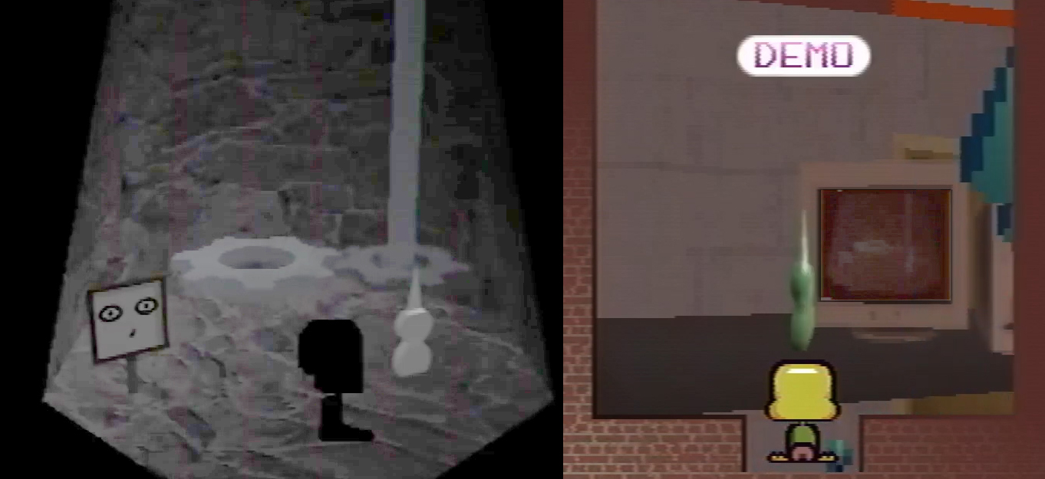

*Comparison of the Windmill (Pieces removed) and screen #7, enhanced for clarity*

The doors behind the computers most likely lead to the eight Ghost Rooms visible in the Surveillance Room. The entire setup may indicate that Petscop can have up to eight concurrent players.

The room itself may be the headquarters of Garalina, as indicated by their logo in the reception, and also on the loading screen shown when entering the area. If so, it’s unknown if Garalina was actually located in the School, or if it’s only there in the game.

“Pall” explores the room briefly, and uses his Green TOOL on the tree to obtain 26 Pieces, which brings his total to 500. The tree disappears, the room darkens, and the computers turn off, although the TV stays on. After some brief follow-up exploration, he proceeds to the Surveillance Room.

#### Third Classroom (Surveillance Room)

The Surveillance Room features Casket 4 (blackboard with red text that’s censored on close-up), school desks, and eight numbered screens (or images) along the walls. Each screen appears to show a different Ghost Room, and likely corresponds to a computer and a door in the Computer Room.

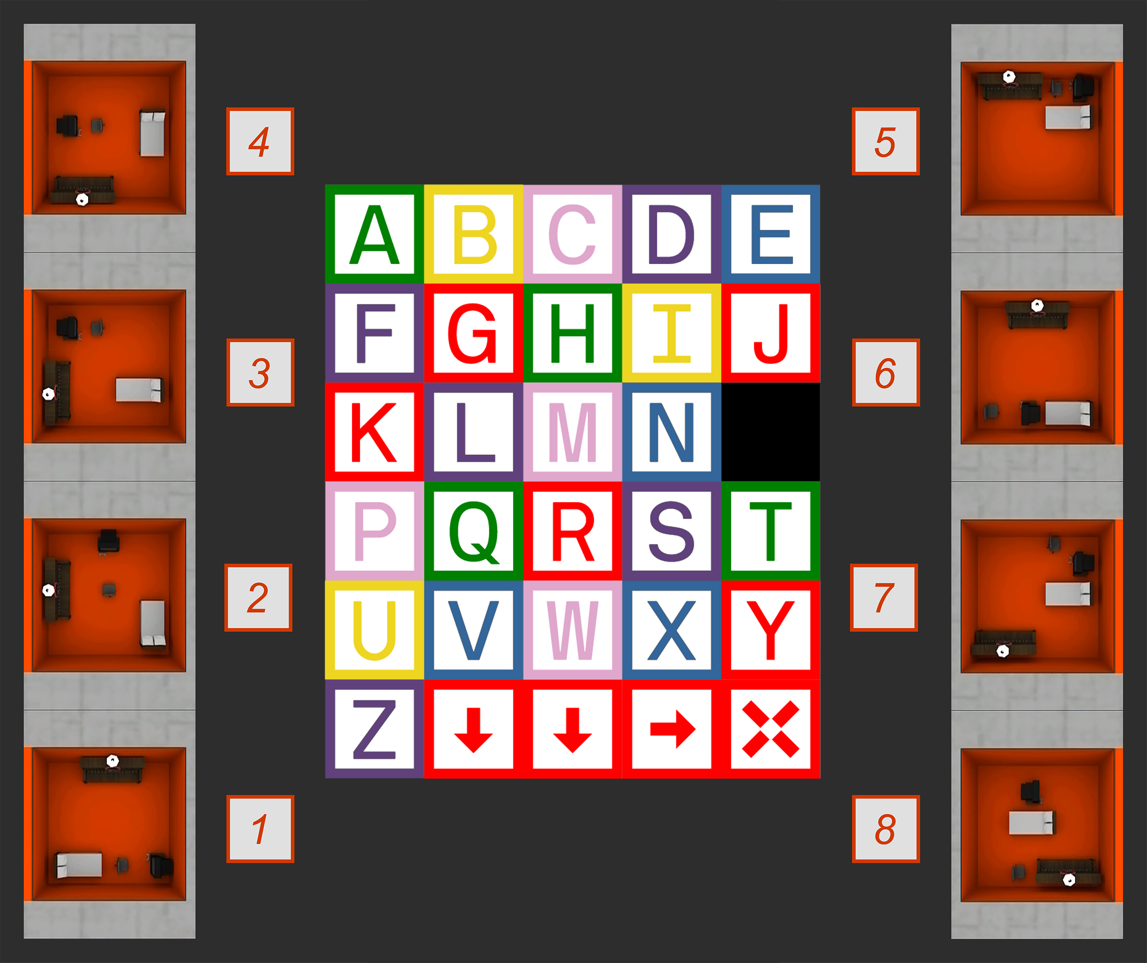

*(Speculated layout of Ghost Rooms around the Computer Room)*

Shortly after entering the room, “Pall” examines the Casket. Once he’s done looking, Marvin is also inside, and asks which room “Pall” is in. After examining each screen, “Pall” makes circular motions to indicate screen #1, which portrays the same Ghost Room as seen in Petscop 16. Marvin replies with “here I come,” to which “Pall” responds with confusion (“what”) and protests (repeated “no”). Even though Marvin stays motionless (possibly indicating that he’s taking action in the real world), “Pall” stops typing in the middle of a word (he manages to type “da” before stopping) and takes no action for an extended amount of time.

Notably, when “Pall” is looking at screen #1, a message created with Draw Mode is displayed for a single frame:

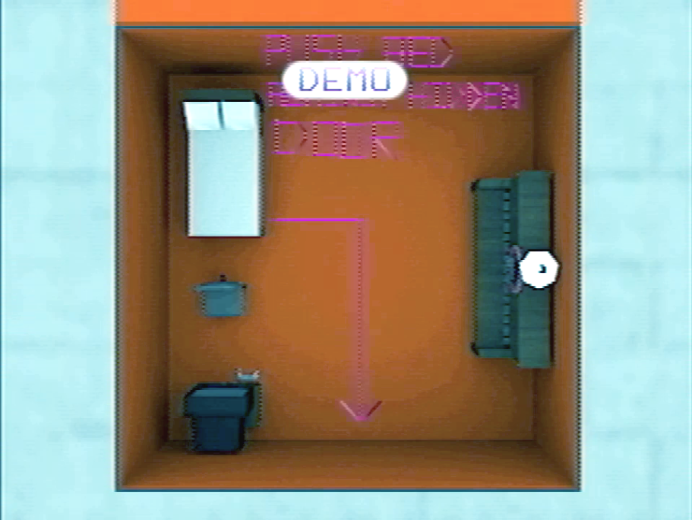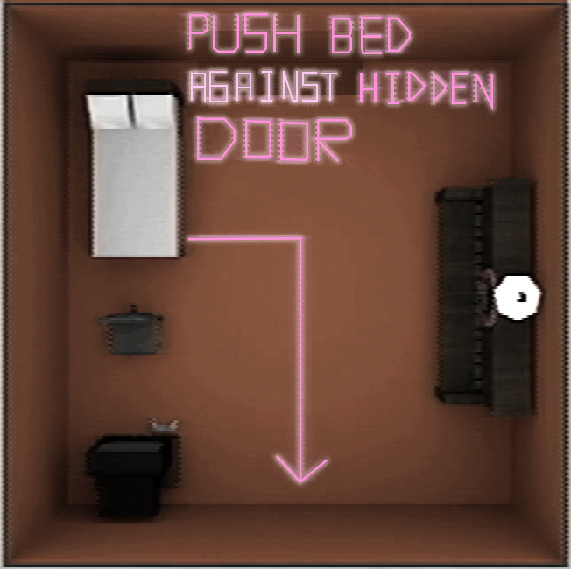

The message reads “push bed against hidden door,” and is most likely written by Belle, presumably so that “Pall” can prevent Marvin from entering. (Interestingly, room #4 already has a bed in that position.)

Eventually, Marvin leaves and “Pall” becomes active again. Shortly, Belle enters the classroom, and expresses her sympathy (“I’m sorry”). “Pall” asks her for help, to which she responds by using Draw Mode to write “9 2 19” on the blackboard (which is also the day on which Petscop 23 was uploaded). They both leave.

—

“Pall” goes back to the ground floor, and uses the numbers from Belle to open the padlocked locker. Inside, he finds a Your New Life letter from “Mommy” to Tiara Leskowitz and a pink-and-purple-striped egg (most likely a remnant from the attempt to turn Belle into Tiara). He then descents to the School Basement, where he goes straight, and enters the Pit.

#### The Pit

The room consists of a large rectangular pit in the middle, surrounded by five objects: a box of crayons, a can of Playdoh, a picture of a child (possibly Carrie), a miniature red building (possibly the School, and made out of Legos), and a traffic cone. A sign in front of the Pit provides some insight into the purpose of the room:

You'll find the machine up ahead.

This is the only entry or exit. You will pass through this room again as you leave.

Keep in mind: everything here, your baby will see.

“Pall” proceeds to push three of the items into the Pit, after with just the traffic cone and Playdoh remain. This triggers the door on the left to open. Beyond is a small space where he finds and captures Care B. He then checks her description, which seems to describe her capture, and may imply that Rainer went grave digging. Afterwards, he leaves the room through the upper exit.

Some of the items found in the Pit—Playdoh and the crayons—overlap with those seen in the Child Library. Combined with the text from the sign, this may indicate that whichever two items remain, will later appear on the table in the Child Library room of the “baby” from the Machine.

#### The Machine

The room is heavily tinted red, and hosts a large device with an input chute similar to the one outside Child Library. When “Pall” enters, Belle and Marvin are already there. “Pall” walks up to the Machine, and deposits his 500 Pieces into it, which then float along the right column. This also causes his Green TOOL to disappear. There’s a seemingly identical number of Pieces already present on the left side, most likely provided by Belle. Judging by the implied combined total of 1000 Pieces, and by the location of the room (“beyond School Basement stairway”), this is most like the Machine mentioned by Pink TOOL.

Marvin commands “Pall” to put a “baby” into the Machine to which “Pall” responds by depositing Care B into it. Marvin then tells “Pall” to play the Needles Piano and spawns it for him. “Pall” begins to play, but he doesn’t play the required melody (possibly on purpose). Marvin becomes agitated, swears, makes a futile attempt at taking the Piano away, and leaves the room.

Once “Pall” finishes playing, the Machine outputs a yellow-and-red-striped egg (the colors associated with Paul (or a default/intended player) and Care). “Pall” picks up the egg, and checks its description in the Pet menu, where it took the final slot:

? You should start thinking about that.

This is a fragment of Amber’s description, suggesting that the egg may be bugged, possibly due to “Pall’s” botching the procedure. “Pall” leaves the room and heads upstairs.

The events that take place in the Machine room are strongly reminiscent of the procedure described by Belle’s Captor in one of his messages to her.

—

After leaving the Basement, “Pall” proceeds to place the egg in the ground floor locker. He then exits the School, and approaches the bench outside of it. Moments later, the sky over the Newmaker Plane turns blue and the game fades to white. A 3D rendered view from inside the Garage can be seen for a few seconds, and the game seemingly reboots back to the title screen. It’s possible that this signifies the end of “Pall’s” playthrough.

### Road Map and Places

In Petscop 20, in the Gen. 8 recording, Marvin descends to a previously unseen area under the Newmaker Plane. In there he encounters a room labeled as “Road Map,” with the (unfinished) Caskets in it.

This may be a place akin to a Developer’s Room, featuring behind-the-scenes information and insights. At the time of Petscop 20, the Caskets are unfinished, so it’s possible that Road Map was meant as a showcase of upcoming content.

Past the Caskets, Marvin encounters another sign, one that reads “Places,” which is then followed by four screens. Those depict an outside view of the Party Room, the House, the School, and the Windmill. Notably, only the latter three are accessible for Paul, while the path to the first one (and to the Caskets) is blocked by a wall. Marvin, on the other hand, doesn’t have the bridge leading into the Office.

### Brick Building

After the secret code is entered in Roneth’s Room, the outside of Even Care appears to be replaced with a brick building. In Petscop 20, Rainer asserts that it’s a simplification of a real world place that should be familiar to Marvin.

## Game Mechanics

### Pieces

Pieces (called “money” by Paul in Petscop 1, and “Pieces” in Petscop 7 (see below)) are the floating collectibles found throughout the game (including the Secret Game). In Petscop 7, Pink TOOL tells Paul that Marvin wants 1000 “pieces” for “machine beyond school basement stairway.” Petscop 23 confirms that the “pieces” referred to are the same collectibles Paul has been collecting since Petscop 1.

In the Sound Test menu, three of the sound effects are named “Piece 1,” “Piece 2,” and “Piece 3,” which are likely the sounds played when the Pieces are collected.

In Petscop 23, “Pall” puts 500 Pieces (possibly the maximum amount a single player can obtain) into the Machine. The remaining 500 were most likely provided by Belle. It’s likely that activating the Machine is the main, or even only, purpose of the Pieces.

Notable observations about piece counts:

* The Demo Guardian in Petscop 9 starts with 0 pieces, making it unlikely for it to be Paul or Belle—but not Marvin. It collects 16 pieces in Odd Care, which are then missing during Paul’s visit there.
* Paul receives 50 Pieces for dismantling the Piece machinery in the Windmill in Petscop 9.
* The School Demo in Petscop 11 starts with 394 Pieces—the exact amount Paul has at the end of Petscop 14. The last time the counter is seen, it displays 425 collected Pieces, and there are 19 uncollected ones on the surrounding floor.
* Even though Paul collects the Bathroom Pieces twice in Petscop 11, they only count once towards his total.
* In Petscop 13, Paul receives 15 Pieces for dismantling the Piece device on the table in the Living Room.
* In Petscop 14, Paul collects the Master Bedroom Pieces multiple times, but they only appear to save after he manages to unlock and enter the Garage door.
* In Petscop 15 Demo, the Guardian begins with 444 Pieces, and no uncollected pieces can be seen on the ground floor of the School—this indicates that this Demo likely happens shortly after the one from Petscop 11.
* In Petscop 23, “Pall” receives 26 Pieces for dismantling the Piece structure in the Computer Room

The teal, cone-shaped Piece is featured more prominently than the others. It’s visible next to the Piece counter, it’s the subject of one of the hidden loading screens, it tops Lina’s grave in Petscop 17, and there’s a large structure of the same shape in the Computer Room with regular teal Pieces floating around it. Its general shape is also similar to how Lina is portrayed inside the Windmill. Its usage may be a motif for Lina.

The green, gem-like Piece is similar in shape and color to Marvin’s head.

The Pieces are sometimes found as complicated contraptions atop other objects:

* In Petscop 9, they form a complicated machinery on the cogs inside the Windmill, with a translucent depiction of Lina slowly rotating above it. This construction appears to turn the Windmill backwards.
* In Petscop 11, they’re placed on top of the devices (possibly a speaker and a microphone) on the table outside of Care’s room.
* In Petscop 23, in the Computer Room, multiple teal Pieces float around a large glitching model of similar shape. The overall appearance is reminiscent of a Christmas tree. Disassembling it turns off the lights and computer screens in the room.

### Shadow Monster mode

Shadow Monster mode is an alternative, black-coloured state taken upon by the Guardian, Marvin, and the Windmill camera. It alters the behaviour of the game, and possibly puts parts of it in a state based on the events from 1977. It’s mentioned for the first time in Petscop 1, by the Note Paul found with the game.

In Petscop 4, Paul encounters a black camera pointing at the Windmill. The camera is later red in Petscop 6, and it appears that it can only film the Windmill while in the former state. Therefore, the camera may have its own version of the Shadow Monster state, and if so, then its Petscop 4 appearance marks the first on-screen occurence of this mode.

In Petscop 6, Marvin uses the state to enter and interact with the Windmill. Afterwards, he manages to spawn multiple game objects (including Toneth), but it’s unknown if that ability is an aspect of the Shadow Monster mode.

In Petscop 9, Paul finds a way of applying the state to his Guardian by walking down the Flower Shack stairs and turning right (thus clipping through the wall) just before reaching the bottom. The staircase applies a darkening effect to the character sprite, and clipping out of it likely prevents the game from clearing it—which also explains why reentering the stairs restores the original appearance. Paul proceeds to use the mode to enter the Windmill, which he previously couldn’t see (aside from a floating platform in its place).

In Petscop 22, Paul once again uses the mode, but his character is hit by an orange car while passing by the Tunnel. This may be connected to Lina’s epitaph, “they didn’t see her”: the driver of the car may have failed to see the Guardian in the blacked-out state, just as a real-world driver presumably failed to see Lina.

### 

### The Gamepad Language

The demo scenes in Petscop 11 reveal a feature that allows the player and other characters in the game to communicate. The game prompts the use of a controller in the second port on the Playstation in order to input a button language. The language itself appears to be [phonemic](https://en.wikipedia.org/wiki/Phoneme).

Known button combinations:

|  |  |  |  |  |  |
| --- | --- | --- | --- | --- | --- |
|  | **R2** | **R1** | **L2** | **L1** | ***N/A*** |
| **Cross** | long "u" / u:  *t****u****ne* | long "a" / eɪ  *b****ay*** | "mm" / m  ***m****ake* | "ss" / s  ***s****ip* | "ah" / ɒ  *b****a****r* |
| **Square** | "puh" / p  ***p****ut* |  | "nn" / n  ***n****ew* | "zz" / z  *fu****s****e* | short "a" / æ  *c****a****p* |
| **Circle** | "tuh" / t  ***t****urn* | long "e" / i:  *b****ee*** | "rr" / r  ***r****oad* |  |  |
| **Triangle** | "buh" / b  ***b****ook* | short "i" / I  *k****i****ss* | "luh" / l  ***l****ook* | "sh" / ʃ  ***sh****ut* | "aw" / ɔ:  *c****a****ll* |
| **Left** | "th" / θ  ***th****eme* |  | short "u" / ʌ  *b****u****ck* |  | short "e" / e  *b****e****t* |
| **Right** | "dh" / ð  *o****th****er* | "pu" / p + ʌ  **†** |  |  |  |
| **Up** | "ff" / f  ***f****ast* | long "o" / əʊ  *c****o****al* | "y" / j  ***y****es* |  | long "i" / aɪ  *t****i****me* |
| **Down** | "vv" / v  ***v****ery* |  | "hh" / h  ***h****at* | "kuh" / k  ***c****ash* | "a"  ***a****m* |
| **Start** | "duh" / d  ***d****oor* |  | "wuh" / w  ***w****ind* | "ch" / ʈʃ  ***ch****ime* | "uh" / ə  *b****u****n* |

***† =*** *This sound is using a combination of "p" and "ʌ" as a single sound.*

For a phoneme combination list (i.e. words), along with all instances of their use, [see the Long Lists Appendix](https://docs.google.com/document/d/19eERbg8QtQwGzX-bC20HeM-teT3mcjQEeNaHFyMSgps/edit#heading=h.4pd72oye423h).

"Not In Table" is an error message, resulting from entering a combination that does not correspond to a word in the dictionary table. In Petscop 15, the player types out a combination corresponding to "Marvin", but it results in the error because it's a proper name and doesn't have any homophones that are regular words. In Petscop 23, an incomplete combination that starts with "da-" also produces this message.

The inputs don’t appear to be case sensitive. An interesting note is that there are 45 button combinations, meaning a standard alphabet system would also have been possible. However, there are also 44 phonemes in the English language, meaning phonemics could’ve been chosen over the alphabet as a better fit to the button mapping. There also appear to be rare mistakes present in the code, where a superficially similar phoneme is used instead of the expected one.

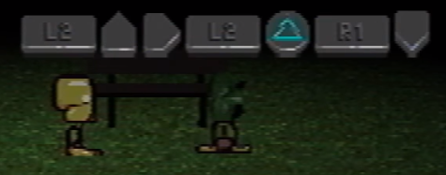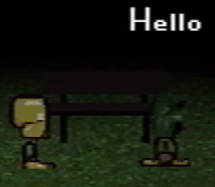

Seeing as Marvin didn’t use this system before to communicate with Paul, it’s possible that it’s only available in some versions of the game, or that its use needs to be unlocked.

Different characters seem to use this system at different speeds, with Marvin being the fastest, “Pall” the slowest, and Belle somewhere in the middle—this may be indicative of their experience in using it.

Each character also makes a different sound while sending a message. Marvin’s sound is derived from a sound effect of a dog bark, while Belle’s is from a bell.

The Sound Test menu appears to refer to the chat messages as “Marvin Message,” “Belle Message,” and “Care Message.” The last one possibly refers to “Pall”’s chat sound, indicating it may be representative of or intended to be Care.

It has been noted that a combination of phonetic spelling and dictionary lookup is characteristic for phonetic lettering systems, such as Japanese Hiragana.

### Draw Mode

In Petscop 15, Belle tells the player to press “Nifty.” When they type it out in the Gamepad Language she directs them to the Player 1 controller. Presumably, she requests them to press the same inputs that would spell “Nifty” in the phonetic language, but on the Player 1’s controller. Upon activating “Nifty,” a screen with texture files is presented to the player. The player is then able to use a pencil icon to draw pink lines on the textures.

This texture editing is similar to how Pink TOOL writes in Petscop 5 and 7. It’s possible this is how a character is communicating to Paul through the Pink TOOL (the text may need to be written specifically on the chalkboard texture).

Draw Mode is presumably used again in Petscop 23, in the Surveillance Room, to write "PUSH BED AGAINST HIDDEN DOOR" and draw an arrow on the Room #1 texture, and later to write the locker combination on the chalkboard. Both messages are most likely authored by Belle.

**Mapping**

[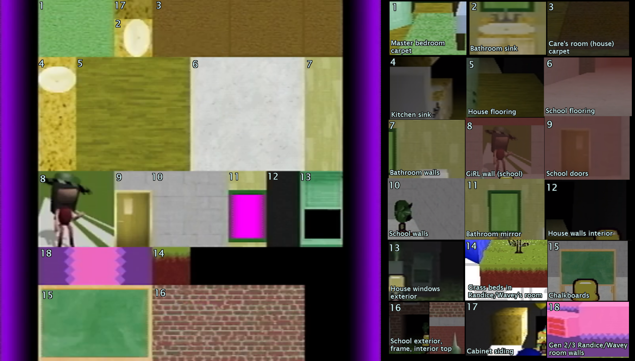](https://vignette.wikia.nocookie.net/petscop/images/e/e2/Texturemap-v2.png)

*Click the image to access a full-size version.*

### Demo

Throughout the series, starting from Petscop 9, footage labeled as “demo” can be seen. In many cases it doesn’t seem to feature Paul’s own gameplay, although it does synchronize with it on multiple occasions.

In Petscop 13, a dialog box suggests that the game is a “growing organism,” and may be collecting player inputs. In Petscop 14, Paul confirms that he’s aware of the demos, that some of them are of his playthrough, that the game appears to decide on its own which demo footage to show, and that discrepancies occur (e.g. lack of music and different messages in Petscop 13). He also mentions that he doesn’t know how new content (presumably his birthday conversation) is added to the game, as it’s stored on a CD-R (i.e. effectively read-only) disc. (However, while data stored on a CD-R can’t be changed, it can still be appended.)

Furthermore, he discovers that normally-closed doors may be in an open state in the demos, and that a demo copy of his character (a replay of his inputs) can be used to perform actions in otherwise unavailable areas. Marvin may also be using this technique in Petscop 8.

The Demos appear to be input recordings played out in specific Generations—often not the ones where the inputs are taken. The “Demo Rot.” setting in All Recordings likely controls which recordings can be used for Demos.

The board game Graverobber appears to follow a similar principle as the Demos: movements made on one board are also executed on the other one.

**List of Demo Footage**

* Petscop 9, features an unidentified player who walks on the treadmill in Odd Care
* Petscop 11, two demos of “Pall” in the School
* Petscop 12 is entirely a demo of Belle
* Petscop 13 is entirely a demo of Paul, including a voiceover—though it is revealed in episode 14 that it is a playback of inputs from a lost piece of footage, with the voiceover added in editing
* Petscop 14 opens with a demo sequence featuring Marvin, and later shows multiple demo clones spawned by Paul’s attempts at using recorded inputs to investigate the House
* Petscop 15 is entirely a demo set in the School
* Petscop 22 features a brief Demo with the Clock sequence
* Petscop 23 is entirely a demo set in the School

### Generations

Petscop 17 introduces the term “Gen.” which is believed to stand for “Generation.”

Generations appear to be different versions (builds) of the game. They differ in the textures and sprites used, map layouts, and object (e.g. door) states. Older Generations may also have bugs absent in later ones. Inputs recorded in one Generation can be played in another, which is often the case with Demo footage, and can be manually achieved with the hidden part of the Sound Test menu. There are fifteen Generations shown to be included in the game. The term “Generation” is also characteristic of genetic algorithms, although it’s currently unclear whether it’s an intended connection.

According to the list of all recordings, the game is cycling through all fifteen Generations, ascending from Gen. 1 to 15, and then resetting back to 1. This cycle has been speculated to serve a purpose, such as rebirthing, or creation of a digital copy/version of a person.

The fifteen discs on the nightstand in the Master Bedroom may represent the fifteen Generations. If so, then the eight disc being distinguished could signify that the Demo takes place in Gen. 8.

It’s possible that the Generation can advance during a playthrough upon a specific trigger. This may be signified by the chorus-like music. If so, then it happens twice thus far: in Petscop 9, when Paul enters the gift box, and in Petscop 14, right before the Strange Situation.

#### Notes about specific Generations:

Gen. 1: Uses an old Guardian sprite with hair (iteration 6), and appears to be a test for Z-sorting (i.e. the order in which objects are rendered in a 3D space in relation to the camera).

Gen. 2: The old Guardian sprite is still in use. Even Care is at least partially implemented, but it uses simpler textures. The Guardian can clip-through the walls (no implemented collision). An easel (possibly related to Toneth) can be seen in the small corner room with the painting, and a large easter egg is placed in Randice and Wavey’s room. Mike is the only known player of this Generation during the first cycle.

Gen. 3: Newer textures for Even Care are used. This and the next two Generations have numerous players (including Mike, Care, and Belle), suggesting gameplay tests are taking place.

Gen. 4: Amber’s room has the same Z-sorting glitches as the ones seen in Petscop 13 Demo.

Gen. 5: The CAUGHT after capturing Pen Z-sorts incorrectly with the floor piano. This is the last Generation played by Mike, indicating that it was made in 1995 at the latest. It’s probably the last Generation to not include the Newmaker Plane—Petscop is likely still a regular game at this point.

Gen. 6: The Garalina logo is rotated 45 degrees (1/8th of a circle) clockwise. Gen. 6 features the secret code from the Note, and the Newmaker Plane. Left/right controls are flipped, and cannot be changed. Marvin is the very first one to play it, and the only known player during the first cycle. Gen. 6 is likely what Rainer began developing in 1996 “for Marvin.”

Gen. 7: Rainer works on it on July 10, 1997. It contains dialogue messages for Marvin and gives him his speed up.

Gen. 8: It is made after Carrie’s escape from the school and return home. Contains multiple areas beneath the Newmaker Plane, including Road Map, Places, Mike’s Grave area, and TOOL’s Room. In the third cycle it’s also the first generation saved on the memory card, suggesting that this may be Paul’s starting Generation—however, Paul doesn’t have the passage to Road Map, and instead has one leading towards the Office. The Garalina logo is in a vertical, 12 o’clock position.

Gen. 9: Possibly the Generation of Odd Care.

Gen. 10: Featured in Room Impulse in Petscop 17. Possibly the Generation of Strange Situation. The Garalina logo is rotated 45 degrees counterclockwise.

It’s possible that the Garalina logo rotates 22.5 degrees (1/16th of a circle) counterclockwise for every Generation.

Gen. 15: The final generation. All recordings from Gen. 15 are labeled as “family.” Afterwards, the game seems to reset to Gen. 1.

### Sound Test Menu

In Petscop 17, the player opens the Sound Test submenu that contains an image of a hand holding an orb (similar to Pen’s), and a long list of all sounds from the game. Many of the sounds are named “????,” which may indicate that they’re empty, or that the sound is unnamed, or that it isn’t unlocked yet. There’s a total of 135 sounds or sound slots on the list—the player can’t scroll it any further.

The player scrolls down to the bottom of the list, and enters a code by repeatedly playing the last two sounds: “Care Says ‘Uh-oh’” and “Care Says ‘Bye-bye.’” The latter of the two is played a total of 366 times—this may be the required amount, or the result of button mashing if the instructions aren’t clear. The code brings up a secret menu with three options: All Recordings, Room Impulse, and Extra Stuff.

For a list of all sounds, and associated theories, [see the Long Lists Appendix](https://docs.google.com/document/d/19eERbg8QtQwGzX-bC20HeM-teT3mcjQEeNaHFyMSgps/edit#heading=h.tz4tcrbg5kx0).

#### All Recordings

The All Recordings option of the hidden menu contains a list of 248 recorded player inputs (44 of which are on a Memory Card, and 204 on the CD). Most of the recordings appear to be named automatically, and labeled by an eight-character long case-sensitive alphanumeric code. Frequency analysis suggests that those codes are random. Once a recording is picked, the user can select a Gen. (presumably the Generation the inputs will be played out in), and set Demo Rot. (Demo Rotation—likely whether or not the recording can appear as a Demo) to ON or OFF.

The list appears to be ordered chronologically, from newest to oldest: the numbers following some of the names ascend from bottom to top (e.g. “mike4” is after “mike,” “mike2,” and “mike3”), and Marvin’s recordings are in the same order as seen in Petscop 20.

The list cycles three times from Gen. 1 to Gen. 15, every time ending on a Gen. 15 “family” video. It’s possible that the game needs to progress through all Generations in order to fulfil its goal—which is currently unknown, although rebirthing, creation of an AI, digitalization of a person, or mind uploading have all been proposed. The “family” and “family2” videos may correspond to Christmas 1997 and 2000, respectively. The ultimate purpose for the first cycle may be related to Marvin (e.g. imprisoning him in the game), while for the second one, it is likely to turn Belle into Tiara (Belle may be the only person to play during the second cycle). The third cycle may be aimed at Paul.

It is likely that this feature was the intended way of exploring the Master Bedroom—by picking a recording and Gen. the player wouldn’t need to wait for a Demo.

For a list of all recordings, [see the Long Lists Appendix](https://docs.google.com/document/d/19eERbg8QtQwGzX-bC20HeM-teT3mcjQEeNaHFyMSgps/edit#heading=h.4agd9x4ytg9p).

Notes about specific recordings and groups of recordings:

* “test5” comes immediately after “sort-test,” with no other test recordings present. This may imply that recordings can be deleted, or that some of the tests fail to produce a working recording.
* Mike appears to be the first, and initially only, tester of the game
* New players are introduced to the game during Generations 3-5 of the first cycle. During Gen. 5 in particular, there’s a large, alphabetically-ordered block of names—this implies a transition from smaller internal testing to a wider and more organized procedure.
* Since Mike died in 1995, all recordings prior to and including “mike10” are taken no later than that. It’s possible that all recordings before “marvin” take place before Mike’s death, and that it was this event that stopped the development of the game.
* Going from the bottom, the “marvin” recording is the first known instance of both Marvin playing the game, and anyone playing Gen. 6. It likely takes places after June 13, 1997 (due to the Note).
* “auto-ugu8PsPt” (Marvin’s first steps in Gen. 7) takes place after July 10, 1997
* “auto-1lTWsbyV” (Gen.8) takes place after November 12, 1997, as Rainer already knows details about Carrie’s imprisonment (e.g. that it took place at School, or about the vase incident). This and “Care-dancing-sign” are the only Gen. 8 recordings in the first cycle.
* “Care-dancing-sign” (Gen. 8), which constitutes the entirety of Petscop 21, is [synched to “The Sign” song by Ace of Base](https://www.youtube.com/watch?v=8F-S1MT-QdM) (the title of the song is also included in the video description of Petscop 21). This is the last named recording before “family” (Gen. 15). The recording likely takes place after Care’s escape, so the lyrics (e.g. “I got a new life, you would hardly recognize me, I'm so glad”) may be symbolic of her freedom from Marvin. Notably, the music video for the song features a combination of ankh (life) and djed (stability) as the eponymous Sign.
* Only four recordings in the second cycle have non-standard names: “belle4” (Gen.1), “tiara” (Gen. 13), “FUCK-FUCK-FUCK” (Gen. 14), and “family2” (Gen. 15). “Tiara” may depict the moment when Belle’s Captor “calls her Tiara prematurely,” and “FUCK-FUCK-FUCK” may be when he realizes the mistake. Belle is likely the only player of this cycle, which purpose may be to transform her (in an unspecified sense) into Tiara.
* Starting from “auto-6wC4CK5r” (Gen. 8, third cycle) all recordings are marked with a memory card instead of a disc. It’s possible that this marks the beginning of Paul’s playthroughs, and that his recordings are stored on a card, as his console doesn’t have the capability to burn discs. Previous playthroughs may have used a device with such a feature, or the recordings may have been periodically moved from memory cards to the disc.
* The third cycle appears to be complete at the time of Petscop 19. This is unexpected, as, judging by the Piece count, it is Paul who operates this menu, and the events depicted in School Demos are yet to occur.
* The first half of Petscop 22 uses footage from recording “auto-b4yw0bHt” (Gen. 8). Based on the dialogue, Paul didn’t originally record the footage, hence a recording had to be used instead.

#### Room Impulse

In Petscop 17, the Room Impulse option is picked from the hidden menu. This reveals a selection of locations:

* anna-office (appears to be the Office)
* cellar (appears to be the first area Paul visits under the Newmaker Plane in Petscop 2—the one with a furnace-like device)
* Sort-test- (appears to be the same Z-sort test as seen in the “sort-test” (Gen. 1) recording)
* gift-plane (Gift Plane entrance)
* grave (Mike’s grave)
* hallway1
* hallway2 (part of Places)
* house (the same view of the House as seen in the Burn-In Monitor)
* house-bath (the Bathroom)
* house-gara (the Garage)
* level1-room (Even Care lobby)
* level1-room (Even Care corridor)

With the exception of “sort-test,” the list is alphabetical, so there are likely additional options beyond what is shown.

The “house” is selected, and followed by a choice of Generation that’s set to 10. This loads a view of the Living Room in the birthday party state previously seen in Strange Situation (this indicates that the party may be associated with Gen. 10). Multiple Pyramid Heads, often semi-transparent, can be seen walking around the room, and a gauge (the same one as seen in Burn-In Monitor) is placed in the corner.

The user can rotate the gauge, and each of its sixty positions is associated with a different Pyramid Head—although only about half of the positions are occupied (the gauge becomes highlighted when an occupied position is selected). Only Pyramid Heads within a few clicks from the current setting are visible. If the current setting corresponds to a Pyramid Head, that Pyramid Head can be selected, which turns it into a Guardian, and makes all other Pyramid Heads disappear. It’s possible that the selected character becomes controllable.

Notably, the arrow of the gauge remains stationary, and the shield beneath it rotates instead. A similar behaviour is previously observed with the minute hand of the Clock in Petscop 11. Since both the Clock and the gauge have 60 distinct positions, there might exist a further connection between the two.

Room Impulse bares visual resemblance to genetic algorithms, which often feature multiple specimens attempting to navigate a task. The term “generation” is also characteristic for such approaches, but it appears to have a different meaning to Petscop (one more akin to “build” or “version”). Alternatively, Room Impulse may be a feature for browsing input recordings by seeing them side-by-side in a room. However, the Pyramid Heads execute only simple, looped movements, which doesn’t align with either of those interpretations.

After multiple rotations, the gauge is set back to the initial position (which is identical to the one seen in Petscop 16, suggesting that it might be the default state), and the corresponding Guardian is selected. The Guardian then leaves through the front door (it’s unclear whether the user is controlling it).

Outside, a total of five Guardians can be seen exiting the House (however, the gauge doesn’t turn by much in this scene, so there are likely more of them in the unseen ranges), but they’re now walking backwards, possibly indicating that their actions are being played in reverse. Messages begin to appear, presumably from Rainer, which first prompt the player to wake up and inform them that they’re free (possibly echoing the first message to Belle), and then proceed to inform them that they’re Carrie Mark, and that the family wants to know what happened to them/her on November 11, 1997. Part of this information is presented as a spell, or a curse that can change the past. This may imply that the intended player—possibly Paul—is Carrie and doesn’t realize it, or that the player is supposed to take Carrie’s role for the duration of this scene, or that the player’s past really is being altered.

The Guardian walks away from the House, while the messages urge the player to remember the aforementioned day. They also mention becoming blind and walking chaotically (e.g. dodging invisible obstacles), the same way as Care during Strange Situation (Petscop 14), or as Demo characters executing recorded inputs in different Generations.

After a cut, the Guardian reaches a spot where Lina went missing, and is told the story of Marvin’s waiting for her with a slice of cake on a bench (author of the messages appears dubious of this event). Prompted by the messages, the Guardian begins walking in a circular pattern similar to the one seen in Petscop 11 (around the Tire and before). A grey text input field appears, and is used to ask “What happened to her?” In response, Lina’s grave emerges from the ground, and the Guardian inspects it.

After another cut, the Guardian finds its way under the Newmaker Plane, and eventually disappears into the car tunnel (notably, there are no Pieces to be seen along the way). The first Demo sequence in Petscop 11 strongly implies that the road past the tunnel leads to the School. It’s therefore likely that the Guardian was retracing Care’s path from the School (which she escapes from on November 10, 1997) to the House (which she reaches on her fifth birthday, on November 12, 1997). This could imply that Care finds Lina’s grave on November 11, 1997.

The second half of Petscop 22 appears to be Room Impulse footage, and may be a direct continuation from Petscop 17, as the Tunnel has been previously shown to lead to the School. If so, this would confirm that the person in control was indeed Paul. The footage depicts some exploration of the School, a visit to the Game Room, and a game of Graverobber. (See the School section for details.)

#### Extra Stuff

The entirety of Petscop 18 is spent on selecting and exploring the Extra Stuff menu. It shows images depicting development stages of various sprites, and presumed concept art.

Notes about specific images:

* 01 guardian_history—sprite development of the Guardian—the first use of the name “Guardian” in the series.
* 02 amber_history—sprite development of Amber
* 03 randice_history—sprite development of Randice
* 04 toneth_history—sprite development of Toneth—his leg isn’t broken in the oldest version.
* 05 pen_history—sprite development of Pen—the earliest four designs include legs reminiscent of xylophone sticks, and only the final one includes the white sphere.
* 06 hudson_history—unfinished sprite development of Hudson—Hudson may be an unused pet. Its designs are reminiscent of the Sun or a satellite.
* 07 wavey_jumping—possibly unused sprites of Wavey jumping as a puddle of water
* 08 gift_plane_map—concept art for the layout of the Gift Plane
* 09 the_house—most likely a simple box model of the House—it slowly rotates during the video, and is accompanied by a silent word-like sound at around 2:03

Earliest versions of the sprites in images 01-06 are all entirely black and white, and similar to how other players see Belle.

## 

## Other

### Loading Screens

#### Surface Game

*(including related recording playbacks)*

|  |  |
| --- | --- |
| **Image**  *(click to visit video w/ timestamp)* | **Appearances** |
|  | Entering the Gift Plane  Petscop 1  Petscop 20 |
|  | Entering Even Care or Odd Care  Petscop 1  Petscop 9 |
|  | Playing the first demo recording featuring Odd Care  Petscop 9 |
|  | Entering an early Generation of Even Care / opening "mike2" recording  Petscop 19 |

#### 

#### Secret Game

|  |  |  |
| --- | --- | --- |
| **Brightened Image**  *(click to visit video w/ timestamp)* | **Appearances** | **Image description** |
|  | Exiting Even Care to the Newmaker Plane after the code from the note is input in Roneth’s room  Petscop 1 | Belle’s head, obscured |
|  | Entering the door to underneath the Newmaker Plane  Petscop 2 | An overhead view of the Quitter’s Room (non-mirrored side) |
|  | Entering or leaving the grass room where Mike’s gravestone and the Flower Shack is located  Petscop 2  Petscop 17  Petscop 22 | Unknown - likely the school basement stairway |
|  | Entering the door up to the Newmaker Plane (near the Quitter’s Room) from either side  Petscop 2  Petscop 17 | Newmaker Plane grass |
|  | Entering the passageway into the Party Room, from Lina’s Child Library room  Petscop 9 | The party hat/cone shaped piece |
|  | Entering/leaving the House  Petscop 11  Petscop 13  Petscop 14  Petscop 17 | Unknown - possibly a piano with a rocking chair in front of it |
|  | Appears before school DEMO beginning with entering the tunnel  Petscop 11 | GiRL, from the second floor of the School |
|  | Entering the School  Petscop 11  Petscop 22 | A head (possibly Marvin’s) with the Needles Piano in front of it |
|  | Entering the open classroom on the first floor of the School (in the P11 DEMO, this is where the Needles Piano is used)  Petscop 11 | A modified upright piano, with a PS1 controller (surrounded by a ring) attached to it  Likely a model of the pianos in the Ghost Rooms |
|  | Entering the Garage during Strange situation  Petscop 14 | A below-map view of the dirt pillar extending under Randice & Wavey’s room in Even Care |
|  | Exiting Even Care to the Newmaker Plane after the code from the note is input in Roneth’s room in the "marvin" recording  Petscop 20 | Unknown - appears to be a dark room in similar style to Even Care, with a revolving door. Possibly a reference to the puzzle posed to Marvin in Petscop 14. |
|  | Entering a door to underneath the Newmaker Plane (alternate room) in the "marvin" recording  Petscop 20 | Unknown—appears to be a real photo of a chair or couch, with a pillow and an open box of crayons on it. The crayons appear to be of the same brand as the ones associated with Care. |
|  | Appears prior to the school basement demo recording  Petscop 23 | A head (possibly Marvin’s) viewed from the side |
|  | Entering the third floor of the School (Computer Room)  Petscop 23 | Garalina logo |
|  | Appears after the Newmaker Plane brightens in the school basement demo recording, before returning to the title screen  Petscop 23 | The garage |

### Menu Text

Throughout the game, various messages can be seen in the menu:

* We hope you are enjoying the game. *(Petscop 1)*
* Have you found anything weird lately? There is much to find in this place. *(Petscop 6)*
* Take them home! *(Petscop 7)*
* You're in the other place too! *(Petscop 9)* 
  + Possibly a reference to footage synching, or the Demo feature.
* The pets really seem to like you. Thanks for playing Petscop. *(Petscop 9)*
* I'll come out in a minute. Keep playing. *(Petscop 11)* 
  + Likely a message from Rainer to the family in regards to his bathroom visit.
* Demo Recording *(Petscop 12 ,13, and more: shows in menus during demo playback)*
* The ghost room is a ship in a bottle. *(Petscop 17)*
  + This may indicate that the ghost room is a miniature copy of a real-world place, or that it’s a means for copying or moving something (possibly the player) into the game, one piece at a time.
* Everything is a trick. *(Petscop 19)*
* There are no changes, only replacements. *(Petscop 19)* 
  + Possibly a reference to the Generations, or how the game is on a CD-R—a storage device on which the data can be appended, but not changed.
* Recording Playback *(Petscop 19 & 20; shows in menus during recording playback)*
* There is so much to discover in the world of Petscop. *(Petscop 20)*
* Your butt leaves a cavity in the chair. *(Petscop 20—shown in the double pause menu)*
* Now: *(Petscop 24)*

### The Tire

At the beginning of Petscop 11, Paul is seen wandering the Newmaker Plane. He explains that he’s following a drawing he made, and expects to find something as a result. After he makes a series of circular movements, a grey text input box shows on the screen. Paul ignores it, walks further into the Newmaker Plane, and finds the Tire.

Paul then proceeds to execute another sequence of circular movements, this time around this tire, which causes it to spin (the direction of the spin depends on Paul’s movement) and once again brings up a grey input box. He asks “where is house?” and the Tire begins spinning rapidly as a result. By following the direction towards which it spins, Paul eventually finds a road that leads him to the House.

A similar set of circular movements is executed in Petscop 17, and it too brings up a grey text input interface. It’s possible that the first instance of such motion from Petscop 11 takes place in the same spot, i.e. on top of Lina’s grave.

In Petscop 22, Paul and his friend discuss going to the real-world counterpart of the Windmill, and searching for other landmarks that could be reflected in the game. It’s possible that Paul finds the Tire through this process.

### Calendars

The first appearance of a calendar takes place in Petscop 10, after Paul asks Red TOOL about the current month and year. The reply is a red calendar, which appears to be non-interactable.

The Living Room, in all its appearances so far, features at least one of three calendars:

* The Green Calendar: 1997. Many days are marked as green, most likely representing time Care spends with Marvin. June 13 is marked with faint symbols, possibly two arrows and an X. (A similar pattern can be seen in Petscop 24 in the Computer Room)
* The Grey Calendar: 2000.
* The Red Calendar: Most likely 2017. It appears during Strange Situation, when Care seems to mimic in 1997 Paul’s words and actions from 2017.

In Petscop 20, Marvin asks Red TOOL about the current year, and is shown a non-interactable green calendar in response.

Since Paul, playing in 2017, is shown the red calendar, and Marvin, playing in 1997, the green one, it may indicate that Red TOOL either knows the current year, or that its creator manages to predict when the game is played.

The left/right navigation buttons on its interface are reversed when compared to a PS1 gamepad. Their functions, however, match with those seen in the Controls in Petscop 20.

**Interactive Calendars from the House:** <https://newdefectus.github.io/calendars/>

### Needles Piano

A purple, pyramid-shaped object given by Marvin to the player character in the classroom during the second demo scene in Petscop 11. Picking it up triggers a short jingle and the message “Play Needles Piano Now.” It is unknown how the instrument is played; no inputs are shown and the instrument appears to simply float in front of the player character. Notes played appear as purple and float up in a circle above the player. Musical notation appears as white circles and houses on the chalkboard in the classroom. The notation is in the key of C, with C being displayed as the house shape on the chalkboard (notably, the same C can also be heard in Care A’s room). A yellow house occasionally appears on the bottom or top left corner of the board while the needles piano is played, seemingly to indicate octave levels.

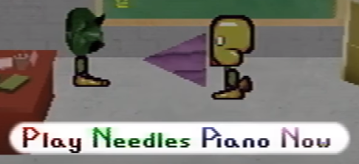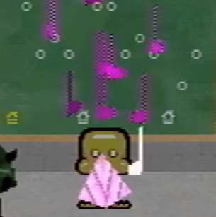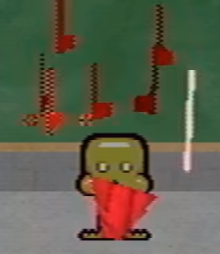

When the player character begins playing cacophonously, the notes, notation, and needles piano all turn red. Because the notes appear to turn red as soon as the player deviates from the melody, it is possible that the game wanted a specific song with precise inputs to be played. This usage of colors is reminiscent of the TOOL and the Daisy.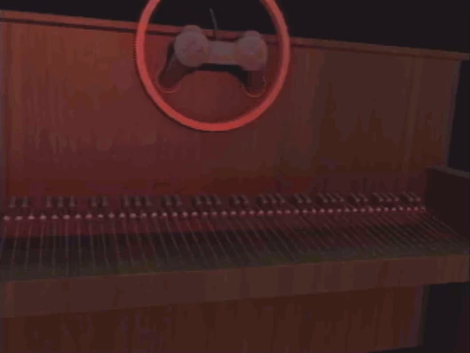

Throughout Petscop 11, multiple hidden loading screens appear, most of which feature either a Needles Piano, or a regular one. The classroom loading screen in particular seems to feature a modified upright piano: a gamepad is attached to its frame, and its keys look as if they were replaced with needles. It’s possible that the pyramid seen in the game is a placeholder, and that the intended form of Needles Piano is the one in the loading screen. Alternatively, they may both be part of a single whole, with only the pyramid being visible in the demo.

In Petscop 12, Belle’s Captor claims to have player the second movement of Stravinsky’s Septet (the music from Petscop 7) on “the Needles” as a part of a procedure through which Belle was to become Tiara. The Needles Piano may therefore be involved with rebirthing.

In Petscop 14, Paul briefly hums a melody [similar](https://clyp.it/evvlla34?token=06fda54b93013fa5223913f1bfeb8535) ([tone shift comp. version](https://clyp.it/woei20s5?token=95f90f87eec070f739cb8ee696ba1a3a)) to the one played in Petscop 11, and comments how he’s playing “this game” too much. This may indicate that he has already encountered the melody somewhere within Petscop by that point.

In Petscop 16, the Burn-In Monitor shows a room with a piece of furniture that may be the Needles Piano.

In Petscop 23, “Pall” plays the Piano (once again spawned by Marvin) in the Machine Room after inserting Care B into the chute. Considering the events described by Belle’s Captor, Marvin’s words from Petscop 11 (“Play music for baby she will become melody”), and how the latter refers to Care B as a “Baby,” it can be speculated that the Piano music is supposed to transform the person placed inside the Machine.

“Pall” plays incorrectly (possibly on purpose), and the result is a red-and-yellow-striped egg. Presumably, the purple-and-pink egg seen earlier is the result of the unsuccessful attempt of turning Belle into Tiara. It’s unknown if the Machine always outputs an egg, or if it’s indicative of a failure.

### The Clock

At the beginning of the first Demo segment in Petscop 11, there’s footage which appears to represent a first-person view from a driving car (notably, there appear to be barely visible walls on both sides). Superimposed on this view is an image of a clock, identical to the one in the House, with its minute hand unmoving in relation to the screen (the clock moves underneath it instead):

<https://cdn.discordapp.com/attachments/301463720570388481/394997805619609611/Petsclock.gif>

Taking this into account, it can be inferred that the Clock starts at 5:10, and ends at 6:15, the latter also being the approximate time of Care A’s kidnapping by Marvin.

The Clock bears some resemblance to the gauge from Burn-In Monitor and Room Impulse: both have sixty possible positions, and both have an immobile hand pointing upwards, and a shield that rotates underneath.

### Plane Parallels

There appear to be multiple parallels (or counterparts) between the Gift Plane and the Newmaker Plane.

The symbols on the white cubes that appear in the Newmaker Plane are the same as background images in Even/Odd Care, and appear to signal connections between the two:

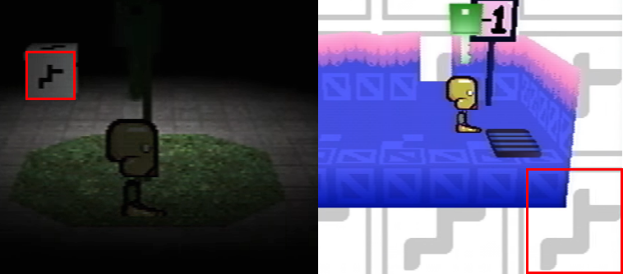

*The treadmill affects the flower petals, allowing the player to catch Care NLM.*

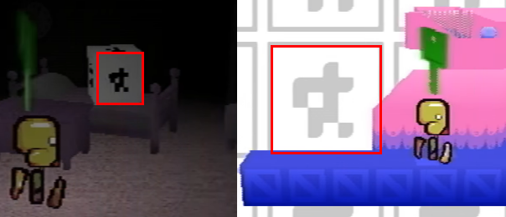

*The cage doors in Odd Care affect the sides of the Quitter’s Room the player can enter.*

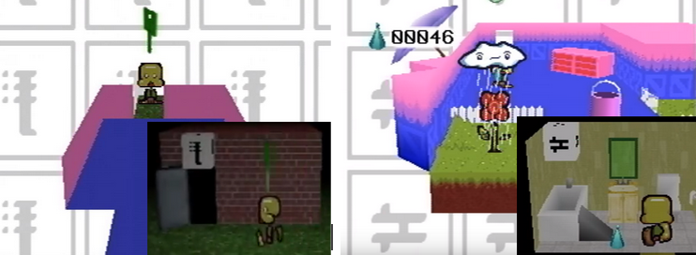

*Odd Care’s entrance shares a symbol with the building used to enter it.*

*Randice & Wavey’s room layout is similar to the House, with a bucket appearing in it later.*

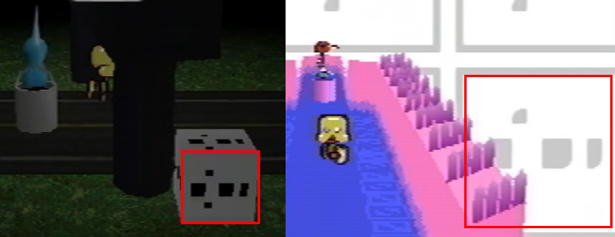

*The methods of catching the teal TOOL and Roneth both involve luring them into a bucket.*

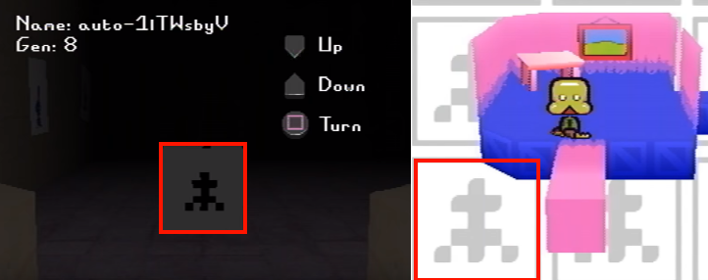

*The relation between these rooms is currently unknown, although the framed picture may be a counterpart for the* *Windmill* *camera feed (it may also portray the daylit state of Newmaker Plane first seen at the end of Petscop 23). The easel that is present in the Even Care room in earlier Generations may also be relevant.*

In Petscop 13, the gate by the road outside the House shares a model with the gate from the Gift Plane:

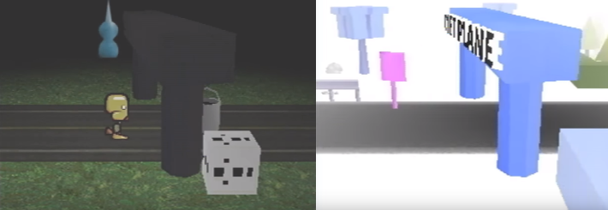

In Petscop 13, Paul acknowledges that the House and Randice and Wavey’s Room are counterparts, due to similar layouts and both having a bucket. He then proceeds to use this information to capture Roneth in a way similar to how he traps Teal TOOL outside the House.

In Petscop 14, a loading screen depicting the column of dirt from Randice and Wavey’s Room shows in the House, when Paul enters the Garage.

### Burn-In Monitor

Petscop 16 introduces a new feature, seemingly triggered by a prolonged idleness of the player. At first, the screen (accompanied by an alarm-like sound) displays a warning that no inputs have been detected for a “very long time,” and advises the reader to not turn off the console and call the provided number. The number is covered by a censor bar, but the first characters can be seen briefly:



(203) is one of the area codes for the southwest Connecticut region, suggesting that at least some aspects of the story take place there.

After the message, the view switches to a top down display of a room, labeled as “Burn-in Monitor (“ghost room” /”testing room”),” featuring what appears to be a bed, a chair, a TV, the Needles Piano, and a screen from the Living Room.

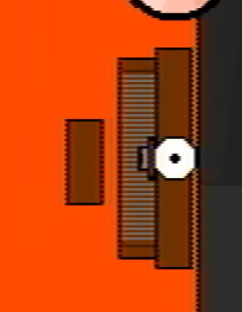

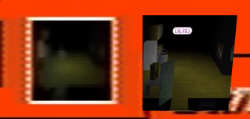

It appears that the bucket may be present in the screen, around the middle of the room (gray spot). It has been proposed that the screen represents the Playstation, possibly by portraying the currently active area.

The display also features a gauge-like meter of unknown purpose, and a quickly pulsating red dot, that’s speculated to represent either Paul or Belle, monitored in real-time by the game. Towards the end of Petscop 16 the dot moves from the bed and sits on the chair, possibly re-engaging with the game.

The name “Burn-in Monitor” may be a reference to screen savers, and how they prevent pixels from burning-in into the screen.

The gauge seen in Burn-In Monitor also appears in Room Impulse, where it’s used to switch between different Guardians. The initial and ultimately selected Guardian corresponds to the same positions of the gauge as the one seen throughout Petscop 16.

A menu text briefly visible in Petscop 17 states that “the ghost room is a ship in a bottle.” This may imply that the ghost room is used to slowly replicate something: possibly a real-world person within the game.

In Petscop 23, the Surveillance Room features eight enumerated screens (or images) portraying eight different Ghost Rooms, including the one seen in the Burn-In Monitor. The room before it, Computer Room, has eight similarly enumerated door-computer pairs, suggesting that it serves as a hub/lobby for the Ghost Rooms.

### Controls

In Petscop 20, Marvin opens the Controls submenu, where he sees an image of a gamepad with buttons labeled with their functions. The left and right buttons are flipped, similarly as on the Calendar interface. Marvin attempts to change the button mappings, but it doesn’t work.

Right before opening the menu, Marvin repeatedly runs into the walls in Roneth’s room, in what looks like failed attempts at inputting the code from the Note. He bumps into both the left wall and the right one presumably due to confusion over the flipped controls: he doesn’t know whether he should use the button that’s on the right side of the pad, or the one that moves the character right (neither works, as he’s also making a mistake in regards to the “start” button).

In Petscop 11, Paul expresses confusion over the “right-tighty, lefty-loosey” mnemonic. In Petscop 14, he briefly confuses left and right during one of his attempts at controlling the Demo character. This may indicate that the controls are also flipped for him.

### Caskets

In Petscop 20, Marvin enters an area labeled as “Road Map.” There he finds four unfinished objects called “Caskets,” which, according to dialogue placed by Rainer, can turn anyone who sees them into “family.” The Caskets are all connected with Marvin and Care’s story, and they all feature the color red prominently (see Color Theory).

The Caskets are strongly implied to be some of the censored items, and each of them appears to represent one of Care’s forms (A, B, NLM, and the unnamed form from the Flower Shack basement).

Belle’s Captor mentions that Belle isn’t family, which could imply that she hasn’t been exposed to all of the Caskets.

**Casket 1**

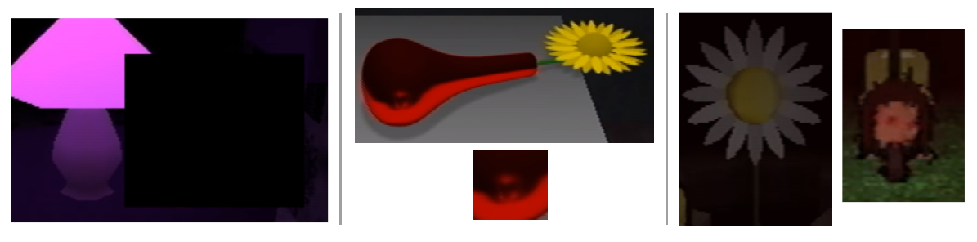

The first Casket is a red vase with a yellow flower. A blurry reflection of Care’s face can be seen on the vase, alluding to an incident in which Marvin tries to convince Care that she’s deformed.

Casket 1, or it’s complete form, is most likely the censored object in Care-with-Mike’s-Eyebrows’s Room: a slightly rounded sliver of red pixels can be seen beneath the censor bar. If said room is indeed Paul’s Room, then the Casket’s presence in it may be indicative of a strong connection between Paul and Care (see Paul and Care).

The Flower Shack bears a strong visual resemblance to Casket 1. The daisy is similar to the yellow flower, and the hole in the floor and the basement below are counterparts to the vase. Once the petals are plucked, Care’s face becomes red and distorted, akin to how she appears in the reflection.

Since this Casket is based on an event happening during Carrie’s imprisonment, and Rainer’s commentary mentions her escape and return home, the Gen. 8 section of Petscop 20 must be taking place after November 12, 1997. Rainer’s knowledge of the vase incident implies that he either is in touch with Care while he is missing (from June to Christmas 1997), or that Gen. 8 is made after his return.

**Casket 2**

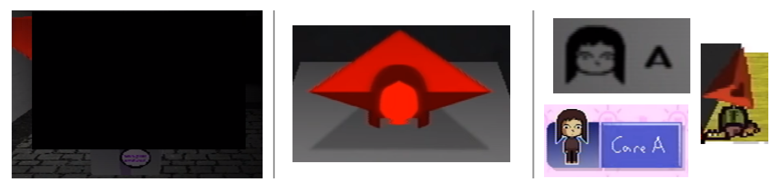

Casket 2 is a red pyramid with an outline of a face in front of it. It references an event during which Rainer is painting the House, and feels disgust upon seeing a spinning Carrie.

The second Casket is almost certainly what’s censored in the Party Room: both objects are red, tetrahedral pyramids, and one of them is literally spinning, while the other was inspired by spinning.

The outline in front of Casket 2 bears a strong resemblance to Care A’s face.

The Casket itself is also similar to Pyramid Head. If the latter is meant to represent Paul, this could suggest a connection between him and Care. Alternatively, it could also mean that Carrie is the intended player for the game.

**Casket 3**

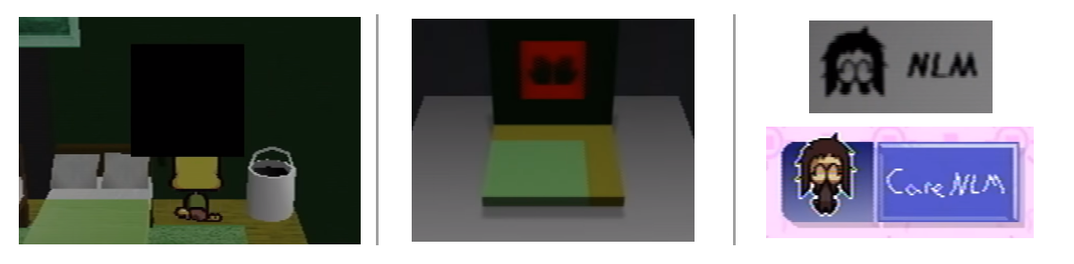

Casket 3 is a red stencil depicting a pair of hands. In the associated commentary, Rainer mentions being asked by Anna to help covering the stencils in the House. He does so using black paint (as seen in Petscop 14) on a Saturday. Anna is busy with work on that day, and she pins him a note with a list of objects. Casket 2 may be inspired by an event on the same day.

Casket 3 is the censored object in Petscop 14, made evident by the matching corner of the rug, the floor, and the wall.

The hands it depicts are likely a reference to Care NLM.

**Casket 4**

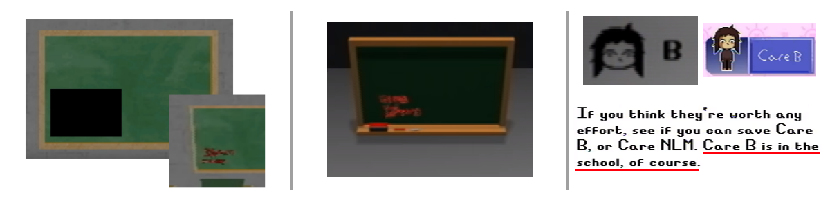

Casket 4 consists of five words written in red chalk on a blackboard. In the commentary, Rainer mentions an abandoned elementary school which Marvin inhabits.

The fourth Casket is likely what’s meant by “written on a chalkboard” in the list of censored items. Furthermore, while the words are too small to be discernable, they bear a resemblance, in both color and shape, to replies given by Red TOOL. This could imply that Casket 4 is an answer to a question, and/or that all of Red TOOL’s answers are written on chalkboards, and copied from them when needed. If so, then Pink TOOL’s answers may be the result of editing a blank chalkboard texture with Draw Mode.

The five words may be the same ones as on one of the pages in TOOL’s room:

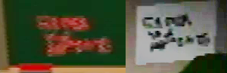

This may indicate that the pages contain transcriptions of Red TOOL’s answers, and would further connect Casket 4 with Red TOOL.

In Petscop 11, Care A’s description mentions that Care B is in the school. Seeing as the remaining three Caskets have clear connections with the remaining three forms of Care, and how similar chalkboards are also found in the School, Casket 4 is likely to have a connection with Care B.

Casket 4 makes an appearance in Petscop 23, in the Surveillance Room, where it’s only censored while zoomed in. Interestingly, it seems to be flipped when compared to its Petscop 20 occurrence:

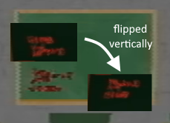

### Board Games

In Petscop 22, Paul encounters a shelf with four board games in the School:

* Graverobber (see below)
* Checkers
* Rotation
* Accident, which shares logo with the animation in front of TOOL’s Room (it may be a simplified depiction of a car accident, possibly the same one as seen in Petscop 22).

#### Graverobber

Graverobber is a two player game similar to [Battleship](https://en.wikipedia.org/wiki/Battleship_(game)). Each player has a board (similar to a chess board) on which they place a windmill and three graves. Once the boards are ready, the players take turns navigating them with their pieces: one on their own board, and one the opponent’s board (there are four pieces in total, two for each player). The goal of the game is to dig up the other player’s graves, which requires figuring out the layout of their board.

*(See the* [*Graverobber Appendix*](https://docs.google.com/document/d/1crl-4Ib14XBU-7mottJJwLYVnySudZfCp1GLnupQGwo/) *for detailed rules and a printable version)*

The game bears some resemblance to the Demo mechanic used by Paul is Petscop 14: the player moves their own piece on their own board, and their piece on the opponent’s board attempts to replicate that movement, but might be stopped by unseen obstacles.

The windmill used in the game looks the same as the Windmill found on the Newmaker Plane.

The three graves per board may be a reference to the graves in Petscop. If so, then that’d suggest the existence of a third, yet unseen grave (i.e. a grave other than Mike’s or Lina’s).

Digging up a grave causes a black box to quickly float up into the sky. This may be connected to the black-boxed birthday gift Anna mentions in her letter to Mike.

### Book of Baby Names

The Book of Baby Names is a menu feature first seen in Petscop 1. In Petscop 6, Paul demonstrates that selecting the feature has no effect, and speculates that it may lead to a list of suggested Pet names.

In Petscop 24, the Book is accessed and plays a credits-like sequence accompanied by a simplified (and slightly altered) version of Even Care music.

The sequence opens with a Petscop Kids logo, followed by an alphabetical list of the Testers, each paired with a moniker. The logo may indicate that “Petscop Kids” was the original name of the game, or that it’s the collective name for the Testers (as possibly implied by one of Red TOOL’s answers). The monikers may be based on play-style, interests, or personality traits. Notably, Belle (smart), Carrie (dizzy), and Mike (painter) are on the list.

The Book concludes with a letter from Anna to Mike, in which she writes about his birthday party and his gift from her (see Mike’s in-game section for details). The letter is followed by a black rosette (🏶), likely used as a signature by Anna.

# **General Theories and Connections**

*Theories or connections that don’t necessarily fit with the specific sections above.*

## Dr. Seuss Connections and Capturing Care

In 1995 Dr. Seuss published a children’s book titled “Daisy-Head Mayzie,” which told the story of a young girl who one day found herself with a daisy growing on her head. This story turns out to have numerous connections with Petscop, and especially with Care:

* In Petscop 3 Paul walks past a large “Good Grief and Alas” carved into a wall—this is a quote from the book
* When Paul first encounters Care there’s a giant daisy growing behind her, visually creating the impression that it may be growing from her head. This is further referenced by Casket 1.
* A vase in the cartoon version of the book looks similar to the vase from Casket 1:

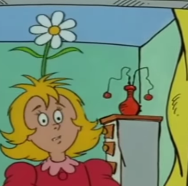 

* In the note in Care’s Room there’s a mention of (presumably) Care saying “Nobody loves me!” This is another quote from the book, and the most likely meaning of “NLM” in “Care NLM”
* Near the end of the story, Mayzie plays a game of “they love me, they love me not.” Petscop seems to reference this: as Paul plucks the petals the screen changes between two color tints, each accompanied by its own sound effect. Care enters a glitched state when the daisy ends up on “they love me not”
* Both Care and Mayzie go through unpleasant events at school (including being mocked for their appearance)

Going further, two pieces of syncing footage imply that the treadmill in Odd Care and the daisy are connected. In particular, the counter above the treadmill seems to correspond to the amount of petals left (it also alternates between two colors). In order to capture Care, Paul uses it to set the petal count to -1, thus artificially changing the outcome to “they love me.” Care’s description seems to reference this by saying “To catch her, you had to lie, but it may not be a lie forever.”

See <http://www.timelessteacherstuff.com/readerstheater/DaisyHeadMayzie.pdf> to read the book.

See <https://www.youtube.com/watch?v=GoqO3665imI> to watch the cartoon.

## Color Theory

Various colors are used to reference specific characters and their quotations throughout the videos. Some speculate that these colors are intended to provide insight into the story.

The color blue is associated with Anna in the note in Care’s room and in her dialogues. There’s also a blue bed in the Master Bedroom, presumably belonging to her. Amber’s name when Paul examines her trophy is also blue. In the same room that TOOL is found in, there are various drawings of a Blue TOOL. These drawings also appear under a slice of cake during Care’s Birthday.

Care is strongly associated with the color yellow, as her name and dialogue is written in yellow several times. Her bed in the House is yellow as well. Daisies are also yellow, and are associated with her character. The egg created after putting her in the Machine has yellow stripes on it.

Marvin is associated with green. His head and dialogue are green, and there’s a green background in his Demo in Petscop 14. The House is initially green, there’s a green bed in the Living Room, and the days Marvin presumably spends with Care are marked with green in the calendar. He may also be associated with Green TOOL or Randice (whose name is written in green).

Tiara’s name and quotes by her are written in purple. The note in the Quitter’s Room is also written in purple, implying a possible connection with Tiara. Belle’s name is written in purple as well and she later insists on being called Tiara. This could imply that Belle was “rebirthed” into Tiara using “the machine.” The egg found with a letter addressed to her has purple stripes on it.

The large TOOL has two known states: red and pink. This is also true of the counter above the treadmill in Odd Care, with even (“They love me not”) numbers being red, and odd (“They love me”) numbers pink. Needles Piano fits into this pattern as well: it’s purple/pink by default, and becomes red after a mistake is made. The two eggs in the School locker also have red and pink stripes on them.

Rainer signs the note in Lina’s room in all white text. In Petscop 11, Guardian’s dialogue in the house is shown in white and without quotation marks. This could mean that Guardian is meant to represent Rainer and/or that he is associated with the color white.

The Ghost Rooms are primarily orange, and so it the car that runs over Paul’s Guardian in Petscop 22, and the term “strange situation” in the Game Room conversation.

**All relevant colored text (in textboxes) as of Petscop 24:**

* 48 Pets remain here, at the time of writing. *[1]*
* We would strongly suggest you to visit our 8 homes and find some friends to take with you. *[1]*
* It's a picture of two friends, Toneth and Randice. *[1, 9]*
* It's a trophy, "awarded to our Amber for being a real champ yesterday and today." *[1, 9]*
* Care left the room. *[2, 11]*
* Michael Hammond *[2, 12, 20]*
* Care is missing. *[3]*
* Your wife says, “Care isn’t growing eyebrows.” *[3]*
* You say, “That’s a puzzle.” *[3]*
* Tiara says young people can be psychologically damaged “beyond rebirthing.” *[3]*
* “Nobody loves me!” *[3]*
* You’ve decided to leave Care NLM. If you change your mind within 6 months, you can take Care NLM back. *[9]*
* “Where have you been? Why were you gone for such a long time?” *[11]*
* “Is this a present? Who is it for?” *[11]*
* “Of course.” *[11]*
* Hi Belle. *[12]*
* You've apparently been running Petscop nonstop for 553758221 seconds, or 153822 hours. *[12]*
* Happy birthday Belle! *[12]*
* I'm calling you Belle because that's who you are. *[12]*
* I was overeager before, and started calling you Tiara prematurely. *[12]*
* If you hadn't given up halfway, you would be Tiara. *[12]*
* “You made it. Happy birthday!”“Why are you covering your face?” “... Oh.” *[14]*
* “Of course I recognize you.” “Those eyes. That nose. That’s still you.” *[14]*
* “Go ahead and have a slice!” “Oh, don’t worry about those.” *[14]*
* “I sure hope you’ve realized by now.” “It doesn’t matter how long you’ve been gone. It doesn’t matter how much you’ve changed.” “You aren’t lost. Stop wandering and come home.” *[14]*
* “Care! Are you okay?” “You ran straight into the door! Did you think it was open? ... Aw, poor baby.” *[14]*
* “Where is the disk? Where are the discovery pages?” *[14]*
* “What are you talking about? What disk? Discovery pages?” *[14]*
* “... Jill, stop fucking ignoring me. Get in here and show me where that disk is.” *[14]*
* “Jill.” *[14]*
* “No, Care, this is Mommy. This is your mommy. Sweetie, I’m right here in front of you. There’s no one else here.” “What are you looking at? What’s over there?” “... Care, can’t you hear me? Can’t you see me waving? Snap out of it. Care! Where are you going?” *[14]*
* You are a girl named Carrie Mark, and you were born on November 12th, 1992. *[17]*
* You have a mommy named Anna, a daddy named Marvin, an auntie named Jill, an uncle named Thomas, a cousin named Daniel, ...... You were kidnapped, and spent 5 months studying in an abandoned elementary school. You ran away, crying, ashamed, covering your face. You were blind. At some point, your movements stopped making sense. *[17]*
* Lina Leskowitz *[17]*
* As I painted, I watched Care dance around the house. *[20]*
* You showed Care her red, blurry reflection in a vase. *[20]*
* You said, “Do you see that? Look at how ugly you are now.” *[20]*
* Care squinted her eyes. *[20]*
* “Nobody wants to see you like this,” you said. *[20]*
* Hmm. I notice you named your file "Strange situation". Is that your name? Please confirm. *[22]*
* Paul. Okay. Your turn, Paul. *[22]*
* And now a message from Mrs. Mark, who is working very hard as we speak. [24]
* Hi Michael! Consider this your BIRTHDAY card! (sorry I can't put money in it...) When I heard how many kids were coming to your party I was impressed. Thank your big brother for letting you and your friends play games all day and making you so popular. Also thank your other Auntie for making this all possible. If you see her, I mean... not everyone can... But anyway ....HAPPY 7TH! I'm so so so sorry that I couldn't be here. I hope my gift makes up for it... it's the one in the black box... CARRIE helped pick it out, thank her!!) Opening gifts is so fun ....a lot of of little mysteries, and all are solved... so "cathartic" Anyway, I sure hope you have fun!! See you later! Love you, Auntie Anna *[24]*
* P.S. Whatever you do, please don't shake the box. *[24]*

All semi-notable uses or occurrences of red in Petscop:

* Coloured text - Mainly numbers.
  + P1: 48 pets, 8 homes. P12: 553758221 seconds
  + Toneth’s name, Graverobber player-input name (Paul)
* Pets - Toneth almost entirely, part of Randice and Roneth
* Part of Guardian avatar head “mouth”
* “They Love me not” petal pluck screen overlay and distorted Care
* Red TOOL and its Ask? Box and responses
* Some of the cars
* Primary color of Mike’s Child Library room
* One of two colors of the Camera (red = cannot view the Windmill)
* Even numbers on the Odd Care treadmill
* School fog color
* Main color of the Machine Room in the school basement
* Ring around the controller on the piano in a hidden loading screen and the Ghost Rooms
* The Needles Piano turns red when “Pall” plays bad music
* Pyramid Head
* The 1995/2017 calendar (“Your Calendar”)
* Caskets - red vase, red pyramid, red stencil, red writing on chalkboard

## Synchronization and Timelines

Throughout the series there are multiple instances of fragments of footage synchronizing with each other. The most obvious one occurs in Petscop 9: [see image here](https://cdn.discordapp.com/attachments/301463720570388481/317222960085598208/videotogif_2017.05.25_04.46.57.gif)

It’s noteworthy that it’s seemingly Paul who perfectly mimics the other character, and not the other way around. A number of explanations have been proposed for this phenomenon:

1. Paul plays the game before without remembering, and is making the same exact movements as before.
2. The game briefly takes control over Paul’s character.
3. The game can predict what Paul is going to do.
4. Paul managed to perfectly mimic the clone’s movements, maybe subconsciously.
5. Paul unknowingly travels back in time and is re-experiencing his past actions.
6. The footage has been altered to create the impression of the paranormal.
7. There are two or more instances of the main character concurrently active in the game.

Another major example takes places between footage from episodes 9 and 2:

<https://www.youtube.com/watch?v=Rc7hxKGVEWM>

In the video, the demo player’s movements on the treadmill correspond exactly with Paul’s movements when he’s plucking the petals from the flower in Petscop 2. Furthermore, when Paul from episode 2 says “wait” the demo character indeed becomes passive and waits for his return. It’s also of interest that not every move or action taken has its “synch up” in the other footage: only those related to the daisy/treadmill seem to be affected. (In contrast with the previous case, this effect could have been achieved by recording Paul’s movements and incorporating them into the demo.)

This synchronization appears to establish a connection between the numbers on the treadmill and petals left on the daisy, with red-backgrounded numbers connecting with “They love me not” petal counts, and pink-backgrounded ones with “They love me.” (See Dr. Seuss Connection and Capturing Care for further details).

There are a few more instances of suspected footage synchronization, but they’re either less clear-cut than the above, or their implications aren’t yet fully understood.

<https://www.youtube.com/watch?v=TfvCk1N_AWo>  
There appears to be a long subtle chain of synchronized events in episodes 9 and 10 that starts on both sides when Paul reloads the game after a crash. It may imply that Paul split the timeline by duplicating his save file, and that the calendar summoned by the TOOL was the 6 month countdown for catching back Care. For further details and considerations, see the video’s description on YouTube.

<https://www.youtube.com/watch?v=i2FsPLWyqmQ&feature=youtu.be>

In this video, the direction changes in the windmill’s rotation are aligned, and in part 9 Paul continues to exit the windmill in a fashion similar to the shadow character (presumably Marvin) in part 6.

Part 9 is involved in all known or suspected synchronization events up to Petscop 11, thus possibly being a hub for them. Its numerous jump-cuts can be interpreted as being an amalgamation of events from two separate timelines interacting with each other, which in turn may be connected with the Youtube ”About” page for the Petscop channel, that directly conflates two completely separate years into one (“"Rainer" gave this gift to us on Christmas 1997 and 2000. It was the single longest day of our lives. We were all certain he was dead at the time. He had been missing since June 1997 and 2000.”). Alternatively, the jump-cuts may be a production artifact from matching the footage of part 9 with that of other videos.

Petscop 11 introduces yet another instance of syncing footage:

<https://www.youtube.com/watch?v=5dcnC0Gs54E> (superimposed)

In this case, Paul’s movement inputs and words match perfectly for over 20 seconds. Paul seems to be vaguely aware of the situation, as the second time around he appears to recall the now-missing white cube.

Two further synchronization events were found in Petscop 12. In the first one, footage from Petscop 10 and Petscop 12 appear to portray the same event:

<https://youtu.be/bPR-serVmzQ?t=21>

This may indicate that Belle sees Paul as the Pyramid Head, Paul sees Belle as Quitter, and that Paul freed Belle from her imprisonment during the events of Petscop 10.

The other sync from Petscop 12 shows that Marvin performed the exact same movement in Petscop 11 and 12:

<https://www.youtube.com/watch?v=g1k87s551mY>

This may indicate that the two events take place at the same time and/or place (but possibly in different Generations). If so, it would mean that the School is located next to the hatch Paul originally used to go under the Newmaker Plane. Part of Care NLM’s description,“Care NLM escaped from the school’s basement and wandered the Newmaker Plane,” also seems to imply a direct passage from the school’s basement to the Newmaker Plane.

In Petscop 14, Paul discovers that he can control a demo copy of his character. The game stores his inputs, and then executes them back in a slightly changed environment: most notably, previously closed doors may be open. By taking advantage of this he can reach and explore previously unavailable areas, although the process of doing so is tedious. Every piece of demo footage resulting from this method should be perfectly synched with a piece of gameplay footage. Not every synch found, however, can be explained by this feature.

## Paul and Care

### Twins Theory

In Petscop 11, when Paul is looking at the green calendar and pondering Carrie’s disappearance, he states that she’s exactly his age:

"I don't remember meeting this girl at all, I don't remember knowing her at any point. I remember you saying that we are, exactly the same age."

Not long later he adds:

"I do agree there is a resemblance, very strong resemblance between us."

This may indicate that Paul and Care/Carrie are twins. Since Paul claims that he doesn’t recall ever meeting her, it’s possible that either one or both of them were adopted.

Earlier in the episode, Paul also reveals that the game is indirectly tied to him:

"there were signs along the way, that I ignored, cuz it, it would've been a completely ridiculous idea to me. But **when I found my room**, it made, well uh I was shocked at first, but it made sense, especially considering where I found the game in the first place, it would be tied in some way to me through you."

This could imply that Care-with-Mike's-Eyebrows’s room belongs to Paul, as it wouldn’t be far fetched for him to look like his twin sister, but with eyebrows. If so, then the censored object in it may be something personal to Paul. Furthermore, if said room does indeed belong to Paul and feature his facial features, it’d indicate that he’s a “member of the family,” as mentioned in Petscop 12.

Paul’s Reddit account appears to be u/paleskowitz, presumably short for Paul Leskowitz. Since this is also Lina’s (Care’s aunt’s) surname, it further implies a familial connection.

### Same Person Theory

A set of alternative theories takes this reasoning further, and postulates that Paul and Care are, in fact, the same person. The specific meaning of this claim varies from theory to theory:

* Care is a boy all along, and is forced to dress like a girl (presumably by Marvin), just like Rainer Rilke was forced to do so by his mother
* Paul goes through gender-change process, and doesn’t remember it
* They’re two versions of the same person from different timelines or realities
* Something supernatural—possibly rebirthing—caused Care to become Paul
* Paul is being brainwashed into thinking that he’s Care
* Paul’s past is being altered

Arguments for the Same Person theories are mostly based on specific events and observations from episodes 14 and onwards:

* During the party scene, Care appears to be hiding something under her hands, and her mother attempts to cheer her up by pointing out that her eyes and nose—two out of three features recognized by the Child Library—are unchanged. This could imply a change to her eyebrows, or rather, that she now has them, as she didn’t have them earlier the same year. (Petscop 22, however, implies that there might be a bruise on her face (“a very big boo-boo”))
* In Petscop 15, the player character, presumably Paul, gets repeatedly dragged towards a picture of a woman, which displays the word “GiRL” upon closer inspection. It has been proposed that the game is misgendering Paul or attempting to remind him of a past identity. (It is however possible that Paul is simply playing the role of Care in this scene, and that the word is directed at her.)
* It appears that during his 2017 birthday Paul controls Care in a similar fashion as he controls the demo copies of his own character. Additionally, Care runs into a door instead of a wall or furniture, which could also indicate that the two parties took place in the same House.
* It’d also explain why Paul doesn’t remember ever meeting Care, despite them seemingly sharing social circles.
* The list of all sounds features the following three entries: Marvin Message, Belle Message, Care Message. This likely references the sounds characters make when using the Gamepad Language. “Pall,” who is most likely Paul, is the only character other than Marvin and Belle who’s seen using this system, and the sound he makes is different from theirs. Based on that, it can be speculated that Paul’s gamepad speech uses the “Care Message” sound—potentially hinting at them being one and the same.
* In Petscop 17, the game outright tells the player that they’re Carrie Mark. It’s unclear if this message is tailored for Paul, or aimed at anyone who might be playing. The message also lists Carrie’s family, but makes no mention of Paul, despite all their connections—which can be resolved by their being the same person.
* Since Lina goes missing at the age of eight (before her ninth birthday), Leskowitz is her maiden name, one which she most likely shares with her sister Anna. After separating from Marvin, Anna could change her surname back to Leskowitz, in which case her child would also go through a name change.
* When seen by other players, Paul’s character is represented by the Pyramid Head. Pyramid Head bares a close resemblance to Casket 2, which, in turn, appears to represent Care A.
* Care-with-Mike’s-Eyebrows’s Room has blocks spelling “CRE” (a letter short from “Care”) and, most likely, Casket 1 on the table. Casket 1 represents a highly emotional moment specific to Carrie, so if this is indeed Paul’s room (as suspected), this would imply a very close connection between the two—one further reinforced by Paul’s silent utterance of “oh my god” while inside.
* Petscop 21 portrays Care [dancing to “The Sign” by Ace of Base](https://www.youtube.com/watch?v=8F-S1MT-QdM). The first line of that song, “I got a new life, you would hardly recognize me,” suggest that Carrie underwent a significant change, possibly to the point of becoming a new person.
* In Petscop 22, the dialogue in Game Room implies that Carrie may have changed her name
* All the Caskets are connected to both Care and the color red. In Petscop 22, Paul’s name is written in red.
* The egg created by placing Care B in the Machine in Petscop 24 has yellow and red stripes. Yellow is usually associated with Carrie, while Petscop 22 writes Paul’s name in red. The egg may therefore represent a transformation (or rebirthing) from one to the other.

A problem noted with Same Person theories is that Care and Paul seem to have separate and non-identical rooms in the Child Library. If they are indeed the same person, then the Library must be differentiating them for an unknown reason. It could be due to different names, different facial features (eyebrows and lack of them), or different self-identity.

## 

## Multiple Players

Petscop 12 implies the existence of autonomous player characters other than Paul who are currently active in Petscop, and who can be seen in some of the footage labeled as “Demo.” All players see themselves as the Guardian, while seeing others as variations of it, such as Pyramid Head or Quitter:

|  |  |  |  |
| --- | --- | --- | --- |
| **Current Player** | **Players from Current Player’s perspective** | | |
| Paul | Belle | Marvin |
| Paul |  |  |  |
| Belle |  |  |  |
| Marvin  ***(speculation)*** |  |  |  |

Possible currently active player characters:

* Paul, who appears as Pyramid Head to others (which may be the default “other player” appearance)
* Belle, who was presumably trapped in the game for over 17 years, and may currently be an entity akin to an AI. Others see her as Quitter.
* Pall. He is, however, likely to be Paul.
* Marvin, due to having a similar body, but his seemingly pre-programmed behaviours cast doubt on his playerhood.

It’s currently unknown which of the players is featured in the demo segment of Petscop 9, but judging by their piece count (which starts at 0 in that demo) they’re unlikely to be Paul or Belle.

Petscop 14 and Petscop 20 confirmed that Marvin looks like the standard player character in his own Demo footage.

Petscop 17 reveals that numerous people play Petscop over the years, and Petscop 19 confirms that current player is seen as controlling the basic Guardian sprite. It is unknown what those other players would look like if they appeared in another player’s game.

In Petscop 23, “Pall” provides only 500 Pieces for the Machine, with the remaining 500 coming most likely from Belle. This may imply that two players need to pool their resources in order to finish the game.

## Candace Newmaker Connection

This connection is based on the frequent use of words such as “Rebirth,” “Tiara,” and “Newmaker.” Candace Newmaker was originally named Candace Tiara Elmore, but was taken from her abusive family at age of five and given a fresh birth certificate in 1996 with the name Candace Elizabeth Newmaker on it. She was going through intensive therapy session with her adoptive mother to treat RAD (Reactive Attachment Disorder). Part of this session included “rebirthing therapy,” a process which reenacts the experience of travelling out of the birth canal by being bound in sheets and pressed on by multiple adults. The child is then meant to fight their way out of the birth canal to be born again, but Candace was unable to get free and suffocated to death.

<https://en.wikipedia.org/wiki/Candace_Newmaker>

<http://www.ratbags.com/rsoles/comment/candace.htm> (transcript of the video evidence provided in the court case against the therapists involved)

The “Quitter” from the Quitter’s Room may be a reference to Candace in this transcript. Quote from the transcript: “Ponder: Quitter, quitter, quitter, quitter, quit, quit, quit, quit. She's a quitter.”

Belle was the name of Candace’s favourite doll.

It should be noted that two of the connected terms (Newmaker and Rebirth) have now been given separate in-universe meanings. It seems the role of this connection was only to add the flavor of a child abuse story, just like the daisy-head maisy reference was to add the idea of the daisy plucking and “nobody loves me” to NLM.

It has been proposed that Belle’s storyline may be loosely based on the Newmaker case. This theory postulates that Rainer, being impressed by Belle’s exceptional performance during early Petscop tests, attempts to rebirth her, an outsider, into a brand new family-member—Tiara Leskowitz (presumably by exposing her to the Caskets). This plan, however, doesn’t fully work out: Belle thinks of herself as Tiara, but Rainer doesn’t recognize her as such.

## The Family

Many plot threads of the show revolve around a family of three who live or used to live in the House:

* Marvin, the husband, and Carrie’s (possibly adoptive) father, represented by color green
* Anna, the wife, Care’s (possibly adoptive) mother, sister of Lina (Marvin’s friend who disappeared in 1977), represented by blue
* Care/Carrie, the daughter, represented by yellow

There are unlikely to be more occupants of the House (at least in June 1997), as upon exploring every room Paul finds only three beds, each color-matched with one of the characters listed above:

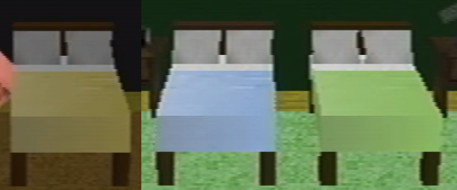

In 1977, Marvin, Anna, and Lina go to an old Windmill. Anna takes photographs of the others, and at some point the Windmill and Lina disappear. Afterwards, Marvin attempts to lure Lina back home by throwing her a birthday party (depicted in Party Room), but the attempt is unsuccessful.

Rainer seems to doubt this story, and believes that Lina lies in an unmarked grave. Marvin’s behaviour in Petscop 20 (especially his almost asking Red TOOL “did you dig (Lina)?”) can be seen as confirming those suspicions.

At unknown later points, Marvin and Anna get married, move into the House, and have a daughter Carrie. Carrie appears to not grow any eyebrows, and is believed to be Lina reborn.

A common theory postulates that the House originally belonged to Marvin, as symbolized by green exterior it has in the picture in Petscop 8, and the green wall in the Master Bedroom. Marvin also keeps referring to it as “my house” when asking to be brought there.

He presumably loses ownership at some point before 1997 (Rainer mentions Marvin’s getting “kicked out” from the House), which may be why the House is later black. The walls of the bedroom also gradually become black, starting on Anna’s side—Petscop 20 reveals that they’re being painted over by Anna and Rainer to cover up the stencils. The Teal TOOL—which may be the same as Blue TOOL and possibly represents Anna herself—turns black as well. This could mean that the color black symbolizes things and people Marvin loses, or it may be the color of another character (possibly Rainer) who’s taking them away.

Marvin and Anna also seem to enter a custody arrangement over Carrie some time before 1997. The green calendar—for the year 1997—starts with every other day marked in green, presumably to note the days when Marvin has Care. After a few weeks the pattern changes to one where only the weekends are green, and later it becomes all-green during the time Care is missing due to being kidnapped by Marvin. Afterwards, there are no green days anymore, suggesting that Marvin no longer has any practical custody over Care.

On June 5, 1997, Marvin kidnaps Carrie, and keeps her hidden for five months at an abandoned elementary school. During that time he gives her unspecified lessons, and makes at least one attempt at convincing her that she’s deformed. She manages to escape on November 10, 1997, and returns on November 12, 1997. It’s unknown what exactly happens to her on November 11 (although it’s implied to be related to Lina’s grave).

Rainer’s involvement with the family is unclear. He originally begins his work on Petscop (Gen. 6) for Marvin, and visits the family on Christmas (when he seems to give them the Petscop recordings), but doesn’t appear to live in the House. He helps Anna by painting over the stencils, and is likely the person to whom Anna’s note is addressed. He may also be in indirect contact with Marvin during the kidnapping, as the game seems to be moving between the two of them at that time.

Petscop 17 reveals that Jill, Thomas, and Daniel are all related to Carrie.

In Petscop 22, Paul’s friend appears to object to being referred to as “not family.”

In Petscop 24, Anna signs her letter to Mike as “Auntie Anna,” thus implying that he too is related to the Family. The letter also mentions Mike’s brother, who might be Daniel and/or Rainer.

At least some members of the Family are the Proprietors. Jill in particular seems to be playing a prominent role in the group.

## Car theme

Cars and roads are a recurring theme throughout the series. This section lists their appearances.

Cars in-game:

* Red and blue cars can be seen driving out of the Tunnel under the Newmaker Plane:

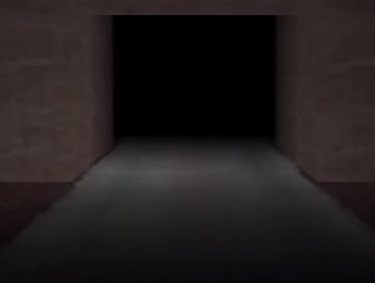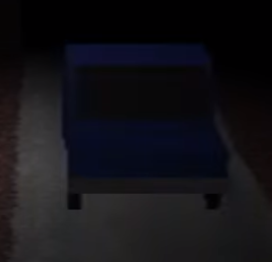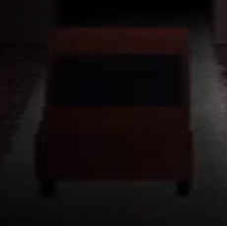

* Petscop 11 Demo appears to feature a first person view from a car driving into the Tunnel and beyond it (notably, there seem to be barely visible walls on both sides)
* Another car can be seen in the Garage in Petscop 16 (and one of the channel icons), and possibly also in Petscop 14, in an unloaded state:



* Lina’s grave in Petscop 17 has “they didn’t see her” inscribed on it. This may imply a car accident.
* Some rooms in the Child Library have toy cars on their tables:

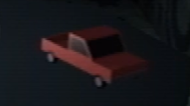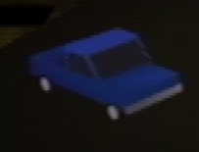

* In Petscop 22, a glowing orange car appears from the Tunnel and hits Paul’s Guardian while he’s in the Shadow Monster state. It may be the same car as in the Garage:

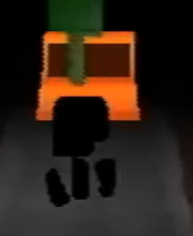

* One of the board games in Game Room is titled “Accident,” which may be a further reference to a car accident. It shares its logo with the animation in front of TOOL’s Room.

Roads in-game:

* Main road through the Gift Plane
* Road from the tunnel (Petscop 2, Petscop 8, Petscop 11 Demo)
* Road near the House in the Newmaker Plane (Petscop 11, Petscop 13, Petscop 14)



* Road-like shapes visible on a carpet pattern of some Child Library rooms:

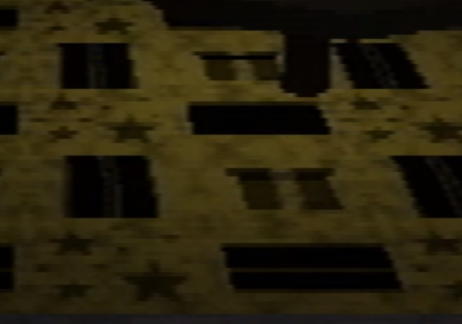

* The Tire

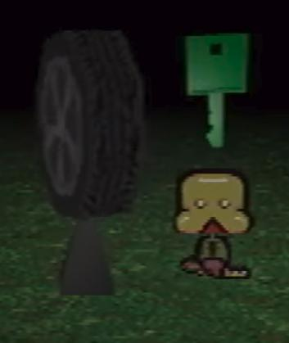

Pet descriptions:

* Toneth:

It makes me think about the dog actually. Because when the car hit him I thought “at least it will be over soon.” He survived it, and I was the only one who still wanted to put him down. A dog is an innocent-

* Roneth:

Because he’s younger, he gets to learn from all of Toneth’s mistakes. That’s why he always looks both ways.

Sounds:

* Near the end of Petscop 13, a series of knocks can be heard, followed by sounds reminiscent of a car door being opened and closed. The meaning of this, if any, is currently unknown, although some people speculate that the latter sound is Paul’s putting down the gamepad or hitting the microphone.
  + In Petscop 22, Paul is asked by his friend about a similar sound, which they appear to mistake for a car door. Paul clarifies it's his front door—this may suggest this sound in Petscop 13 was also his front door.
* In Petscop 16, sounds of cars driving by may be heard in background microphone audio

# 

# **Other Stuff**

## Sound Effects, Textures, and Fonts

Various sound effects and fonts found used in Petscop.

**Sound effects**

**From kiarchive (big free sample collection)**

Clap sound effect at the end of a dialog box “Text Done” — claps015.xi “Claps”[Audio](https://clyp.it/y11vfyx0?token=959d762fd085b70d77c6b5ea3dd5efe8) | *kiarchive\CATEGORY\PERCUSS\CLAPS\BASIC1\claps015.xi*

Snap sound effect during dialog box “Text Next” — fsnap03.xi “Fingersnap”

[Audio](https://clyp.it/eov31h0b?token=1756a6a0bf49c5f2d4f2ec2c548ecf39) | *kiarchive\CATEGORY\PERCUSS\ETHNIC\FSNAP\fsnap03.xi*

Belle’s P2 to TALK chat sound “Belle Message” — TUBBL01.XI “Tubular Bells”

[Audio](https://clyp.it/ba2d3yyq?token=1bfa07b82fb4ebc275a6757183b4027f) | *kiarchive\CATEGORY\BELL\TUBULAR\TUBBL01.XI*

Marvin’s P2 to TALK chat sound “Marvin Message” base — dog1.xi “FX Dog”

[Sample](https://clyp.it/krtfirwk?token=32e57e0560170e9d6abd3d38f90a9a84) | *kiarchive\FX\NATURE\ANIMALS\ANIMALS1\dog1.xi*

Lock interactivity noise from the School instrument — glsbl01.xi “Glass Bell”

[Audio](https://clyp.it/qti2pdrr?token=f1b98d04068fb14259036b07f7a17e9c) - [Sample](https://clyp.it/uqhk0c23?token=a31307be292689b6838afd726e6fd526) | *kiarchive\CATEGORY\BELL\GLASS\SET001\glsbl01.xi*

Pause sounds ("Pause 1" "Pause 2" "Pause 3") — xylo01.xi "Xylophone C5"

[Audio](https://clyp.it/qlnnds3r) - [Sample](https://clyp.it/s5zyazzg?token=e7e032fa350f5578f18509b7447b4508) | *kiarchive\CATEGORY\CHROM\XYLO\xylo01.xi*

**Other**

Earthquake sound in child library after putting a face on the easel

[*https://freesound.org/people/uagadugu/sounds/222521/*](https://freesound.org/people/uagadugu/sounds/222521/)

Phone ringing

[*https://freesound.org/people/northern87/sounds/88531/*](https://freesound.org/people/northern87/sounds/88531/)

Odd Care music vibraphone — "Vibraphone" from SGM Soundfont

[Audio](https://clyp.it/5p53pw51?token=4937472733a69ab55c80b0027b66f203) - [Sample](https://clyp.it/fc0t05ap?token=84888dc8abbe0d0a5fe840fd2d3b3612) | [*https://sourceforge.net/projects/androidframe/files/soundfonts/*](https://sourceforge.net/projects/androidframe/files/soundfonts/)

**Textures**

*Most of these have been edited from their source for Petscop.*

Newmaker Plane grass — Grass0005 from textures.com

[Comparison](https://cdn.discordapp.com/attachments/481893855596118017/630088776873541642/grasssy.png) | [*https://www.textures.com/download/grass0005/3411*](https://www.textures.com/download/grass0005/3411)

Newmaker Plane door — DoorsWoodSingleOld0204 from textures.com

[Comparison](https://cdn.discordapp.com/attachments/481893855596118017/627767975042088960/hatchcompare.png) | [*https://www.textures.com/download/doorswoodsingleold0204/88137*](https://www.textures.com/download/doorswoodsingleold0204/88137)

Newmaker Plane brick building door — DoorsWood0145 from textures.com

[Comparison](https://cdn.discordapp.com/attachments/347541882131316756/638908071690895412/unknown.png) | [*https://www.textures.com/download/doorswood0145/87409*](https://www.textures.com/download/doorswood0145/87409)

House & Quitter's Room floorboards — DoorsWoodSingleOld0204 from textures.com

[Comparison](https://cdn.discordapp.com/attachments/481893855596118017/628402846685200424/TexturesCom_WoodFine0038_1_seamless_S.gif) | [*https://www.textures.com/download/woodfine0038/33549*](https://www.textures.com/download/woodfine0038/33549)

School walls — ConcretePlates0205 from textures.com

[Comparison](https://cdn.discordapp.com/attachments/481893855596118017/628422375486259221/school_wall.gif) | [*https://www.textures.com/download/concreteplates0205/123858*](https://www.textures.com/download/concreteplates0205/123858)

School bricks — BricksSmallOld0067 from textures.com

[Comparison](https://cdn.discordapp.com/attachments/481893855596118017/637284996574478356/brickcompare.png) | [*https://www.textures.com/download/brickssmallold0067/38884*](https://www.textures.com/download/brickssmallold0067/38884)

House doors — DoorsWood0010 from textures.com

[Comparison](https://cdn.discordapp.com/attachments/559577335817437204/634885492365852703/unknown.png) | [*https://www.textures.com/download/doorswood0010/16226*](https://www.textures.com/download/doorswood0010/16226)

House windows — WindowsHouseOld0350 from textures.com

[Comparison](https://cdn.discordapp.com/attachments/481893855596118017/628550644415856640/2v3avpinvN.png) | [*https://www.textures.com/download/windowshouseold0350/70635*](https://www.textures.com/download/windowshouseold0350/70635)

Party room brick floor — FloorStreets0084 from textures.com

[Comparison](https://cdn.discordapp.com/attachments/481893855596118017/629337852404039730/brickcomapre.png) | [*https://www.textures.com/download/floorstreets0084/53192*](https://www.textures.com/download/floorstreets0084/53192)

Windmill brick pattern — BrickRound0132 from textures.com

[Comparison](https://media.discordapp.net/attachments/481893855596118017/629694676856995840/windl.png) | [*https://www.textures.com/download/brickround0132/117080*](https://www.textures.com/download/brickround0132/117080)

Machine room tiles — FloorsCheckerboard0038 from textures.com

[Comparison](https://cdn.discordapp.com/attachments/559577335817437204/634883089696292885/unknown.png) | [*https://www.textures.com/download/floorscheckerboard0038/100210*](https://www.textures.com/download/floorscheckerboard0038/100210)

Game Room chair & shelf wood — WoodFine0001 from textures.com

[Comparison](https://cdn.discordapp.com/attachments/481893855596118017/629701228749783080/woody.png) | [*https://www.textures.com/download/woodfine0001/14121*](https://www.textures.com/download/woodfine0001/14121)

Child Library floor — TilesPlain0066 from textures.com

[Comparison](https://cdn.discordapp.com/attachments/481893855596118017/638064547437084702/MAMAMAMAM.png) | [*https://www.textures.com/download/tilesplain0066/51743*](https://www.textures.com/download/tilesplain0066/51743)

Underground tiles — ConcreteFloors0048 from textures.com

[Comparison](https://cdn.discordapp.com/attachments/481893855596118017/638414838737141782/bruh.png) | [*https://www.textures.com/download/concretefloors0048/38711*](https://www.textures.com/download/concretefloors0048/38711)

**Fonts**

**Custom Font Remakes**

Petscop UI — [*https://giftscop.com/fnt/PetscopWide.ttf*](https://giftscop.com/fnt/PetscopWide.ttf)

Counters and “GEN.” — [*https://giftscop.com/fnt/PetscopTall.ttf*](https://giftscop.com/fnt/PetscopTall.ttf)

“PANICSV” text — [*https://giftscop.com/fnt/PanicTF.ttf*](https://giftscop.com/fnt/PanicTF.ttf)

**Other**

Gift Plane loading screens, Title screen, GiRL, signs font — [Poetsen One](https://www.dafont.com/poetsen-one.font)

*On its use in the title screen and signs, the font is decimated.*

Garalina intro/logo font — [Days Sans Black](https://www.1001fonts.com/days-sans-black-font.html)

Calendars, lock dial, Checkers game — Lucida Sans

Living Room & locker notes, Burn-in Monitor, Graverobber & Accident games — Times New Roman

Controls, mike2 recording Loading screen, testing room numbers, Rotation game — Arial

## 

## Maps

**Full Map**

by Quady14 -[Source](https://www.reddit.com/r/Petscop/comments/6ecxrq/petscop_world_map_uptodate_oh_jeez_this_is_a_mess/)

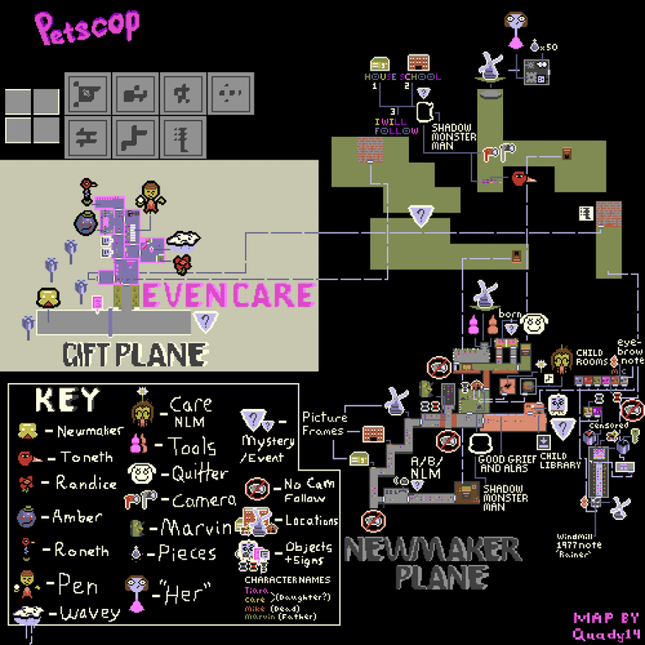

**Tile map of under the Newmaker Plane**

by isofaux

[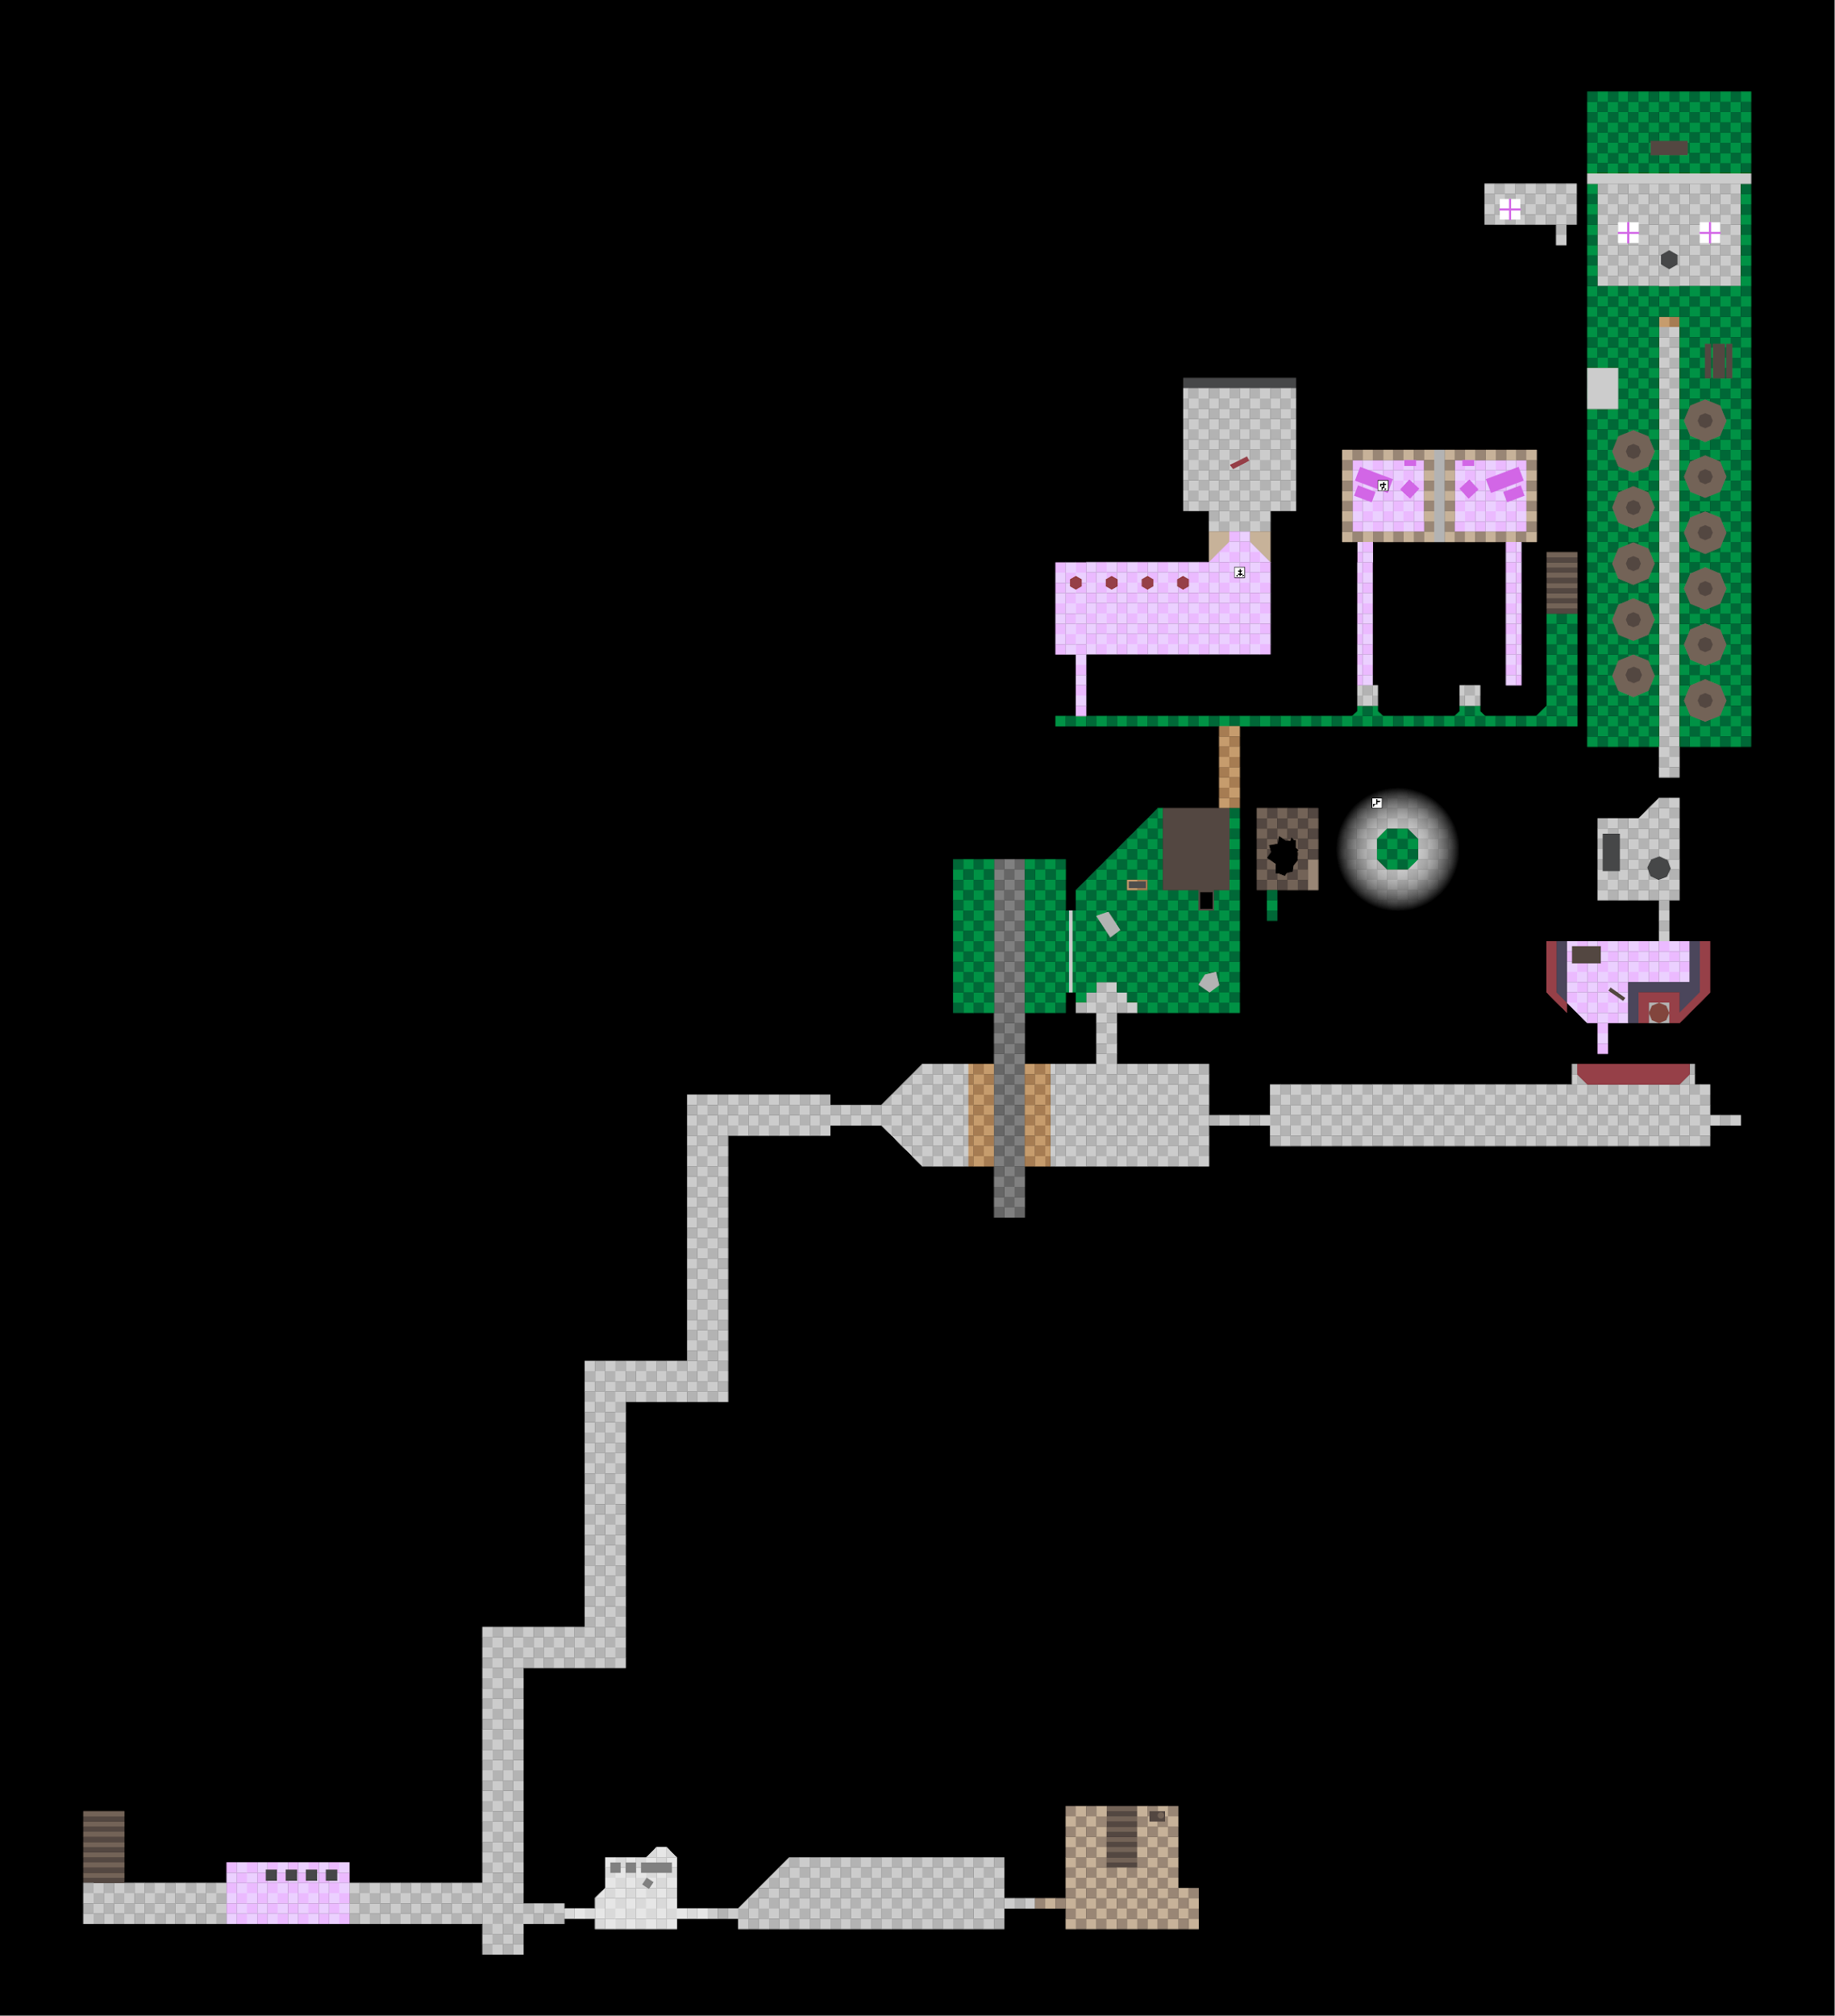](https://cdn.discordapp.com/attachments/301463720570388481/639289059797106708/unknown.png)

*(Click the image for a larger version)*

**Even Care tile map**

[Full size image](https://vignette.wikia.nocookie.net/petscop/images/c/c6/EC-tilemap-label.png) / [Grid maps by u/towl3r](https://imgur.com/a/i758Yfk)

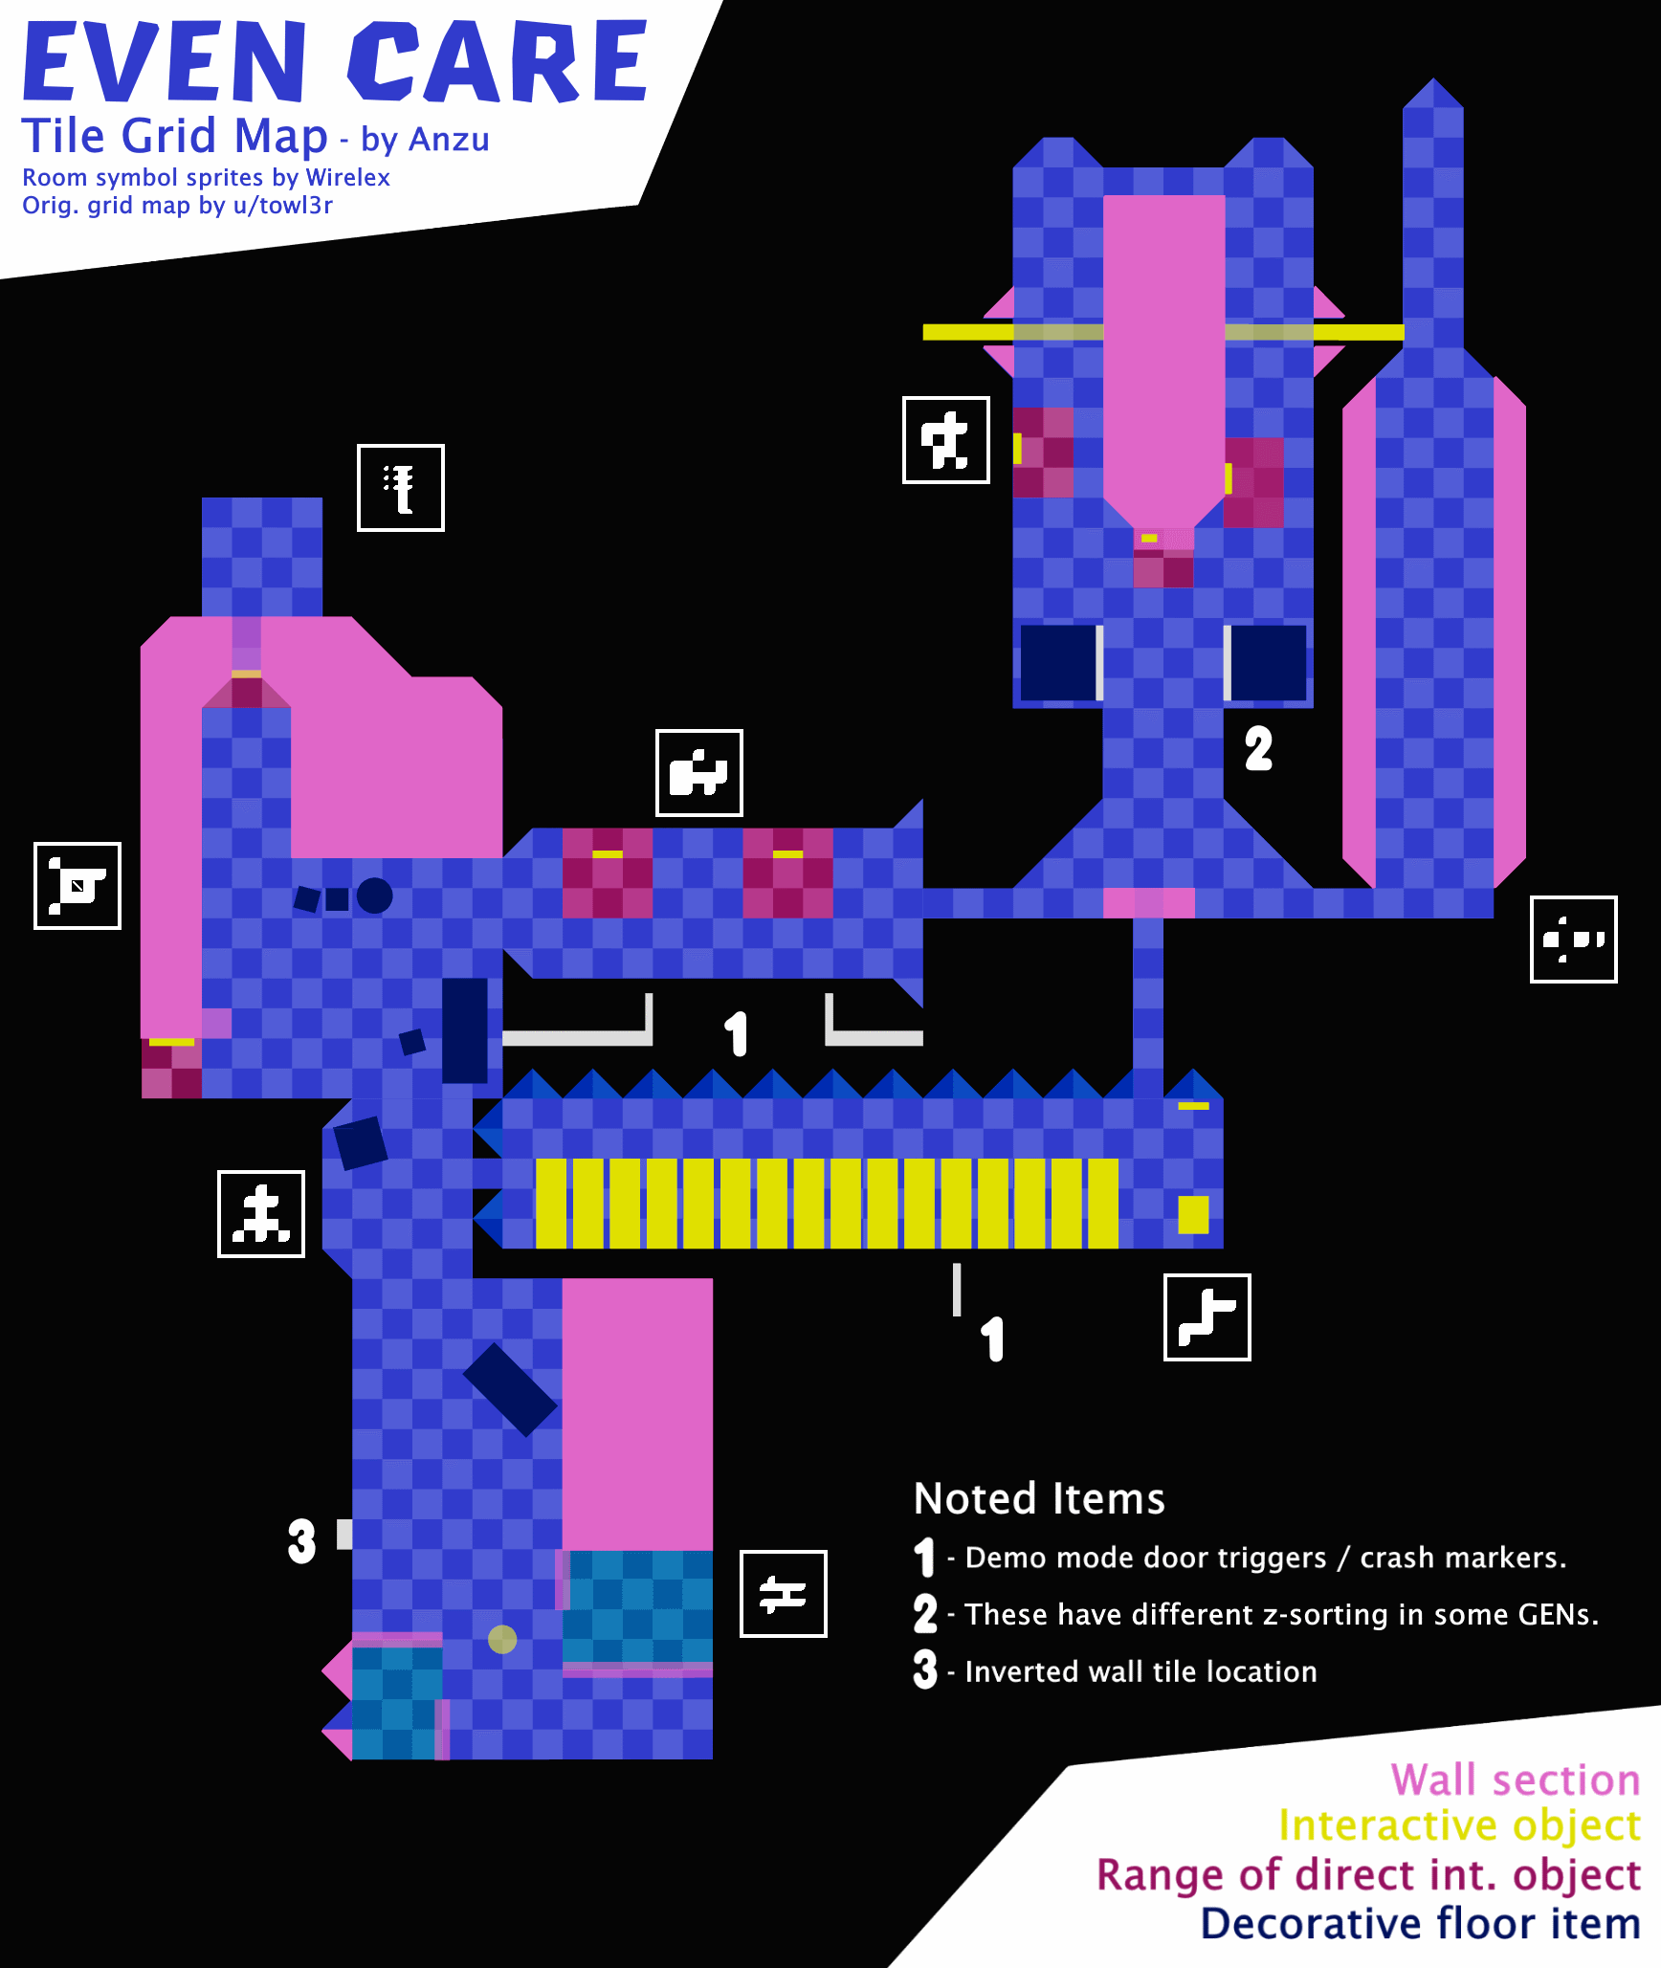

**Individual room grids:**

|  |  |  |  |  |  |  |  |  |
| --- | --- | --- | --- | --- | --- | --- | --- | --- |
| **Even Care**  [**w/o legend**](https://vignette.wikia.nocookie.net/petscop/images/8/81/EC-tilemap-full.png) | [Room 1](https://vignette.wikia.nocookie.net/petscop/images/b/b8/EVEN-1.png) | [Room 2](https://vignette.wikia.nocookie.net/petscop/images/8/8d/EVEN-2.png) | [Amber](https://vignette.wikia.nocookie.net/petscop/images/5/54/EVEN-3.png) | [Roneth](https://vignette.wikia.nocookie.net/petscop/images/1/12/EVEN-4.png) | [Pen](https://vignette.wikia.nocookie.net/petscop/images/b/be/EVEN-5.png) | [Connector](https://vignette.wikia.nocookie.net/petscop/images/1/11/EVEN-6.png) | [Randice / Wavey](https://vignette.wikia.nocookie.net/petscop/images/7/77/EVEN-7.png) |  |
| **Odd Care**  [**w/o legend**](https://vignette.wikia.nocookie.net/petscop/images/1/1e/OC-tilemap-full.png) | [Room 1](https://vignette.wikia.nocookie.net/petscop/images/e/e2/ODD-1.png) | [Room 2](https://vignette.wikia.nocookie.net/petscop/images/5/55/ODD-2.png) | [Amber](https://vignette.wikia.nocookie.net/petscop/images/b/b4/ODD-3.png) |  | [Pen](https://vignette.wikia.nocookie.net/petscop/images/6/69/ODD-5.png) |  |  | [Alt. Entrance](https://vignette.wikia.nocookie.net/petscop/images/f/fb/ODD-8.png) |

**The House tile map**

[Full size image](https://vignette.wikia.nocookie.net/petscop/images/4/4a/House-tilemap-label.png) / [Alt grid maps by u/towl3r](https://imgur.com/a/F0flDxU)

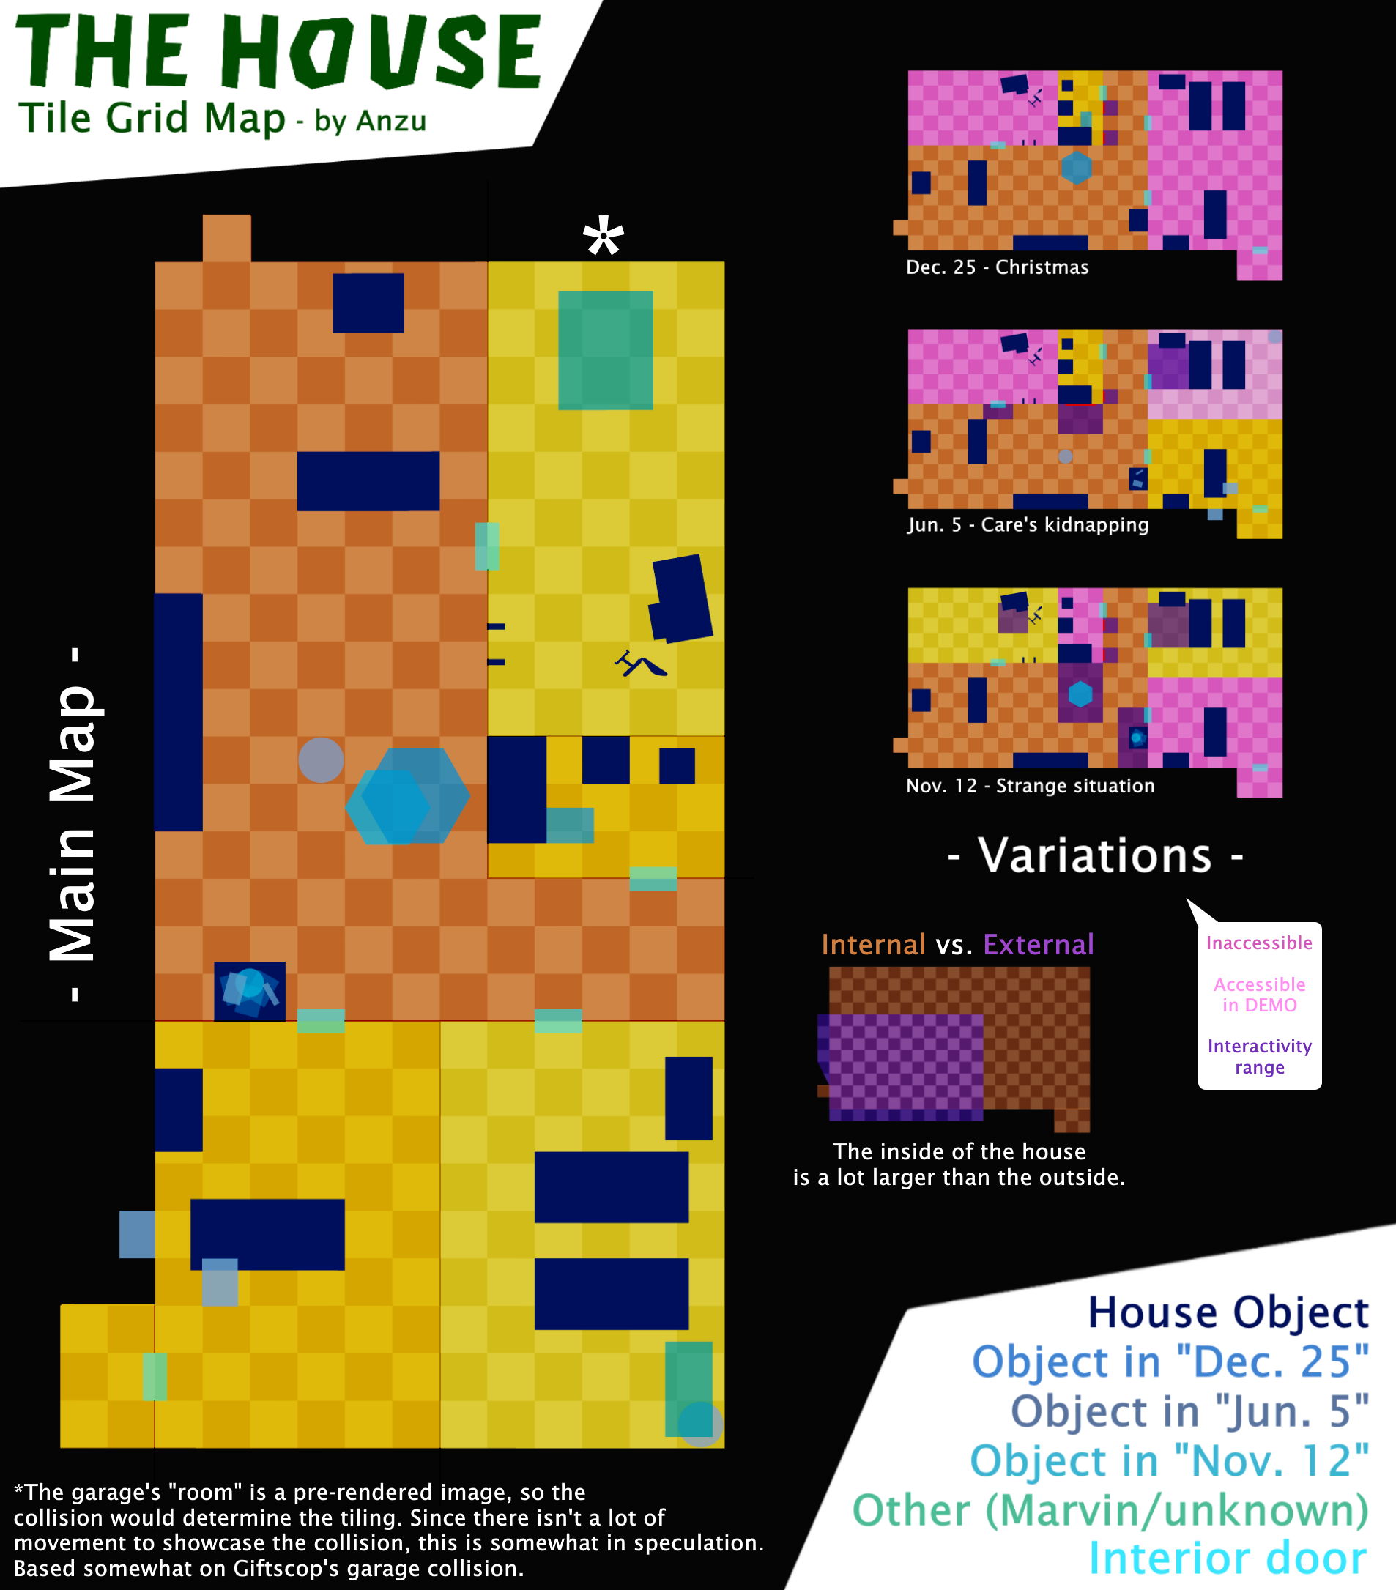

**Variation grids with interactivity ranges / no legend:**

|  |  |  |  |
| --- | --- | --- | --- |
| [**Full w/o legend**](https://vignette.wikia.nocookie.net/petscop/images/1/1a/HOUSE_plain.png) | [December 25](https://vignette.wikia.nocookie.net/petscop/images/9/94/HOUSE_dec25.png) | [June 5](https://vignette.wikia.nocookie.net/petscop/images/5/50/HOUSE_jun5.png) | [November 12](https://vignette.wikia.nocookie.net/petscop/images/2/27/HOUSE_nov12.png) |

## 

## Random Tidbits

*This section covers anything unusual or interesting that appears in the videos, but doesn’t seem important or relevant to what is known so far.*

### Other Hidden Images

The 20th frame of the first Petscop video contains a column of symbols:



In Petscop 14, after adjusting the brightness and contrast of a seemingly white frame at 25:01, the following is revealed:



**Channel banner**

The banner of the YouTube channel appears to be a black stripe, but it’s actually the top part of a Newmaker Plane screenshot:



No changes to the banner have ever been observed.

**Camera anomalies**

In Petscop 20, when Marvin lowers the camera through the ground, two of the frames stand out among the others:

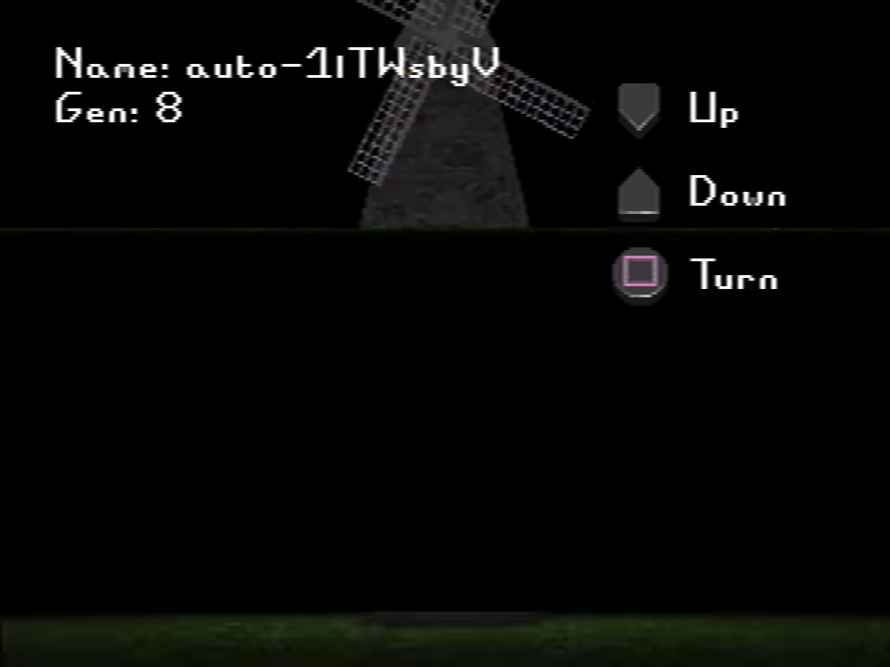 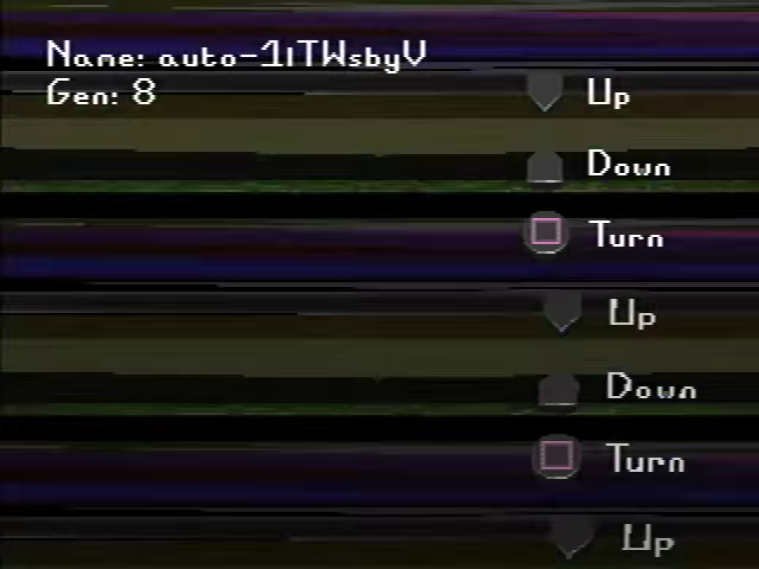

In the first one (left), two instances of the Newmaker Plane can be seen, the lower of which seems to be of the camera capturing the top of its own output screen. This would indicate that the screen is located just below the ground, and that, when viewed like this, it shows the hidden state of the Windmill (only the floating platform is visible).

The second frame (right), shows layers of distorted textures, most likely caused by the camera clipping through the ground while also filming its own output screen (thus duplicating the interface buttons). Notably, some of those textures appear neither above the ground nor in TOOL’s Room, but instead bear strong resemblance to Even Care.

**Even Care background symbols on a grid and with corresponding rooms:**

[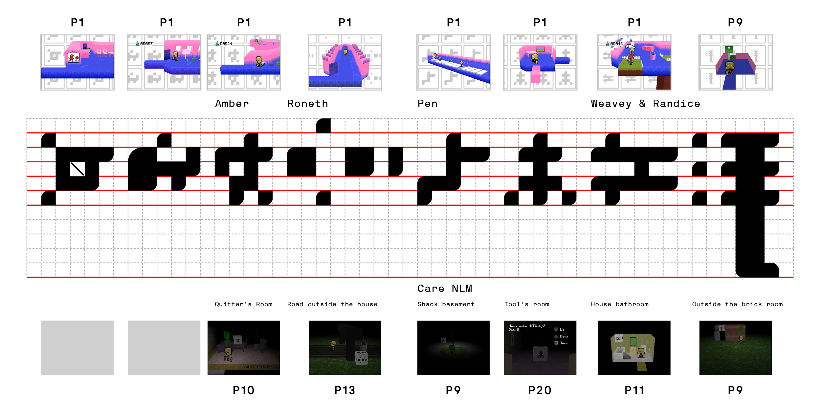](https://cdn.discordapp.com/attachments/301463720570388481/636110717648371714/Symbols_guide.png)

*(click the image for a larger version)*

The dirt in Randice’s room (left image) extends below the floor of the level. This occurrence does not happen in any other part of Even Care, and only appears in later generations. One of the loading screens from Petscop 14 (right image) shows a view of this from under the level.

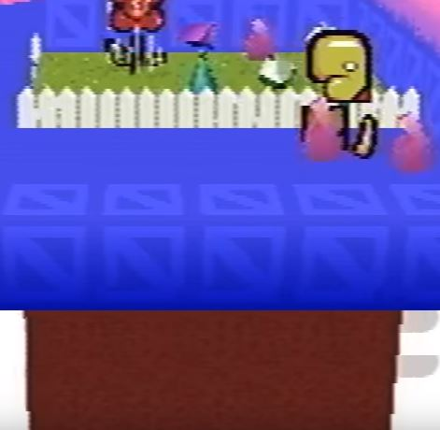****

If the colors in CAUGHT are inverted, the same colors appear on opposite sides.

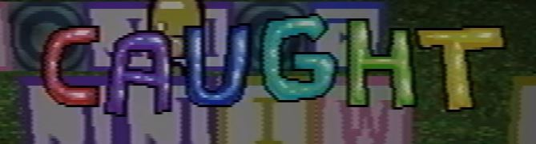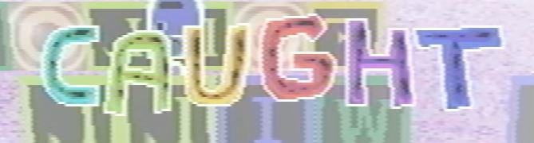

Boxes of crayons are found in Care’s room, the Flower Shack, Care’s bedroom, and as one of the items that can be pushed into the pit in the school basement: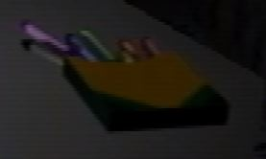



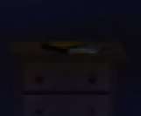

They also appear in a hidden loading screen from Petscop 20.

**Petscop 13 lingering “Options”**

In Petscop 13, when Paul selects “Pets” from the menu, the “Options” button briefly lingers instead. This is likely a bug caused by the missing “Quit” option, which causes a shift in button positioning. This doesn't happen in other instances of "Pets" being selected where the "Quit" option is missing (recording or demo playback), so it may have been fixed for later videos.

**Every child’s bedroom as of Petscop 7**

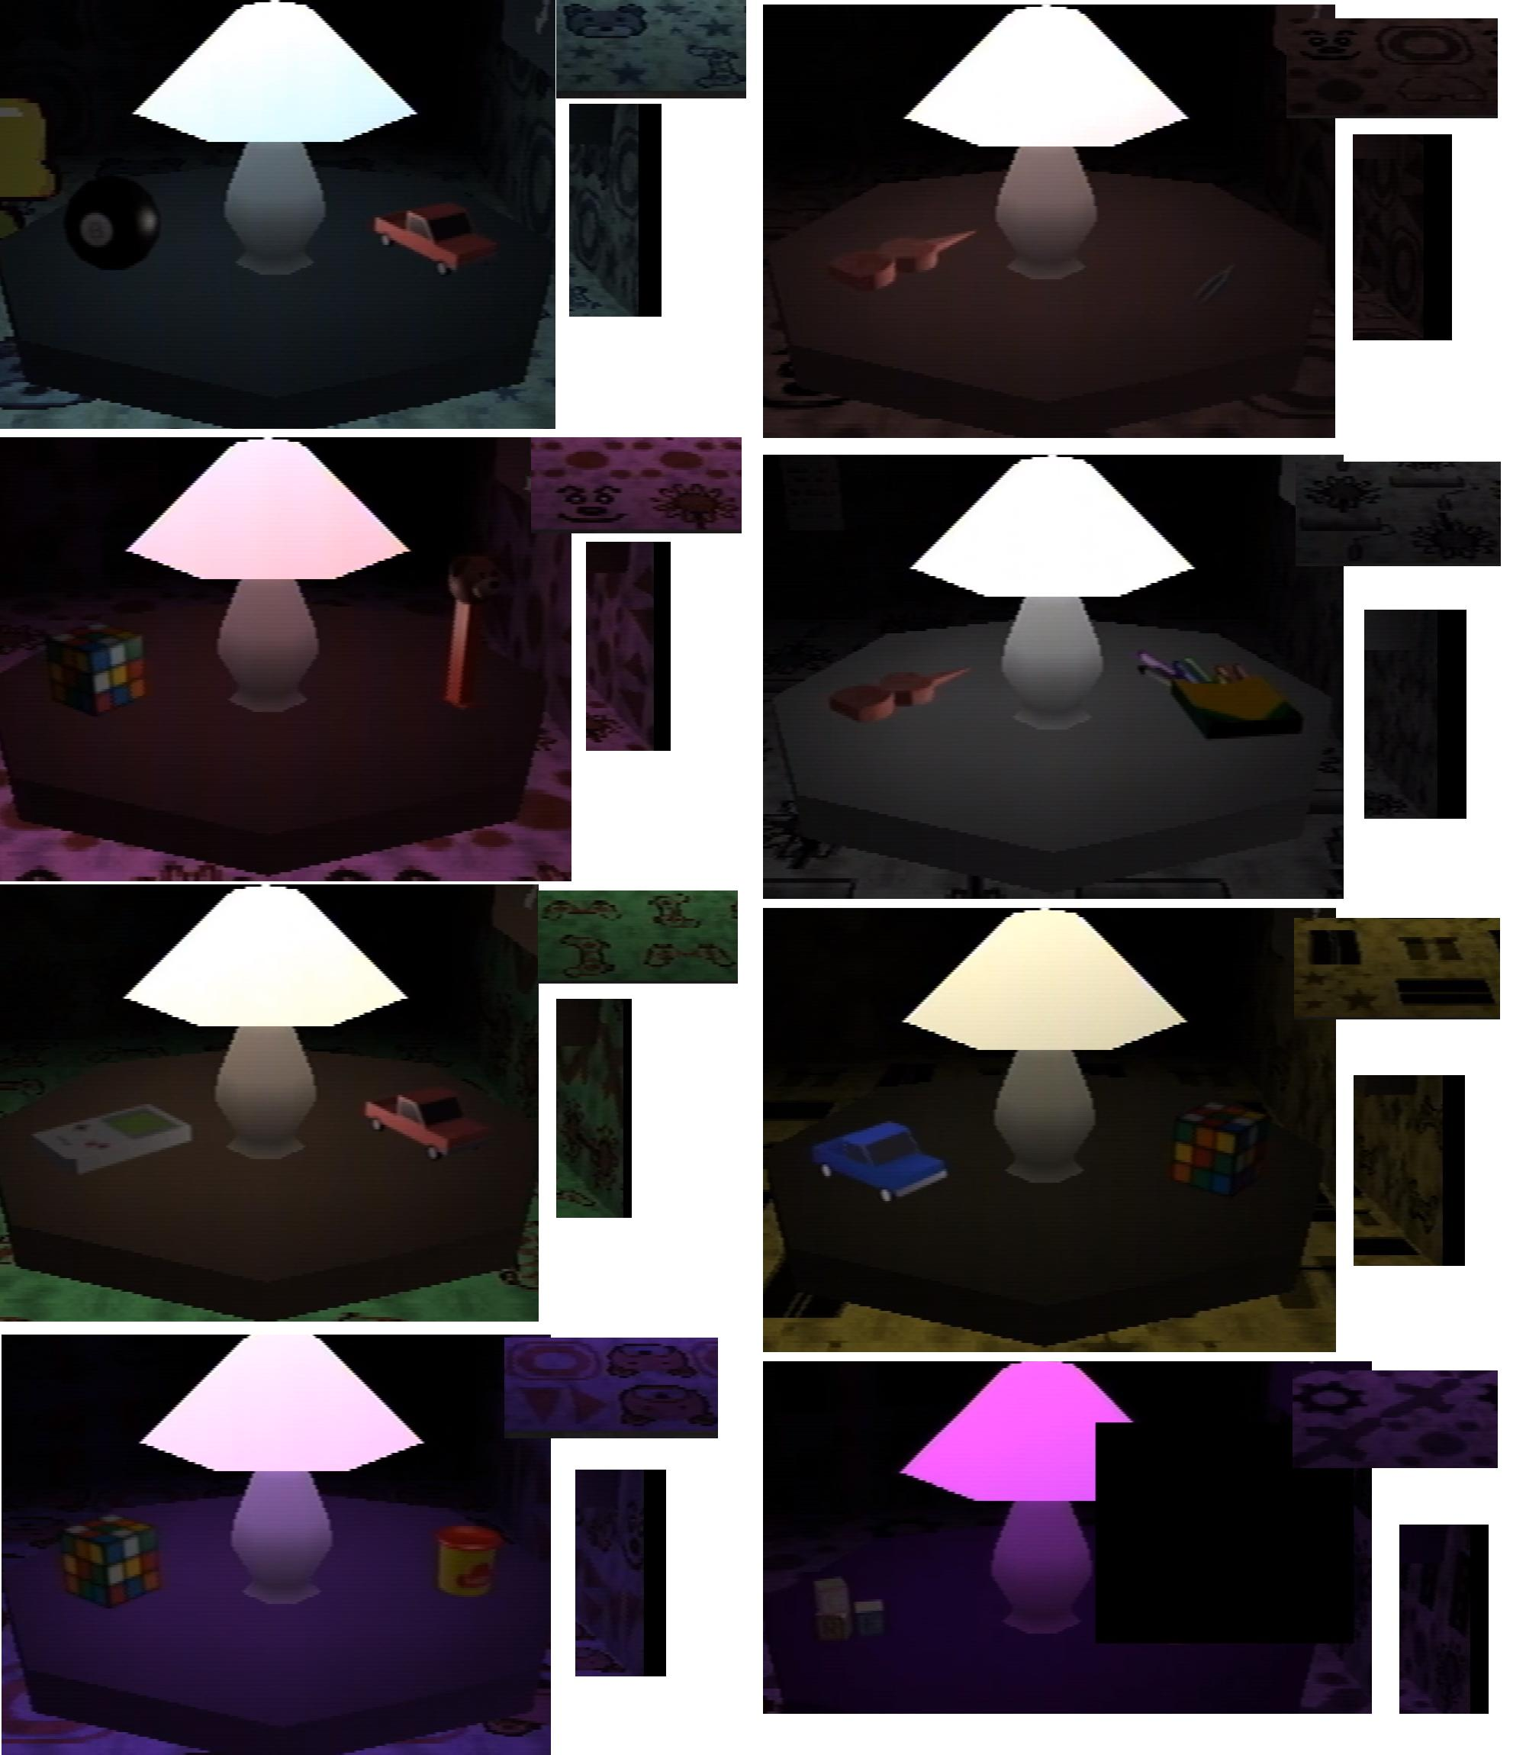

The O in the Shadow Monster Man’s messages in Petscop 6 is the same as the texture found in one of the generic children’s bedrooms (it’s also in Mike’s room):

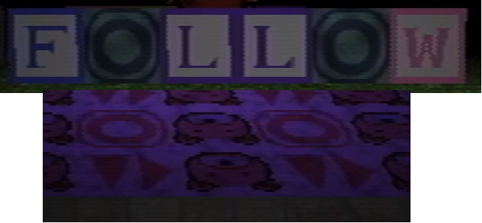

The remaining letters likely originated from the Computer Room floor, where the letter ‘O’ is blocked by a Piece contraption.

The floating platform in Petscop 4 is slightly transparent.

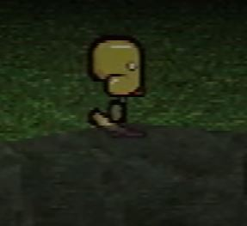

The handwriting on the note in the Quitter’s Room, Red TOOL’s answers, and the Pets menu are similar:

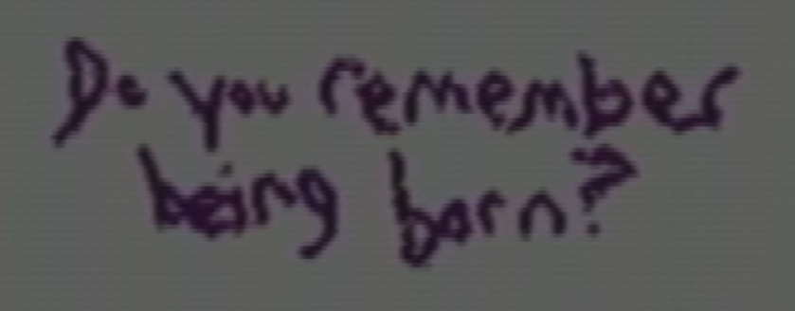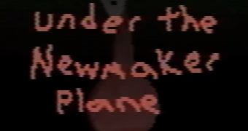

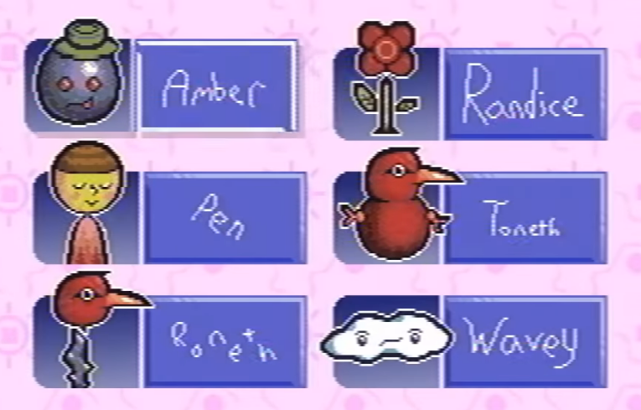

The same shovel and rake found in the Flower Shack randomly appear in Petscop 6 while the Shadow Monster Man is spawning blocks. They’re also present in the garage:

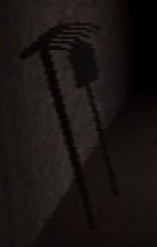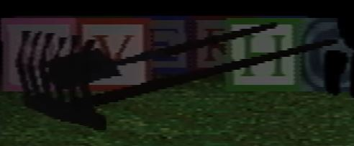

The game does have a save feature, but it’s unclear how it works. In Petscop 1, Paul says he can’t turn off his console because he wouldn’t be able to find the cellar door again. It’s possible he didn’t know there was a save feature in the game at that point, as it is hidden behind the “Quit Game” option. It’s also possible that the game doesn’t save the player’s exact position, and would place him somewhere away from the cellar door.

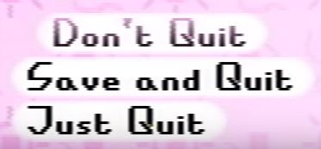

In Petscop 5, around 6:30, the video seems to glitch out. It looks like video compression artifacting, but it could be intentional. Similar glitching occurs briefly in Petscop 13 with Wavey’s sprite and in Petscop 15 while waiting for the “present.”

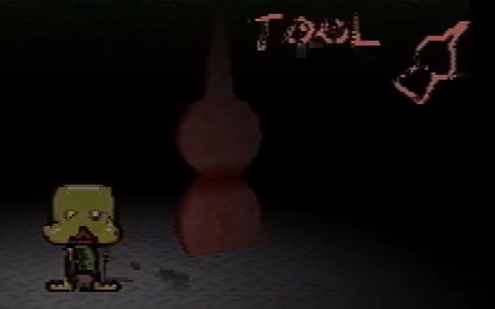

**Textboxes**

In Petscop 1 through Petscop 5, there is a consistent margin bug with all textboxes (including pet descriptions and menu text) in which the margin from the top increases with the amount of lines in the text box. This is corrected in Petscop 6 and is no longer present in any videos onward, presumably since Toneth’s pet description, being long at points, would not display properly with this issue.

This can be experimented with here: <https://f.hs.vc/ptopoc/>

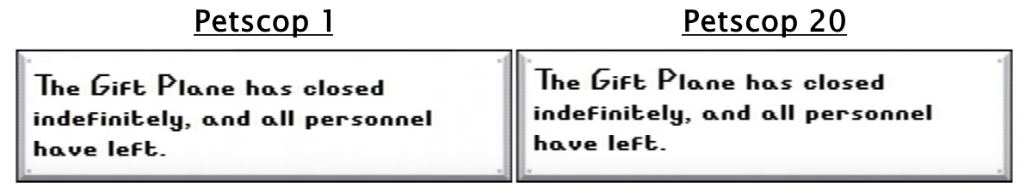

From Petscop 16 onward,black text-boxes (of all types) appear to have an unexplained orange box in a particular location:

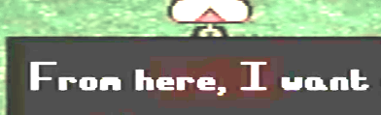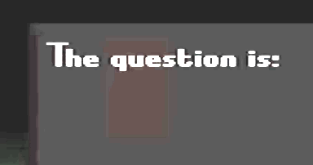

**Website and the Computer**

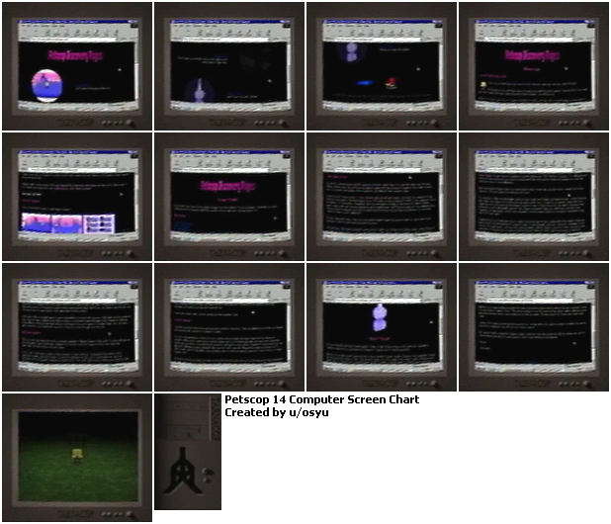

**Timeline Spreadsheet**

<https://docs.google.com/spreadsheets/d/1EZ3dg5vNt8ReJTJV520DioUcSX7kpRLgqiUgOsqULU0/edit?usp=sharing>

**Duality Motifs**

Petscop features multiple instances of objects, characters, or places that mirror each other, are parallel or interconnected, or posses two distinct states:

* Cages in Amber’s room
* Quitter’s Room
* Red and Pink TOOL
* The Daisy (“they love me” and “they love me not” states with distinct sounds and visuals)
* The treadmill in Odd Care (even numbers have a red background, and odd ones pink)
* Multiple parallels and connections between Even/Odd Care and places under the Newmaker Plane
* The Windmill changing directions, and having a regular state and a placeholder state
* The duplicated Guardian in Petscop 9 in Lina’s Room
* Footage synchronization
* The dual dates (“1997 and 2000”) in the “about” section, and pairs of calendars in the House
* The bathroom scene in Petscop 11
* The kidnapping scene in Petscop 11
* The Needles Piano (pink when played correctly, turns red after a mistake is made)
* Lina and Carrie, Belle and Tiara, Carrie and Paul
* The door puzzle for Marvin
* Mechanics of Demo recordings used by Paul in Petscop 14 (i.e. two instances of the Guardian following the same inputs in different environments)
* Paul and “Pall”
* Caskets and the forms of Care
* Graverobber (played on two boards, with the game pieces attempting to execute the same moves on both)
* Two eggs in the locker, and the implication of history repeating itself. Furthermore, one of the eggs features pink, and another red (along with the colors of Belle and Care).
* Newmaker Plane and the real world (Windmill and a large stone, likely more)